Ambulance Services Sustainable Funding Review
Citation: Ministry of Health. 2004. Ambulance Services Sustainable Funding Review. Wellington: Ministry of Health.
Published in January 2005 by the
Ministry of Health
PO Box 5013, Wellington, New Zealand
ISBN 0-478-25781-3 (Book)
ISBN 0-478-25782-1 (Internet)
HP 3848
This document is available on the Ministry of Health’s website:
http://www.moh.govt.nz


Foreword
It is with satisfaction that I can present this review of the ambulance service in New Zealand. This review is a combined effort of the ambulance funders and providers that significantly increases the understanding of the ambulance service.

The ambulance service is deservedly held in high regard in our community. Ambulance officers regularly rate as one of the country’s most trusted professions and the road ambulance service attracts large numbers of community volunteers. On the back of significant Crown funding and the responsibility placed by the Crown on the sector, the organisations that run our road and air ambulances are able to attract significant financial support from communities and corporate sponsors.

The advent of the modern ambulance service in New Zealand can be traced back to the 1880s. The need for rapid access to medical care has long been recognised and often connected to developments for military purposes. Formal first aid training in this country dates back to the 1880s and 1892 saw the first division of St John formed in Dunedin. By 1907 there were 41 such divisions. In 1927 Wellington Free Ambulance was inaugurated.

In the public hospital system, many developed either their own ambulance services or a collaborative structure utilising St John volunteers. With the various restructurings of the health system, most public hospitals exited this service leaving only Taranaki DHB, Wairarapa DHB and the Marlborough part of the Nelson Marlborough DHB operating ambulances today.

The history of St John in New Zealand is one of expansion of small, semi-autonomous units through to the 1970s with the progressive strengthening of regional, and then national, structures through to the present.

Air ambulances are a more recent innovation. While the concept of air rescue by helicopter was first seen in the Korean War, uptake of the idea in New Zealand was a more sporadic affair. Individual drive, responding to a range of motivations, has led to the independent creation of helicopter emergency rescue services since the 1970s. These services attract more funding from community support and corporate sponsorship than from the Crown. Some have also developed fixed wing inter-hospital transfer services for transporting patients around our increasingly specialised medical care system.

The direction of the service is one of increasing co-ordination and professionalism. Better co-ordination is possible with the introduction of new communication and GPS tracking technologies. The number of communication centres operating across all ambulance providers is being reduced from eight to three. Each centre will be able to maintain services in the event of operational failure of any other centre. Professionalism is improving through the development of voluntary standards with common quality standards, provision for agreed links between qualifications and scopes of practice, etc, and through evolution of protocols for dispatch, transfer and delivery. The provider forum of Ambulance New Zealand is harnessing the momentum of the sector with the assistance of an air ambulance specialist forum, Air Rescue New Zealand.

The Sustainable Funding Review for Ambulance Services is the first step towards a real understanding of the costs and activity of the ambulance services. The Regional Health Authorities had made a start on such a review but were phased out before it could progress. In 2002 the Ministry of Health, ACC and Ambulance New Zealand endorsed the project under a formal understanding between the organisation that provided a framework for undertaking the review.

The collaboration between funders and providers has lead to new insights into the fundamental structure of the ambulance service. Further work is needed to fully understand the connection between cost and quality of service. The future work in this area, supported by improved information from the restructured communication centres, will look at the relative input of the injury versus the medical emergency funders (ACC and the Ministry of Health), account for the input of volunteers, provide for the integration of road and air ambulance services and finalise the costs of the ambulance standards.

I look forward to ongoing co-operation between the Ministry of Health, ACC, the Order of St John, Wellington Free Ambulance, the DHBs and the many air ambulance operators to progress this ambitious enterprise.



Hon Pete Hodgson
Associate Minister of Health

Contents
Foreword iii
Statement from the Project Steering Group xi
Executive Summary xii
1 Introduction 1
2 Project Scope 2
3 Principles 3
4 Main Findings 4
Existing levels of revenue 4
Scope of service 4
Costs and funding 4
Relationship with quality 5
Financial model 5
5 Sustainability 7
Working definition of sustainability 7
Current state 7
Performance against quality measures 7
Management of assets 8
Effective management 9
Management of demand 10
6 Preconceptions 11
Evidence of significant financial pressure 11
Consistent service quality 12
Full crew levels 12
Air ambulances as replacement for road ambulances 13
Funding sources 13
7 Service Description 15
Nature of service 15
Service standard 17
Service levels 18
Full crew 18
Volunteers 21
Response times 22
Qualification levels 24
Current funding / contracting models 24
8 Financial Viability 26
Non-DHB road ambulance operators 26
9 Conclusions 28
Population drives volume 28
Volume drives cost 29
Economies of scale 30
Utilisation and cost 31
Volume mix and cost 33
Service coverage case studies 33
Provider cost function 35
Air ambulance services 36
Part A: Road Ambulance Services; Technical Report 37
1 Introduction 40
2 Technical Background 41
3 Financial Situation 48
4 Fundamental Analysis 58
5 Cost Driver Analysis 88
6 Pricing and Funding Analysis 117
7 Summary 126
Appendices 130
References 138
Part B: Air Ambulance Services; Technical Report 139
1 Introduction 142
2 Data Quality 143
3 Data Synthesis 146
4 Analysis of Data 148
Appendices 176
Part C: Appendices 182
Appendix A: Project membership 183
Appendix B: Service levels 185

List of Tables
Table 1: Full crew cost options 20
Table 2: Response time targets 22
Table 3: Estimated response time performance 23
Table 4: Qualification mix 24
Table 5: Outlier stations explained 34
Table 6: Provider cost-weights 36
Part A: Road Ambulance Services; Technical Report
Table 2.1: Stations excluded from the station level analysis 47
Table 3.1: 2002/03 NGO providers’ financial performances ($ million) 49
Table 3.2: Five years’ financial performances ($ million) 49
Table 3.3: 2002/03 financial performances from data reported ($ million) 54
Table 3.4: 2002/03 financial performance with nominal rents in expense ($ million) 55
Table 3.5: Revenue data reported ($ million) 55
Table 3.6: Health revenue data reported ($ million) 57
Table 4.1: Station distribution at service level 58
Table 4.2: Geographic statistics at provider level 60
Table 4.3: Travel time (h) per incident at provider level 63
Table 4.4: Number of dispatches per incident at provider level 64
Table 4.5: Number of patients per incident, at provider level 64
Table 4.6: Ratio of travel time to service time at provider level 65
Table 4.7: Correlation coefficients between volume proxies 65
Table 4.8: Volume data 66
Table 4.9: Volume structure among six categories 67
Table 4.10: Emergency volume proportions between accident and medical 67
Table 4.11: Volume proportion at station service level 70
Table 4.12: Emergency volume proportion at station level 71
Table 4.13: Road ambulance vehicles available 72
Table 4.14: Vehicle rostered hours 72
Table 4.15: Vehicle utilisation 73
Table 4.16: Labour utilisation 74
Table 4.17: Full crew for emergency services 75
Table 4.18: Operating cost structure by cost component 76
Table 4.19: Personnel cost proportion over total cost 77
Table 4.20: Paid staff hour rates based on raw data 77
Table 4.21: Actual hour rates ($) 78
Table 4.22: Paid staff hour rates recalculated 79
Table 4.23: Paid staff hour structure 80
Table 4.24: Response time targets 81
Table 4.25: Station level response performance information 82
Table 4.26: Estimated response time performance 84
Table 4.27: Qualification mix 85
Table 5.1: Correlations among the factors at station level 88
Table 5.2: Key statistics between population, volume, and cost at provider level 89
Table 5.3: Regressions of total volume on population 90
Table 5.4: Regressions of emergency volume on population 91
Table 5.5: Regressions of cost on total volume 94
Table 5.6: Regressions of cost on population 96
Table 5.7: Provider cost functions 97
Table 5.8: OSJN case study of cost relativities between EAS and PTS stations 104
Table 5.9: Correlation coefficients for all of stations with Equation 2 105
Table 5.10: Estimation of cost weights for six categories of volumes 105
Table 5.11: Correlation coefficients for Level 6_5_PTS stations with Equation 2 106
Table 5.12: Estimation of cost weights with Equation 3 106
Table 5.13: Correlations for the variables in Equation 3 107
Table 5.14: Correlations for the variables in Equation 5 107
Table 5.15: Option 1, ACC:MED = 1:1, regressions with Equations 4 and 5 108
Table 5.16: Option 2, ACC:MED = 1.5:1, regressions with Equations 4 and 5 108
Table 5.17: Option 3, ACC:MED = 2:1, regressions with Equations 4 and 5 108
Table 5.18: Cost relativities estimated with Equations 4 and 5 109
Table 5.19: Outlier stations explained 111
Table 5.20: Metropolitan stations 112
Table 5.21: Metropolitan stations’ statistics 112
Table 5.22: Metropolitan stations’ indices 113
Table 5.23: Volunteer costs projected 114
Table 5.24: Cost weighted volume projected 114
Table 6.1: DEA efficiency scores for Level 5 and 6 stations 119
Table 6.2: Estimation of national average costs 121
Table 6.3: Emergency funding analysis 121
Table 6.4: Full crew costings 125
Part B: Air Ambulance Services; Technical Report
Table 1: Organisations that responded to the Ministry of Health’s data request 143
Table 2: Breakdown of availability of job cycle times 146
Table 3: Difference between given job cycle time and flying hours/mission (minutes) 147
Table 4: Number of observations 148
Table 5: Flying times by aircraft type 148
Table 6: Cost curve parameters with outliers removed 165
Table 7: Cost curve parameters with all data points 166
Table 8: Cost curve parameters and average costs by aircraft type 167
Table 9: Cost curve parameters with outliers removed 168
Table 10: Cost curve parameters with all data points 169
Table 11: Average number of aircraft operated by each class of air ambulance operator 170
Part C: Appendices
Table B1: Road ambulance service levels 185
Table B2: Basic, intermediate and advanced life support defined 186

List of Figures
Figure 1: Impact of replacing volunteers with paid staff 22
Figure 2: Station population versus emergency incidents 28
Figure 3: Population versus emergency incidents (excluding cities) 29
Figure 4: Incidents versus cost 30
Figure 5: Economies of scale 31
Figure 6: Unit cost versus utilisation 32
Figure 7: Unit cost versus utilisation (volunteer-only stations) 32
Figure 8: Examples of outlier stations 34
Figure 9: Cost differences by provider 35
Part A: Road Ambulance Services; Technical Report
Figure 2.1: Cost drivers and service delivery process 43
Figure 2.2: The process of SFR analysis 46
Figure 3.1: NGO providers’ financial performance 50
Figure 3.2: OSJC financial performance 51
Figure 3.3: OSJM financial performance 51
Figure 3.4: OSJN financial performance 52
Figure 3.5: OSJNRSI financial performance 52
Figure 3.6: OSJS financial performance 53
Figure 3.7: WFA financial performance 53
Figure 3.8: Revenue structure by income sources 56
Figure 3.9: Revenue structure by providers 56
Figure 3.10: Health revenue structure 57
Figure 4.1: National station distribution at service level 59
Figure 4.2: Population proportion at provider level 60
Figure 4.3: Average distance from station to emergency department at provider level 61
Figure 4.4: Average travel time from station to emergency department at provider level 62
Figure 4.5: Medical versus ACC emergency volume at provider level 68
Figure 4.6: Medical versus ACC emergency volume at station level 68
Figure 4.7: Volume proportion among six categories 69
Figure 4.8: Volume proportion among providers 69
Figure 4.9: Volume proportion at station level 70
Figure 4.10: Emergency volume proportion at station level 71
Figure 4.11: Operating cost structure at national level 76
Figure 5.1: Total volume versus population at provider level 90
Figure 5.2: Total volume versus population at station level 91
Figure 5.3: Emergency volume versus population at provider level 92
Figure 5.4: Emergency volume versus population at station level 92
Figure 5.5: Emergency volume versus population at station level (excluding cities) 93
Figure 5.6: Cost versus total volume at provider level 94
Figure 5.7: Cost versus total volume at station level 95
Figure 5.8: Cost function differences by provider 98
Figure 5.9: Economies of scale: average cost versus volume at station level 99
Figure 5.10: Average cost versus volume for volunteer–run stations 100
Figure 5.11: Average cost versus volume with exclusion 101
Figure 5.12: Average cost versus vehicle utilisation rate at provider level 102
Figure 5.13: Average cost versus vehicle utilisation for volunteer-run stations 102
Figure 5.14: Average cost versus vehicle utilisation with exclusion criteria 103
Figure 5.15: Examples of outlier stations 110
Figure 5.16: Metropolitan: emergency volume versus population 113
Figure 5.17: Metropolitan: average cost versus vehicle utilisation 114
Figure 5.18: Metropolitan: projected average cost versus vehicle utilisation 115
Figure 5.19: Metropolitan: projected average cost per cost-weighted volume versus cost-weighted volume per vehicle 115
Figure 5.20: Metropolitan: projected average cost per cost-weighted volume versus cost-weighted volume per on-duty staff hour 116
Figure 6.1: Production frontier: emergency volume versus non-emergency volume 118
Figure 6.2: Impact of replacing volunteers with paid staff 123
Part B: Air Ambulance Services; Technical Report
Figure 1: Proportions of total flying hours for single engine rotary aircraft 149
Figure 2: Ranges of flying hours for single engine rotary aircraft 149
Figure 3: Proportions of total flying hours for twin engine rotary aircraft 150
Figure 4: Ranges of flying hours for twin engine rotary aircraft 150
Figure 5: Proportions of total flying hours for fixed wing pressurised aircraft 151
Figure 6: Ranges of flying hours for fixed wing pressurised aircraft 151
Figure 7: Proportions of total flying hours for fixed wing non-pressurised aircraft 152
Figure 8: Ranges of flying hours for fixed wing non-pressurised aircraft 152
Figure 9: Proportion of total flying hours by mission types 153
Figure 10: Number of flying hours per mission type 154
Figure 11: Proportions of total missions for single engine rotary aircraft 154
Figure 12: Range of number of missions for single engine rotary aircraft 155
Figure 13: Proportions of missions for twin engine rotary aircraft 155
Figure 14: Range of number of missions for twin engine rotary aircraft 156
Figure 15: Proportions of total missions for fixed wing pressurised aircraft 156
Figure 16: Range of number of missions for fixed wing pressurised aircraft 157
Figure 17: Proportions of total missions for fixed wing non-pressurised aircraft 157
Figure 18: Range of number of missions for fixed wing non-pressurised aircraft 158
Figure 19: Proportion of total missions by mission type 158
Figure 20: Number of missions by mission type 159
Figure 21: Comparison of proportion of flying hours versus proportion of missions 160
Figure 22: Charge rates for single engine rotary aircraft 161
Figure 23: Charge rates for twin engine rotary aircraft 161
Figure 24: Charge rates for fixed wing pressurised aircraft 162
Figure 25: Charge rates for fixed wing non-pressurised aircraft 162
Figure 26: Average hourly charge rates 163
Figure 27: Flying hours vs costs with outliers removed 165
Figure 28: Flying hours vs costs with all data points 166
Figure 29: Average cost per mission with outliers removed 168
Figure 30: Average cost per mission with all data points 169
Figure 31: Proportion of total revenue for operators with only rotary aircraft 171
Figure 32: Range of revenue for operators with only rotary aircraft 172
Figure 33: Proportion of total revenue for operators with only fixed wing aircraft or with both fixed wing and rotary aircraft 172
Figure 34: Range of revenue for operators with only fixed wing aircraft or with both fixed wing and rotary aircraft 173
Figure 35: Range of revenue for all air ambulance operators 173
Figure 36: Proportion of total revenue received 174
Figure 37: Average revenue received 175
Figure 38: Range of surplus/deficit from operations 175

Statement from the Project Steering Group
The Sustainable Funding Review provides the first comprehensive review of emergency ambulance services in New Zealand and is the result of a joint project between funders and providers of road and air ambulance services.

The review has greatly improved sector and Crown agency understanding of the scope and scale of the country’s ambulance services.

The Steering Group is very pleased with the high level of commitment from the participants in this project, especially ambulance providers who have made a valuable contribution to the information base and greatly helped to improve the knowledge in the sector of the management and delivery of these important services.

The Steering Group acknowledges that the current information systems and data collection requirements were not sufficient for the review to complete its set goals. This is an important finding for the sector as it highlights where we need to focus in the future to increase our understanding. It is noted that outputs from the Ambulance Communications Project and work on the Ambulance Standards will improve data consistency and quality.

The Steering Group is satisfied that the review has met a number of the Review goals and understands the reasons why some goals have been unable to be met at this time. The ultimate goal of establishing that the sector is sustainable going forward was not fully met and is still dependent on satisfactorily costing the proposed ambulance sector standards and better understanding the drivers of volume growth.

The review is an excellent building block for understanding the factors which influence ambulance services and has also identified those areas that deserve further exploration, such as the role and value of volunteers, service level classifications, inter and intra provider variations in efficiency, and the interface between air and road ambulance services.

The Steering Group is appreciative of all the work undertake by the funders and providers of air and road ambulance services in the Review and is greatly encouraged that this work will continue under the same collaborative arrangements to extend the findings over time.

The review’s findings as they are, represent a ‘snapshot in time’ based on one year’s data (2002/03) and provide a useful starting point for future modelling requirements. The lessons learnt and trust gained by all parties bodes well for future data collection and analysis of this nature. The future use of the model will be enhanced when work on implementing the Ambulance Communications Project and the Ambulance Standards is completed ensuring New Zealand communities continue to be well served by ambulance services.

Executive Summary
The Ministry and stakeholders have broadened their knowledge of the ambulance sector through the process of this review. The review does much to quantify the drivers of cost and compiles a lot of information that will be useful for the providers, service funders and other stakeholders in agreeing future developments.

In terms of sustainability at current levels of service, the review has not identified a need for a material correction in funding levels for ambulance services.

The main findings of the review reinforce a number of intuitively obvious drivers relating to the provision of ambulance services. The following findings relate to cost drivers.
- Population and volume demand are closely matched at all levels of analysis and this is particularly true of emergency volume demand.
- There is a strong match between resourcing of stations and demand, with very few stations appearing as outliers.
- The cost of service provision is closely matched with volume demand.
- There are clear economies of scale in station costs.
- Cost per unit of volume decreases with increasing utilisation of ambulances.
- Cost per unit of volume varies according to the nature of the volume and significantly varies between emergency and non-emergency volumes.
- There are significant differences in station cost structures between providers. These can only be partially explained by the information provided for this review.

The review notes the following about wider cost pressures on the service.
- The total reported revenue of the non-governmental organisation road ambulance providers (inclusive of other activities) for 2002/03 was $124 million, with expenses of $117 million. For road ambulance activity alone, the revenue for the same period was $83.5 million against expenses of $86.3 million. These figures are inclusive of activities funded by ACC and the Ministry such as the Primary Response in Medical Emergency scheme (PRIME), air ambulance services and disaster preparedness. Against these reported figures, it should be noted that the combined St John annual report has a deficit for ambulance activities of $0.249 million and that these figures largely exclude the semi-independent trusts that support ambulance and other activities, for example, the St John Area Committees. The total and ambulance-related revenue and costs for the air ambulance sector have not been made known to this review.
- A push to fully crew all ambulances has come from the initiation of a Standards document in the ambulance service (‘NZS 8156:2002; Ambulance Sector Service Standard’). However, lack of clarity of the aims of full crewing and incomplete or contradictory data provided to the review limit the ability to estimate the cost of such a provision. Rough estimates of the cost of implementing full crewing range from $17.5 million to $4.8 million or less. The appropriate place for costing a move to universal full crew levels will be with the assessment of the Standards.
- The Standards document also describes the appropriate qualification mix for different classes of ambulance. This review did not collect information on the numbers of ambulances in these classes, but a view has been obtained of the relative qualification mix of ambulance stations. The degree of overlap between service levels has meant that no clear benchmarks are available on this criteria and no overall cost estimate can be made of moving to those benchmarks.
- Response time performance appears to be better than that regularly reported to funders. A complete picture of response time performance is not available from the data provided, but a representative sample indicates that overall performance may be around 2 percent below target (ie, 78 percent of emergencies are getting an ambulance officer on the scene within a time for which the target is 80 percent, and 93 percent of emergencies are getting a response within the 95 percent target).

1 Introduction
The sustainable funding review arose as a response by various parties to a perceived need for a better understanding of the funding requirements of the ambulance service. It was considered highly preferable that this understanding be shared by those on both sides of the negotiating table, both funders and providers, without the process of achieving this understanding being itself a negotiation. The main parties involved in initiating this review were the Ministry of Health, ACC and Ambulance New Zealand as signatories of a Memorandum of Understanding that establishes a forum for high level discussion of common ambulance issues. The spokesgroup for District Health Boards (DHBs), DHB NZ, was also invited to be involved. DHBs have an interest in these services both as funders of inter-hospital transfers and as the main delivery point for emergency transports.

Funders and providers have come to this review with slightly different imperatives. The Ministry faced claims of substantial deficits from at least one provider, had a long-standing intention to better understand ambulance service cost drivers and, therefore, undertook to provide the bulk of the analytical input to the review. Ambulance NZ, as the representative of providers, had also been consistently advocating that the Crown needed to sort out the mix of funding arrangements it had with the sector and that such a review was a means to achieve this.

Rather than devolving the emergency ambulance contracts it inherited from the Health Funding Authority to DHBs, the Ministry opted to first review what would be required to achieve a sustainable service of appropriate quality. The Ambulance Services Sustainable Funding Review project was to achieve these aims. To be successful, the review required a collaborative environment with input from a wide range of providers. Both funders and providers were represented at a working and governance level through the establishment of the Project Working Group and Project Steering Group. Membership of these groups is set out in Appendix A.

The Ministry also widened the scope of the exercise to include both air and road ambulance services, as it believed at the time that an understanding of the interface between these modes of transport would be informative. As the air ambulance sector was not the main driver for this review and did not have the same reliance on Crown funding as the road ambulance sector, its incentives to be party to this review were quite different. Data collection from this sector was treated differently, both from the point of view of their background in the review and because of the greater competition between air ambulance providers. The separate technical reports appended to this document originate from this decision.

Although the report is the product of the Ministry, it has only been possible with the goodwill and effort of ambulance providers. The Ministry acknowledges that shortfalls in the ability to address certain questions posed of the review relate more to ambulance service information systems being designed for other purposes than to a lack of willingness to participate in the project.

2 Project Scope
The sustainable funding review was tasked to conduct a bottom-up analysis of ambulance costs, volumes, distribution, and income to develop a model to assist in determination of appropriate funding levels for the provision of ambulance services in New Zealand.

The project’s objectives were to:
- establish a shared understanding of the existing levels of revenue (Crown funding and other) available for the provision of ambulance services in New Zealand
- establish a shared understanding of the scope of the service delivered by ambulance services in New Zealand (including service inputs such as infrastructure and crewing and service outputs such as volumes and response times) and how the various services interact
- establish a shared understanding of the costs (fixed and variable components) and the cost pressures relating to the provision of ambulance services in New Zealand
- build on the agreed understanding of costs, revenue and coverage to develop a model describing the relationship between ambulance service revenue and ambulance service costs and quality of service
- produce a robust financial model reflecting the sustainable funding of ambulance services acceptable to both the funders and the sector, to be used as the basis for determining funding approaches in future engagement practices.

3 Principles
The steering group set the overarching principles of the sustainable funding review. These are in the form of general assumptions within which the review was to operate.
- The ambulance sector will continue to be supported by volunteers and receive revenue from a variety of sources including Crown funding.
- The review is a technical project to develop a shared understanding of the scope of the current service coverage costs and revenue of New Zealand ambulance services (it is not a negotiating process).
- The project will evaluate the complete scope of ambulance services in New Zealand and identify appropriate performance and efficiency benchmarks for those services.
- Sufficient information should be obtained on the non-core ambulance services provided by ambulance operators (including income) to fully comprehend the revenue and costs of the ambulance service.

4 Main Findings
This section links the project goals with the outcomes of the analysis. There were five project goals, the last two of which were the most dependent on consistency of data between providers. The goals of the review are presented in the statement from the project steering group (see page xi).

Existing levels of revenue
The ambulance service in New Zealand is in relatively good financial shape to provide the current level of services required of it.

For road ambulance services, revenue has been growing faster than costs. Ongoing surpluses are being achieved after expenditure from direct Crown and patient funding and charitable input for these services. Most of the charitable revenue and revenue from other activities is being directed to charitable or commercial activities. Overall, the contribution from volunteers is a critical non-governmental organisation input.

Air ambulance services differ markedly in that direct Crown funding is a minority source of revenue. Direct Crown funding for operators of helicopter-only ambulance services amounts to about 15 percent of their total revenue, most in the form of ACC fee-for-service payments. The equivalent figure for other operators (either fixed wing or a combination of fixed wing and rotary) is 35 percent. The responses to the survey did not provide a complete representation of the revenues to the air ambulance providers. Any optimisation of the air sector would have to take its reliance on non-Crown funding into account.

Scope of service
The project scope asked for the development of a ‘... shared understanding of the scope of the service delivered by ambulance services in New Zealand (including service inputs such as infrastructure and crewing and service outputs such as volumes and response times) and how the various services interact’. This report, together with the appended technical reports on road and air ambulance services, provides a wide range of information on the scope of ambulance services. Key points can be found in the Executive Summary and the Conclusions sections as well as in the Summary section of Part A of this report. Discussion on quality issues can be found in sections on full crewing, response times and volunteers.

Costs and funding
This report describes, for road ambulances, the clear relationships discovered between population and demand and demand and costs, plus the cost drivers identified in utilisation, mix of activities, and input from volunteers. Cost weights based on the available data are specific to existing providers of road ambulance services. A relationship between cost and quality could not be accurately determined from the information provided. Further information would be required to identify the costs for different utilisation rates for each class of fixed wing aircraft.

It is unlikely that any savings would be gained by greater use of air ambulances in rural areas. Savings would only arise if the capacity of the remote road ambulance services could be reduced. These services are already operating at well below optimal utilisation and are only possible as a result of the local community input.

Relationship with quality
The preceding goals of the review helped the understanding of how the non-governmental organisation status of providers and their use of volunteers influences the Crown and provider’s decisions around the location of services. In doing so, part of the fourth goal, the relationship between revenue and costs, has largely been achieved.

The pre-review expectation that there would be sufficient consistency of data to permit the setting of benchmarks relating cost and quality for road ambulance services has not been fulfilled. The implications of having at least two ambulance officers in each emergency ambulance (full crewing) cannot be reliably calculated from the data currently collected by providers. Without plentiful stations shown by the data as operating at the required response time performance levels, the review cannot estimate the cost implications of these targets. The implications of meeting qualification expectations can be assessed for existing staffing, but is of limited value given that the staff implications of full crewing and response times are unknown.

Resolution of the relationship between cost and quality in the road ambulance service will, to a large extent, be a natural outcome of the processes relating to understanding the implications of the Ambulance Sector Standards (‘NZS 8156:2002; Ambulance Service Sector Standard’). In moving to adopt those Standards, the sector will need to assess the staffing and access implications and present to their funders options for what can be achieved in a cost-effective manner. Currently the necessary information rests with the ambulance providers and, although this information will be nationally consistent following the implementation of the Ambulance Communications Project, work could commence at an earlier date based on regionally consistent information. To some extent, however, the performance of the ambulance service needs to be considered in the context of the wider health sector, particularly primary care, in terms of drivers of medical emergency demand. It is in that area that the Ministry will need to focus.

Financial model
An outcome of this review is a much better understanding of the funding constraints within which the sector operates. This understanding is based on study of a single year. There is no reason to suspect that the year was unusual and sufficient reason to conclude that ambulance funding has kept pace with the cost of demand growth. Funders can now be confident that any additional money put into road ambulance services would result directly in improved services.

Outstanding work on funding includes:
- gaining an understanding of the premium required for a fee-for-service style of contracting over a bulk contract approach (capacity funding)
- determining appropriate comparative volumes between accident and medical emergencies (cost relativities)
- determining and agreeing on an appropriate division of funding responsibility between ACC, Vote: Health and the charitable fundraising of the providers.

These matters were not necessarily the intent of the review but will continue to be topics for further work between ACC and the Ministry, and between those parties jointly and service providers.

5 Sustainability
In Section 4 of this review it was concluded that, at the current level of service and revenue, the ambulance service is sustainable. The proviso relating to the current level of service is quite deliberate. In this section, the report considers the concept of sustainability for the ambulance sector for the longer term.

Working definition of sustainability
For the purposes of this review, a service is considered sustainable if, with effective management, optimised resource distribution and appropriate triaging of demand, it can continue over time to at least break even financially and perform to the standard expected of it within the resources available to it.

Current state
There are two main factors that contribute to the statement that, at the current level of service and revenue, the ambulance service is sustainable. The first is that the assessment of the financial state of providers shows that they continue to at least break-even financially. The second is the imprecision in the specification of performance.

The imprecision in the specification of performance arises from joint service specifications that reference the Standards document but require only that providers make ‘reasonable endeavours’ to meet the expectations of that document. The service specifications take that position as the Standards, although they are a huge step forward in compiling expert opinion on the direction of the service, are not yet at a stage where costs and benefits can be assessed. Until that assessment occurs, the Standards cannot be reviewed with rigour, gaps in its coverage will be difficult to find and fill, and an informed position cannot be presented to the Minister of Health to be mandated. [Note that the Health and Disability Services (Safety) Act 2001, s18, requires, amongst other things, that the Minister of Health be satisfied that requiring providers to comply with the Standards would be in the public interest, having regard to the extent to which compliance would ensure the safe provision of services and the likely costs of compliance.]

The lack of clarity around the specification of service quality leads to the uncomfortable position that the ambulance service is considered sustainable in its current configuration as long as it meets the condition of prudent financial management.

Performance against quality measures
A mixture of analysis and anecdote indicates that ambulance providers are not meeting the quality measures compiled in the Standards document. As stated above, the quality measures in the Standards document will need to be shown to be in the public interest before they will be included in an approved compliance document, but are taken as valid for the purposes of this review.

Direct staff costs at the time of the review for all ambulance services were about $45.5 million. The cost estimates for meeting the full crew requirement for the Emergency Ambulance Service vehicles only range from $16.4 million to $4.8 million or lower. In terms of increase over current staffing levels, these equate to an increase of anything up to 36 percent. As such, questions relating to full crewing will be central to future debates on implementation of the Standards. It will only be once there has been a full assessment of the benefits of full crewing (including crew retention, avoidance of harm to crew, added patient observation and care in transit, and improvements in time for the vehicle to come available following patient delivery) that decisions will be made on the level of full crewing that will be considered part of the sustainability equation.

Shorter response times are seen as key to improvements in recovery or survival in serious medical emergencies or severe trauma. Ambulance providers devote significant effort to reducing response times through maximising the availability of spare ambulances at times of expected high demand, and reducing activation times through having crew on duty in their vehicles and improving call management. These variables are within the control of ambulance management and their importance will be specific to a given locality. Through the thorough understanding of these local dynamics, information should arise on the extent to which gaps in response time performance could be met by improved management and the cost of meeting any remaining performance gap.

The benefit of the shorter response time declines with declining severity of the cases. For this reason the response time targets are only set on ‘priority one’ callouts; those occasions when the ambulance is responding with maximum urgency. Decisions on the appropriate priority of the callout, however, are made on limited information and any evidence of declining acuity of callouts will call into question the appropriateness of the targets.

The achievement of response time targets are, therefore, an issue that requires in-depth knowledge of the local callout process, crew scheduling, vehicle positioning, and the local relationship between spare capacity and response times. Decisions on investment in additional resources to make the achievement of those targets sustainable require this in-depth knowledge.

This review does not have sufficiently robust information to assess the sustainability of an improved response time performance measured against an agreed Standard. The available information gives only an indication of performance on response times at the provider level. Although this indication is that the road ambulance service is slightly under-performing against existing contracted response time targets, there is no indication of the degree to which that under-performance relates to controllable factors or under-resourcing of the service.

Management of assets
An organisation may be meeting its financial obligations for some short to medium period without being sustainable in the longer term, by reducing the quality or quantity of its asset base. A sustainable organisation takes a long-term view of service provision and, therefore, maintains its assets. To do this, depreciation must be recognised as a cost against the organisation and assets must be replaced once they have reached the end of their useful life.

Depreciation in the road ambulance sector almost matches capital expenditure ($9.969 million cf $10.088 million). This indicates that this sector has the financial capability to maintain business capacity on an ongoing basis; that its capital stock is being maintained at a constant level (assuming that the scope of activity remains largely unchanged). There are, however, indications that the quality of vehicle stock is variable between providers; that some vehicles are older than the depreciation term. The depreciation term to which road ambulance services operate is not standard but varies between eight and ten years for vehicles. Although it is not clear that all vehicles older than the depreciation term are at the end of their useful lives, the cost of replacing all vehicles within the depreciation term would increase overall costs by between $0.8 million and $1.7 million depending on the depreciation term used. Compared with the overall cost of the service, the age of the fleet would not appear to be a significant issue.

Effective management
Management effects sustainability both in terms of its impact on efficient use of resources and in terms of the overhead implications. To the extent that sustainability is viewed from the framework of maximum efficiency, both are relevant to this discussion.

It is clear from Figure 5.8 (Part A technical report) that there are differences in costs between providers although it is not clear whether the factors influencing this are to do with management or some other factor. The discussion on response times above indicates some of the management focus in the ambulance sector on effective management.

The costs of production are only partially under the control of providers. There are areas where services are being provided for reasons relating to access and at high unit cost that non-essential services would regard as uneconomic. In other words, providers may have a limited ability to optimise service provision to manage within a national average funding rate. In such situations, the fixed costs do not change and the marginal costs (or saving) relate only to about 15 percent of costs that may be considered variable.

Production costs are also influenced by inflation. Inflation is considered to be largely outside the control of providers as long as they are taking decisions to keep costs under control as much as possible (eg, becoming more fuel efficient). There is no accepted measure of inflation that relates specifically to the ambulance service. Providers and funders need to develop an understanding of variable costs and how prices should be influenced by inflation to ensure this risk is well managed.

With overheads, efficiencies may be obtained through the amalgamation of administrative functions. The Order of St John responds to about 85 percent of incidents and has progressively evolved into more centralised administrative structures. The effective control of the organisation has moved from districts to regions and, more recently, to a national administrative structure, even though the community aspect has been largely retained through area committees. In further strengthening the national administrative structure there will be opportunities for efficiencies in removing duplication of various functions. Such efficiencies would lower the administrative overheads and reduce the overall cost per incident. An example of moves towards amalgamation of functions is the Ambulance Communications Project that rationalises and standardises the number and quality of control centres. This project should create a communication and control mechanism that will not alter with provider structure changes, but will allow better understanding of demand, acuity of calls and help with management of low acuity demand.

Management of demand
The most vexed question in relation to sustainability is that of volume growth. The ambulance service is one that is generally seen as demand-driven, at least with emergencies. Emergencies may be divided into accidents and medical events. Accidents have a body of legislation to define what they are and various programmes to reduce their occurrence (eg, road accident campaigns). Accident emergencies, as defined by law and interpreted by ACC staff, have been reported as decreasing, both in absolute terms and on a per capita basis. Any growth in medical emergencies should relate to changes in the size of the population and increasing health needs (generally related to the effects of ageing). The current net effect of these drivers, assuming the level of acuity accepted for dispatch of an ambulance is constant, is a per year increase of around 1.3 percent (the benchmark calculated from hospital discharge information for assessment of DHB hospital demand growth assumptions).

Providers, however, are reporting increases in medical emergencies that are more significant. This would imply a reduction in the level of acuity of medical emergencies. As funders have not altered the service specification in a way that would decrease acuity (and the service specifications are common to both ACC and the Ministry), these additional volumes beyond the effects of population change appear to be, at least partially, within the control of the ambulance providers. Certainly, they do not appear to be increasing costs.

A growth in medical emergencies beyond that implied by population and the consequential reduction in acuity may be linked to the growth of other ambulance sector activities like alarms and caring callers. These activities alter the balance of responsibility for the activation of an ambulance from the public to the ambulance provider.

The difference in acuity between differing categories of emergencies will impact on sustainability. Areas with higher proportions of serious emergencies will need to maintain larger fleets and assume lower usage to ensure there is spare capacity when needed. Areas of lower acuity will be able to more fully use their fleets and are sustainable at lower levels of input per incident. As discussed elsewhere in this report, cost-weighting of volumes will need to occur to standardise for differences in acuity.

6 Preconceptions
The sustainable funding review set out to test certain preconceptions that have persisted for a number of years. These preconceptions were that:
- the road ambulance sector is under significant financial pressure
- the quality of service is variable and, generally, below that required to meet service standards
- full crewing is an essential goal for ambulance providers
- air ambulances should replace road ambulances in certain situations
- ACC subsidises other ambulance service funders.

Evidence of significant financial pressure
The review considered and received independent advice on annual reports from the non-governmental organisations that provide the bulk of the road ambulance services in this country. (Three DHBs provide services independent of the non-governmental organisations, but account for less than 5 percent of incidents attended. Their accountability documents have a different focus from those of the non-governmental organisation providers and their performance is managed through Crown Funding Agreements.)

The view of the Ministry is that this is a financially healthy sector with an overall surplus of $6.7 million (excluding GST) in 2002/03. To a large extent, this surplus is a result of non-ambulance activities developed around either the goodwill the public have towards the ambulance service (eg, gaming activities and subscription schemes) or the infrastructure that supports the ambulance service (eg, alarm monitoring).

The road ambulance activity itself is, effectively, fully funded for the services it provides, recognising that much of this service is only affordable with the input from volunteers. There is, however, a limited dependence on charitable funding. In the year reviewed, 2002/03, donations credited to this activity made up 0.3 percent of revenue for the activity. The other 99.7 percent was made up of direct funding for emergency services, patient transports or event attendance from ACC, the Ministry of Health, or their clients in the form of either a fully commercial transaction or as a part-charge for medical emergencies. The net revenue from part-charges accounts for 7 percent of activity revenue.

Fixed costs in the road ambulance service do not appear to be a significant cost driver. Although there is evidence that the quality of the road ambulance stock is variable across the country, estimates of the additional fixed costs that would arise from updating the fleet are of the order of $0.8 million to $1.7 million. These estimates are sensitive to assumptions of the value of an ambulance and the term for depreciation.

Consistent service quality
The review considered information provided on several aspects of either input or output quality with the aim of linking quality with resource use to create robust benchmarks for good practice. The data did not support this aim as no relationships could be found between quality and cost. However, information gained is of use in guiding improvements in data collection for future benchmark and target development.

One quality measure suggested by the working group was the proportion of incidents to which an advanced paramedic responded. For this quality measure, the data was incomplete and the targets undefined. Standard application of station coverage area definitions will need to be implemented before significant improvements in response time information will arise. Clarity will be necessary around the definition or scope of full crewing and significant improvements will be required in data collection before full crew status will be routinely available. This review was limited by time and scope.

Full crew levels
There is a perception that there ought to be at least two ambulance officers attending each emergency so that patient care can be maintained by one officer while the other drives. As an aim, this could be achieved in two main ways:
- full crewing every vehicle
- use of multiple single-crewed vehicles (eg, a first response unit plus an emergency ambulance), in some instances using other emergency service vehicles (eg, fire engines) as the first responders.

Road ambulance operators make every effort to get appropriate resources to each incident efficiently. They risk being publicly chastised for those occasions when resources do not permit this. It is difficult, however, to get an objective view of the benefits that arise from having full crews in all vehicles.

The lack of clarity over what full crewing might mean to the public, the service funder and the service provider is in contrast to the expert opinion expressed in the Standards document (‘NZS 8156:2002; Ambulance Sector Service Standard’) which, on face value, aims for full crew in every emergency ambulance, every first response unit, and every patient transport vehicle. It is understood that this was not the intent of those drafting the Standards. Ministry and ACC contractual specifications do not require full crewing of first response units, and DHBs are free to decide on how patient care is provided in the patient transport vehicles they use.

This review has attempted to form a view on the cost of meeting certain quality standards, with full crewing being part of that task. The data available to the review was insufficiently accurate to robustly estimate the current state of crewing within ambulances, let alone the frequency with which two crew members attend appropriate incidents. The estimated cost of full crewing varies widely from over $17 million per year to almost $5 million per year, where even that lower estimate may be excessive.

This review proposes that the debate over the benefits and costs of full crewing should more properly occur within the evolution of the Standards document towards an officially ratified Standard.

Air ambulances as replacement for road ambulances
Planes and helicopters can potentially respond more quickly under certain circumstances than road ambulances, but have certain disadvantages. A fixed wing aircraft can only land at designated airports, limiting their role to inter-hospital transfer with the assistance of road ambulances at either end of the journey. Aircraft take significantly longer to activate than land vehicles although this is partially due to volumes not warranting 24 hour on-duty staffing. Aircraft are more limited in their ability to operate in adverse weather and at night and usually require assistance to secure the safety of a landing site (eg, a helicopter would not land directly on a highway until traffic has been stopped). Aircraft are also much more expensive to operate than road ambulances, especially if they are to be of sufficient size to allow patient care to be maintained.

Helicopters have high fixed and maintenance costs which, with the training and skill maintenance requirements of pilots, limits the number in use. This is particularly true of those helicopters that are of sufficient size to permit patient care to occur in transit. The number of helicopters, together with the additional time to activate one, leads to consideration of their use being predominantly limited to areas that are well away from roads or well away from main centres of population. These are largely the same areas where limited demand means establishment of paid officer road ambulance stations is not currently an option from both a funding and a skill management perspective. Such stations are likely to be operating at levels of use well below the optimum for cost-effective stations with all paid staff and would not support maintenance of full-time officer skills. Additional use of helicopters in remote areas will not reduce the need for a road resource to be in place to serve less urgent local cases and to support or replace the use of air ambulances in adverse conditions. The conclusion, therefore, is that greater use of helicopters should be judged on the grounds of benefit to the patient rather than potential cost savings.

Funding sources
In costing road ambulance services, it has been found that the relative share between emergency and non-emergency ambulance services places an inappropriate reliance on emergency services. The share of costs between road inter-hospital transfers, emergency ambulances and private hire is in the order of 1:2:1. Relating revenue directly with costs indicates that revenue should also be split along these lines (ie, half of ambulance provider revenue should come from inter-hospital transfers and privates hires and half from emergency contracts). However, the current revenue distribution places significantly more reliance on emergency ambulance revenue.

Within emergency road ambulance services, several factors indicate a prima facie case for a higher price per unit to be incurred by ACC. These include:
- ACC not directly paying for patients cared for at the scene and not transported
- the process of meeting ACC’s information requirements and claim vetting procedures may be a disincentive to the full capture of trauma-related activity
- low acuity medical cases may be attributed as medical emergencies as a result of the Ministry’s bulk funding method
- the higher risk that a provider faces in ACC’s fee-for-service environment than in the Ministry’s bulk funding environment.

The scale of the price differential cannot be determined directly from the data collected for this review. Such a determination would require a separate study with this as a specific aim.

7 Service Description

Nature of service
The nature of the ambulance service is often described as one of a ‘capacity’ service. This comes from the view that the service needs sufficient capacity to respond with appropriate promptness to demand. This view is consistent with the observation that the service is one where marginal costs form a limited proportion of total costs.

The primary focus of this review is on road ambulance services as these perform the bulk of activity. Air ambulances are included as they perform a vital function and represent a significant resource investment. There is also general support for their greater use where there is clear benefit to patient outcomes and the service is cost-effective. Water ambulances are a rarity in New Zealand. There are understood to have been two operating in Auckland at the time of the America’s Cup, but elsewhere, marine ambulance work tends to rely on relationships between the ambulance service and coastguard or harbour board vessels. For reasons of the small and varied nature of the marine ambulance situation these were excluded from the review.

In theory, population distribution determines the spacing of services, with the result that those stations covering relatively low populations have highly variable demand and difficulty in establishing an appropriate capacity. Those sparse, low population, low demand, stations tend to fit with the model of community managed services; linked in to the emergency communications network, but staffed entirely by volunteers.

Still developing in the more remote areas is the Primary Response in Medical Emergency scheme (PRIME). This scheme is a medical and advanced paramedic support to more remote communities through the training of GPs and nurse practitioners in paramedic skills. It adds to the quality of service through a multidisciplinary approach.

Further along the spectrum are the more common type of station in terms of workload. Core working day service is provided by one or more on-duty paid staff, who often remain on call to support volunteer staff at night and weekends.

At the most productive end of the road ambulance spectrum are stations staffed largely by paid staff with relatively predictable workloads and more directly under the control of professional management.

The ambulance service falls into the category of ‘worthy causes’ to which people donate time and resources with some confidence that they are helping their community. However, there is some debate that resource contributions are available for the provider to venture into non-ambulance charitable or commercial activities and a view within the service that ambulance activities should be fully Crown or ACC funded. The extent to which ambulance service providers should act as non-governmental organisations versus commercial providers of ambulance services is yet to be clarified.

Air ambulance services have a more recent history as a mode of emergency response, are not reliant on volunteers and are much less reliant on Crown funding than their road counterparts. Corporate sponsors seem highly appreciative of any association they can form with emergency air ambulances.

The provision of corporate and other sponsorship has meant that there is a larger number of air ambulance providers operating at a lower level of activity than would otherwise be viable. It also means that there is a wide range of quality of service in this area with limited ability for the Crown or ACC to push for improvements. The most important levers for the Crown and ACC are Ministry/ACC contracts with providers and the ambulance control centres, owned and operated by the road ambulance services.

Most air ambulance providers are also involved with other activities, but there are a handful of dedicated air ambulance providers. These generally operate craft that facilitate the continuous care of the patient throughout the flight. To improve overall consistency of quality of service delivery, contractual requirements could favour dedicated air ambulance providers over those for which the service is only part of their business model.

The type of patients served by air ambulance providers is of interest to funders. It appears that with emergency medical patients (those whose condition does not relate to a trauma) fewer patients benefit from an air response than do trauma cases. Most cardiovascular emergencies, for example, are resolved in less time than it takes to get an ambulance airborne. This ‘golden hour’ philosophy developed mainly around serious trauma cases with the understanding that outcomes may be improved if the patient can be taken to definitive care within an hour of the injury being sustained and that severe trauma may be associated with internal bleeding for which surgery is most often indicated. Consistent with this view, emergency air ambulance services (largely by rotary wing aircraft) are mostly utilised by ACC claimants.

Medical emergency cases are more likely to be taken by road to the nearest Emergency Department, stabilised, assessed and, if necessary, transported to the appropriate point of definitive care. When this point of definitive care is a greater distance away than could reasonably be expected to be covered by road or the condition of the patient requires it, the simplest appropriate form of air transport is used. Cases that can be transferred with a nurse assisting would be likely to use a charter fixed wing aircraft with limited additional medical services available and with the nurse supplied by the transferring hospital. Cases requiring services such as available in an intensive care unit (ICU) would be more likely to be retrieved by a team of specialists from the receiving hospital in a fixed wing aircraft equipped effectively as a ‘flying ICU’. The flying ICU must be dedicated to ambulance work and so would not be able to spread its costs over other activities. The cost to the user of these services is, therefore, quite different.

The differing imperatives on the road and air ambulance providers lead to a tension where air ambulance providers monitor and publicly question the appropriateness of control centre decisions. There are appropriate channels for such debates to occur productively and, with road ambulance providers controlling both the mode of response and the supply of trained paramedics, it seems unlikely that this tension would degenerate into roadside disputes over who is best placed to transport a patient.

Control centres are currently maintained by each of the nine road ambulance providers with the exception of that operating in most of Marlborough as part of the local DHB (ie, eight control centres in the country). Calls relevant to Marlborough are dispatched from Christchurch. Any 111 phone call asking for an ambulance response will go to one of two Telecom call centres and will be directed to one of these eight ambulance control centres.

Key decisions affecting the speed of the response, the responding ambulance in terms of appropriate skill level and whether to respond by road or by air are largely taken by ambulance control centres (Search and Rescue co-ordinators may also initiate air responses, sometimes with vehicles that may not be ideal for ambulance work, but these may result in a claim to ACC for an ambulance transport). As these decisions have a direct influence on the income of competing ambulance providers, the objectivity and neutrality of those decisions is critical to the sustainability of the air ambulance sector. (A separate project aims to improve the quality and objectivity of triaging and dispatch from control centres, with an overall increase in staffing but a reduction in number of centres to three.)

Service standard
In reviewing the service being provided, attention must be given to the standard of service expected of providers. With road ambulance services there are two different sets of expectations by which the service may be judged. At the instigation of Ambulance New Zealand and under the auspices of Standards New Zealand the document ‘NZS 8156:2002; Ambulance Sector Service Standard’ was compiled in 2002. This is referred to in this review as the Standards document or the Standards. The other measure of service standards is the set of service specifications compiled jointly by the Ministry and ACC. Neither set of expectations is the ideal starting point for judging service quality.

The Standards document is maturing but it will be some time before it has the cost and benefit information that will allow it to be considered for ratification by the Minister of Health and become mandatory. In the normal course of events such standards can be expected to develop from an expert committee opinion available for voluntary adoption, through the development of assessment or audit tools, the appointment of expert independent auditors, the process of a cost/benefit analysis and redrafting of the document before being ratified as an official Standard. Many such documents do not progress fully through this process. The Standards are taking the initial steps to progress past the first stage of this process, that of an expert committee opinion, by developing and promoting a voluntary self-assessment workbook for the purposes of completing a stocktake of existing services.

The service specifications jointly prepared by the Ministry and ACC confine themselves to the area of emergency ambulance services that these organisations purchase. They do not, for example, make any requirement about full crews being available on patient transport service ambulances purchased mainly by DHBs. These specifications were drafted in the knowledge of the Standards document and linked to that document in a number of areas. Such links were made with an awareness that the Standards would have to go through several steps before they finally matured and that the contracts in which they were used did not require an absolute adherence to the specifications. In the Ministry contracts, for example, they are referred to as something the providers were to make ‘reasonable endeavours’ to achieve. With full crewing, the specifications took a deliberate step away from the Standards by stating there would be no full crew requirement for Level 1 stations.

In the absence of a definitive statement on service standards, this review has opted to measure quality of emergency ambulance service against the service specifications with the removal of the ‘reasonable endeavours’ clause. No quality standard has been used for the non-emergency ambulance services.

Service levels
Service levels describe the mix of service capability found in any ambulance station. This description of services was developed in one region of the ambulance service and was adopted for wider use by the funders. They relate mostly to the crew qualifications of the active vehicles. Appendix B sets out these requirements in detail with Table B1 showing the crewing and other requirements while Table B2 shows more of the relationship between various modes of transport. Both tables come from the service specification used by both the Ministry and ACC in their respective contracts and differ from the crewing expectations of the Standards document in that full crewing is not an expectation on the most remote stations.

The data showed less consistency of unit costs by service level nationally than anticipated. Discussions with ambulance service representatives indicated a degree of subjectivity in assigning service levels. Whatever the cause, this inconsistency has meant that service levels are less useful for benchmarking purposes than anticipated. Any future repetition or extension of this review will need, at an early stage in the project, to design and test a categorisation of ambulance stations that reflects resource inputs.

A group of stations that are clearly similar in terms of costs are those with no paid staff. These display a high degree of predictability between unit costs and volumes. Volunteer-only stations occur in the three least complex service levels and the result reinforces that the chief variable in establishing station costs is staffing.

With the air ambulance service, a two-way classification was reviewed, both by type of aircraft and by the number of ambulance-related flying hours. The flying hour aspect was dropped through issues relating to sample size. These vehicles were, therefore, simply classified into fixed wing, single-engined rotary and twin-engined rotary, with some distinction within fixed wing between pressurised and other aircraft.

Full crew
Full crew levels are a particular issue for the road ambulance service. In general terms, having a full crew in an ambulance means having two ambulance officers on each rostered vehicle although that definition may not be absolute for first response units and patient transport vehicles. It is not clear that having full crew on either first response units or patient transport vehicles assists either officer security or patient care. It is also unclear what the impact is on either of these concerns of having two single crew vehicles attend incidents, where this is considered warranted, with one vehicle being left for later retrieval if there are any doubts on patient care.

From the perspective of the service funders, there is some ambiguity in the definition of ‘full crew’. The Standards document, which will need to go through a cost-benefit assessment before it could be considered for ratification, implies that the full crew requirement applies equally to patient transport vehicles, first response units and emergency ambulances. The joint Ministry/ ACC service specification relates only to emergency vehicles and applies discretion with Level 1 services (Level 1 services are entirely staffed by volunteers). District Health Board requirements for patient transport vehicles vary but, from a limited sample, tend to expect the ambulance service to provide only vehicle and driver.

Any future review of the full crew requirement in the Standards should compare the advantages of having two officers in each emergency ambulance with those of having additional ambulances. The addition of extra ambulances with a single ambulance officer would reduce response times, but would require greater reliance on the secondary vehicles in those serious emergencies that would benefit more from application of ambulance officers skills at the scene or in transit than from arrival at an emergency department in shorter time. The benefit to the patient of full crewing the existing number of ambulances is mostly that they can be better monitored in transit. Other benefits accrue to ambulance officers in full crewing in the lifting of patients and backup in cases where there are threats of violence and no other emergency service personnel. Such benefits could be assessed in terms of variance in recruitment or retention of staff.

There has been a call in the Standards document for full crews on all ambulances, not only the emergency vehicles. This would mean additional officers on first response units and patient transport vehicles that also come under the general definition of ‘ambulance’.

A second officer on a first response unit is not a requirement of the current joint Ministry/ACC service specifications. The second officer would be largely superfluous, as these vehicles are not expected to transport patients.

Similarly, a second officer would be superfluous on a patient transport vehicle except when specifically required by the DHB. Patient transport vehicles operate between hospitals and the continuity of patient care would be provided either by hospital staff or an ambulance officer if so requested. This is a decision for the DHB concerned.

Data available to the review provides conflicting information on the gaps in full crew levels. It is not clear:
- whether the number of rostered vehicle hours were consistently reported (eg, whether a vehicle is considered to be ‘rostered’ on when the staff are on call)
- the extent to which computer aided dispatch systems are able to advise accurately on the crewing levels of individual responses (this appears to be particularly in stations where the workforce is largely a volunteer one)
- the extent to which incidents have two officers attend (even if on separate vehicles)
- if single crewed vehicles tend to be used mainly to provide support to less qualified full crews.

The data available on existing full crew levels is insufficient to use as the basis of a quality measure for the following reasons.
- Calculating the level of single crewing based on vehicle rostered hours and staff available does not appear to give a reliable result based on the reported single crew rates of the small sample of stations with all paid officers.
- The sample of stations with all paid officers is too small to be used as the base of any extrapolation for an index of quality.
- For the large number of stations that are totally reliant on volunteers, an assumption may be made that these only respond when full crews are available, rendering either the rostered hours or the staff hours incorrect and making a quality index irrelevant.
- Almost half the number of stations operate on a mix of paid and volunteer staff for which any data on which an index would be based is unreliable.

With the definition of full crew being unclear and the current status against the range of possible definitions also being unclear, it is not surprising that the range of cost estimates to meet a full crew target are going to be quite wide. Starting with the assumptions that the target cannot be met by attracting further volunteers and that these additional staff will be all on duty (it may be that many gaps could be met by lower cost on-call arrangements), the review came up with a range of cost estimates from $17.5 million (to put two officers on each rostered vehicle) to $4.8 million (to do the same but take into account the preferential dispatch of full crew vehicles). Even this lower estimate may be excessive.

Table 1 presents the results of calculations of full crew requirements based on a range of assumptions. Even the lowest of these costings may exceed the true cost as it accounts for preferential dispatching of full crews only in a minority of stations.

Table 1: Full crew cost options
Full crew percentage | Full crew definition (no. of crew) |  |  | Additional cost
Full crew percentage | EAS | FRU | PTS | Additional cost
Calculated from vehicle rostered hours and actual staff hours | 2 | 2 | 2 | $17.5 million
 | 2 | 1 | 2 | $16.4 million
 | 2 | 1 | 1 | $16.4 million
As above except assume no additional staff needed for volunteer-only stations | 2 | 2 | 2 | $16.7 million
 | 2 | 1 | 2 | $15.2 million
 | 2 | 1 | 1 | $14.1 million
As above except assume no additional staff needed for stations with 50% or more volunteer staff hours | 2 | 2 | 2 | $14.1 million
 | 2 | 1 | 2 | $12.7 million
 | 2 | 1 | 1 | $11.6 million
Take into account claimed full crew rates where these represent higher full crew levels, as improvements over calculated levels may show management effectiveness [full crew definition makes no difference in this costing] |  |  |  | $4.8 million

The Standards document requires the development of audit tools and a cost/benefit assessment before it progresses. It is recommended that consideration of the future direction of full crewing would be more properly kept as part of that process.

Volunteers
Volunteers are used in most levels of road ambulance service provision. In particular, however, they are the mainstay of stations that have low usage. It is assumed that these stations exist because the community values improved access to health services in an emergency, but where the demand is low due to sparse population.

The review has been told that volunteers are becoming increasingly difficult to attract and retain. This is a common concern of non-governmental organisations and has been linked with social changes. The sustainability of the volunteer input to the ambulance service is uncertain but the cost of replacing volunteers with paid staff can be estimated to give a view on the magnitude of the risk should this input wane. In such an event, however, serious consideration would need to be given to alternative modes of providing emergency response in rural or remote areas as it is difficult to imagine how full-time crews could maintain the higher qualifications they hold given the low levels of usage.

Two assumptions were used to estimate the cost of replacing volunteers with paid staff.
- Volunteer hours would be costed directly, based on the total cost of providing paid staff hours at each qualification level with a proxy cost for volunteer hours on the lowest qualification level (say 75 percent of National Certificate rates).
- Volunteers on the lowest qualification level would be retrained to National Certificate level and there would be additional training costs at this level on an ongoing basis.

On the first assumption, the cost of replacing volunteers is about $21.8 million whereas the second assumption gives a larger first year cost because of the training input ($86.0 million), and an ongoing annual cost of $32.6 million. In reality, of course, any move to modify the workforce would not be possible over a short timeframe as finding and training the staff would be a more significant task.

Figure 1 indicates the effect on unit costs for the 80 stations with all volunteer input when their staff hours are re-costed based on the first assumption. Unit costs per incident increase at least three-fold in this calculation even when all hours for these stations are at the lower on-call rate. Note that the ACC contract rates per flying hour for helicopters in 2002/03 were $2245 for single-engine and $3002 for twin-engine craft. Only 11 stations cost more than the ACC single-engine helicopter rate of which six also cost more than the twin-engine rate. These 11 stations account for 367 incidents in total.

Figure 1: Impact of replacing volunteers with paid staff
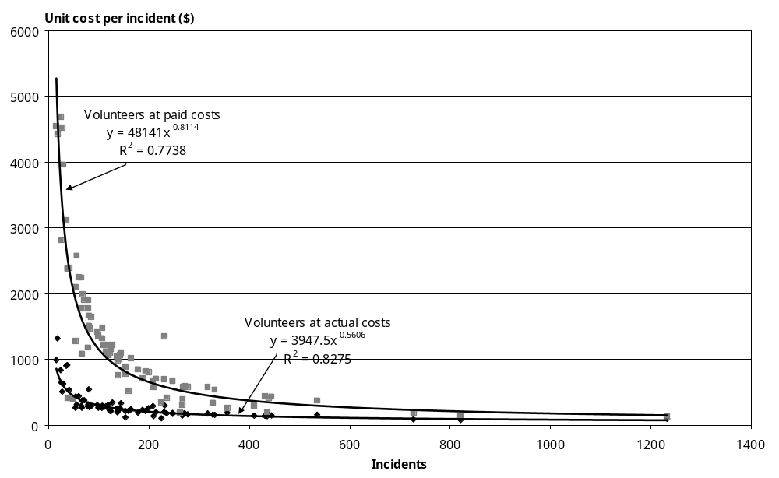

Response times
Response times are measured from the time when sufficient information is received from the caller to activate an ambulance to the time an ambulance officer arrives at the incident location (ie, the time excludes initial call processing). Not all situations require an urgent response so contracts specify that only those cases in the more urgent category, ‘priority one’, need to be measured against the relevant targets. The targets are set with international norms in mind and recognise the reality that sparse populations cannot support the service expected in more densely populated areas.

The current targets for priority one calls are indicated in Table 2 where the times are the targets within which the relevant percentage of incidents are to have a response. The Standards follow a similar structure but the targets relate to different percentile levels as indicated below.

Table 2: Response time targets
Source document | Percentile | Urban | Rural | Remote rural
Contract | 80% | 10 min | 16 min | 30 min
Contract | 95% | 20 min | 30 min | 60 min
Standards | 50% | 8 min | 12 min | 25 min
Standards | 95% | 20 min | 30 min | 60 min

A major issue in the study of response times is that of the geographic categories used. These need to be unequivocal. Looseness in definitions makes comparison of performance across providers on these categories very difficult.

Reporting against these targets to the Ministry is inconsistent both in terms of gaps in individual providers’ records and in comparison with each other. Information collected for this review is equally inconsistent with some quite rural areas reporting against urban, rural and remote targets. The data collected for the review seems to indicate providers tend to overstate the urban nature of the station coverage areas. This will give a false impression of poor performance, as they will be measured against a target they are not required to meet. Providers have indicated a willingness to work with funders to rationalise the information they collect and report on response times.

A review of all 210 stations reveals that 47 have coverage areas that correlate to all three of the geographic response time targets against which they are reporting. Including these 47 stations, there are 116 stations overall for which response time performance is provided for the main category of the coverage area (urban, rural or remote) AND where that category matches with an external assessment of the nature of that coverage area.

The available data for response times has been converted to an index for each station. This index uses the ratio between the difference in the actual and target performance and the target, all weighted for the proportion of the station’s coverage area population to which that target would apply.

Across the 47 stations with a consistent match between population and performance reporting, the index shows an overall performance 2.1 percent below target. The additional 69 stations in the sample show an overall performance of 7.7 percent below target. This implies we can use the larger sample of stations (116) but should scale the indices for the stations with the less precise geographic match to account for the mis-representation of performance.

Based on a response time index value of 1000 (meaning that the average for the 80 percent and 95 percent performance values equals the target performance), the performance for stations of varying categories can be anticipated (scaling as described in the previous paragraph applies) as shown in Table 3. The four cities with multiple ambulance stations are presented with their reported performance combined to compensate for the impact of dynamic deployment.

Table 3: Estimated response time performance
 | Weighted mean | Expected performance on 80% target | Expected performance on 95% target
Overall | 979 | 78% | 93%
Urban | 988 | 79% | 94%
Rural | 889 | 71% | 84%
Remote | 949 | 76% | 90%
Auckland | 983 | 79% | 93%
Wellington | 1074 | 86% | 102%
Christchurch | 930 | 74% | 88%
Dunedin | 1001 | 80% | 95%

Qualification levels
Qualification levels effectively determine the capability of the ambulance. Emergency ambulances crew are defined as Basic Life Support (BLS), Intermediate Life Support (ILS) or Advanced Life Support (ALS). Both BLS and ILS crews need backup from ALS. However, BLS crews are generally qualified at the entry level to ambulance officer status whereas ALS crews tend to be at the more experienced end of the spectrum with at least one officer generally being qualified to National Diploma in Ambulance Paramedic standard. The Standards document does not provide an easily quantifiable ideal for the mix of ALS, ILS and BLS ambulances and the review did not collect information on that basis.

A measure of the service quality relating to the qualification mix of ambulance officers may be obtained at a station level by reviewing the weighted staff cost per hour compared with the national average. Table 4 shows the output from this process where the national average is set at 1000.

Table 4: Qualification mix
Service level | Minimum | 1st quartile | Median | 3rd quartile | Maximum
1 | 567 | 567 | 567 | 567 | 765
2 | 567 | 567 | 616 | 702 | 1574
3 | 567 | 785 | 894 | 962 | 1574
4 | 813 | 1007 | 1147 | 1553 | 2311
5 | 858 | 1112 | 1329 | 1417 | 1608
6 | 983 | 1324 | 1436 | 1657 | 2311

The degree of overlap between index values by service level and the apparent inconsistency between values for service levels 4 and 5 does not support the use of this method to inform quality.

Current funding / contracting models
Ambulance funding arrangements are regionally inconsistent for medical cases and inter-hospital transfers and, for emergency ambulance services, divided according to the cause of the emergency.

Inter-hospital transfers are (mostly) the responsibility of health agencies (primarily DHBs, but the Ministry of Health contracts for transfers by road in the former Central RHA region). Differing funding approaches, for these road transfers, between the Ministry and DHBs is not a major issue for providers as they occur in differing geographic areas, each covered by a separate provider.

Three DHBs, Taranaki, Wairarapa, and Nelson Marlborough (for Marlborough only), are funders and providers of both emergency and transfer services. Their funding for medical emergencies and inter-hospital transfers is included in their Crown Funding Agreement.

All ambulance providers, however, face two contractual frameworks for emergency ambulance services. ACC contracts directly with each road and air ambulance provider for a set fee for each claimant transported that meets the set criteria. The Ministry contracts with each road ambulance service provider for a set amount nominally representing the non-accident case share of the capacity required to respond to emergencies, inclusive of necessary air ambulance responses. With the Ministry’s contracts, the relationship with the air ambulance providers is through the road ambulance contract.

Road and air ambulance providers argue that contractual arrangements that are entirely fee-for-service place undue risk on them in their need to maintain a capacity to respond without the certainty of revenue.

8 Financial Viability

Non-DHB road ambulance operators
Road ambulance providers are in a relatively good financial situation. Collectively and over all of their activities, the non-DHB providers had:
- revenue growth across all activities of 10 percent between 2001/02 and 2002/03 to $118 million
- ‘other income’ (interest and donations) of $5.4 million, $1.5 million more than the previous year
- cost increases of 8 percent to $116 million
- a surplus of $6.7 million (cf $3.3 million in 2001/02)
- depreciation almost matching capital expenditure ($9.969 million cf $10.088 million) indicating financial capability to maintain business capacity
- cash flow surpluses for those that provided data (ie, all except St John Southern Region) of $16.0 million and, after capital expenditure, of $6.4 million, again indicating financial strength
- equity of $78.2 million excluding assets held outside their financial statements (eg, St John Northern indicates assets of $15.1 million in area committees and the Wellington Free Ambulance Trust indicates assets of $4.9 million)
- cash and investment reserves greater than three months of cash expenditure.

Although two providers, St John Northern and Wellington Free Ambulance, are better capitalised than others, the 2002/03 accounts do not show any providers having signs of financial stress.

It is difficult to establish a clear separation between ambulance and non-ambulance activities. However, the St John national consolidation of its financial performance indicates a net deficit from its ambulance activity after its direct ambulance service funding of $0.249 million in 2002/03 (0.3 percent of ambulance-related expenses) compared with an overall surplus of $6.3 million. These figures exclude St John’s 142 area committees. The above assessment is therefore considered conservative.

All road ambulance providers have a wider range of activities with which they are engaged than ambulance services alone. For the three DHB providers, ambulance services are additional to the range of health activities expected of DHBs. Other road ambulance providers have a range of charitable and commercial activities which feature significantly in their operations. These non-DHB road ambulance providers may also have assets available to them that are recorded against other entities, making a thorough financial assessment difficult. An example of this is where St John area committees purchase assets for ambulance use for which a rental might be charged to the regional organisation.

Most road ambulance providers are expanding their non-ambulance businesses and in all likelihood producing ongoing surpluses. As indicated elsewhere in this report, these activities are not considered essential to the financial sustainability of the ambulance service. It is impossible to accurately separate out the impact of these activities from the annual accounts or the extent these might occur without having an ambulance core function to their organisations. These activities include:
- alarm monitoring
- servicing events
- first aid supplies
- training (internally and externally)
- subscription schemes
- gaming.

In assessing road ambulance costs, costs associated with the PRIME scheme have been excluded. Because of the slow uptake of PRIME localities, the actual rate of revenue has exceeded costs by $854,000. In assessing financial viability, the total revenue and costs of the service were taken into consideration. In essence, this approach puts the surplus from PRIME into the ambulance activity. The scheme will be the subject of a separate review but, in the meantime, contracts should be adjusted to reflect the costs incurred by these different contract lines.

Finally, the point has been made that although depreciation matches capital expenditure and the ambulance services capital appears to be in a ‘steady-state’, it appears that the ‘quality’ of the vehicle stock is variable. In other words, the service seems to be operating with a number of vehicles older than the depreciation term (‘written off’). Evidence from the vehicle fixed costs supports this assertion. Ignoring the DHB providers who are bound by different financial rules, it would seem that particular challenges exist with St John’s Northern Region (South Island) and Central region. Both regions have numerous stations with low usage. Should all available vehicles be included in the sustainable cost regime, overall costs would rise by $0.8 million to $1.7 million. (This assumes a vehicle capital cost of $125,000 each and depreciation over either 8 or 10 years.) Whether or not it is appropriate to keep the entire ambulance fleet on a consistent replacement cycle may depend on the actual level of use of the vehicles in the more remote areas.

9 Conclusions

Population drives volume
Analysis has shown that population domiciled in the areas covered by each station is the single most important determinant of volume for road ambulances. This is particularly true of emergency volumes. In the case of city stations, there is significant overlap between their nominal coverage areas and it is therefore more sensible to combine those areas for comparison between volumes and populations. Figure 2 illustrates the strong relationship that exists between volumes and populations with stations in the four main cities combined. City stations’ volume and population have been combined and stations that specialise in patient transports but have no set coverage area have been excluded.

Figure 2: Station population versus emergency incidents
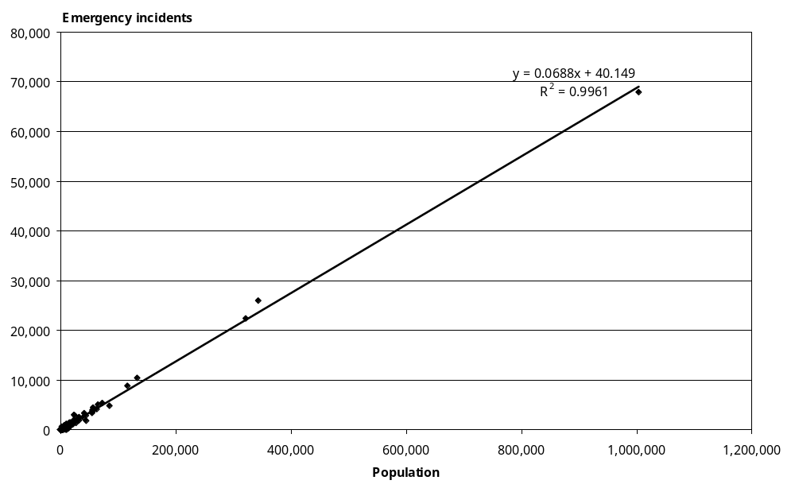

To demonstrate the relationship more clearly, Figure 3 shows only those stations that are not in one of the four main cities or Hamilton.

Figure 3: Population versus emergency incidents (excluding cities)
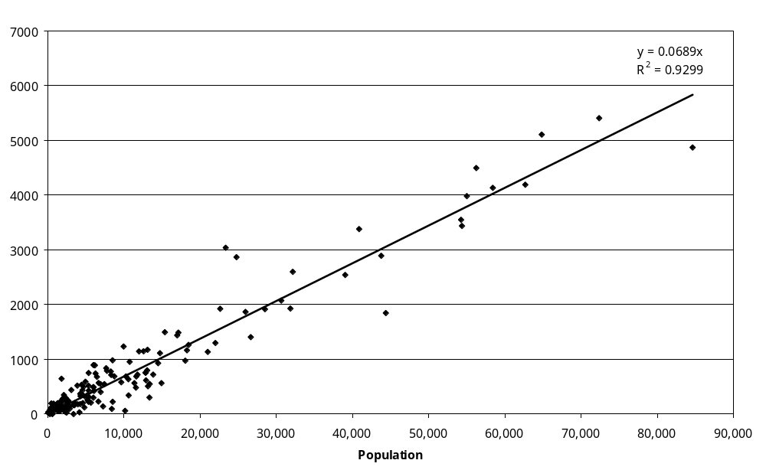

A fuller discussion of this point is provided in the appended technical report.

These graphs indicate that, on average, any population will generate road ambulance incidents of almost 7 percent of the number of people, but that this could vary from about 4 percent to about 12 percent of the number of people. For a funding formula based on the station domicile populations to be useful, it would need to include explanatory variables that account for this range.

It should be noted that any consideration of population-based funding of ambulances should only follow full assessment of the impact of low usage in rural and remote areas.

Volume drives cost
The relationship between population and incidents still leaves unexplained significant variation when comparing stations serving similar sized domicile populations. A more direct relationship may be expected between volumes and cost.

Figure 4 shows something of this relationship with stations beyond the 95 percent confidence interval lines named.

Figure 4: Incidents versus cost
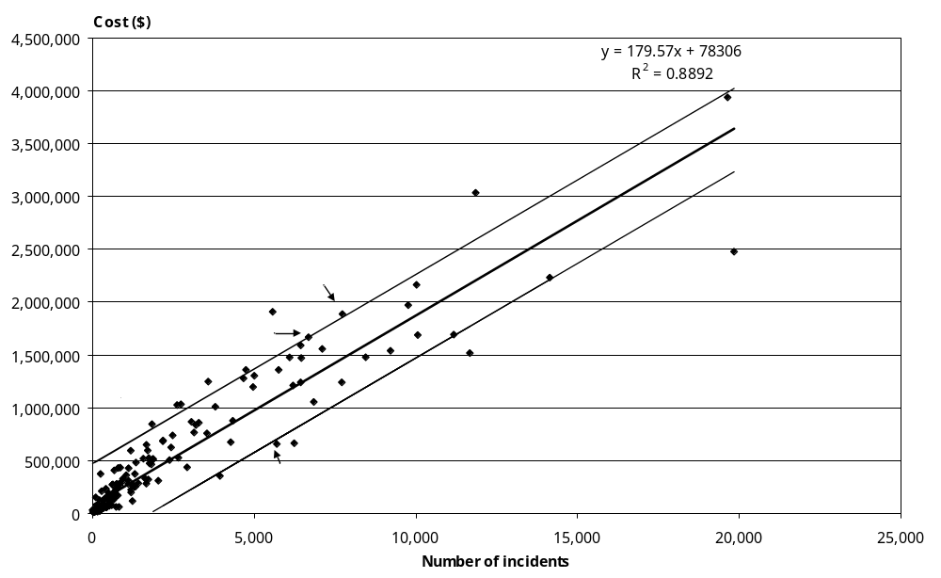

Although the overall correlation between volume and cost is clearly important, the variation in cost between stations with similar total volumes needs further explanation. It is interesting to note that removal of the four mostly patient transfer service stations in the northern region improves the R² to 0.91 and increases the slope of the ‘best fit’ line to 191. Clearly volume mix is a factor to be considered.

It is not essential that the relationship between station coverage, population and costs is sufficiently strong to drive a funding formula. Relationships between cost, usage, emergency demand and volunteer input are insufficiently strong to generate such a funding formula.

Economies of scale
As station volumes increase, the variation in unit costs decrease and the absolute unit cost decreases, that is, the fixed costs get spread more thinly with increasing volumes. Much of the variation seems to be explained by service level analysis although the degree of fit of similar service level graphs is not as good as anticipated, perhaps due to subjectivity around classification of stations into service levels. Figure 5 shows how unit costs decrease with increasing volume.

Figure 5: Economies of scale
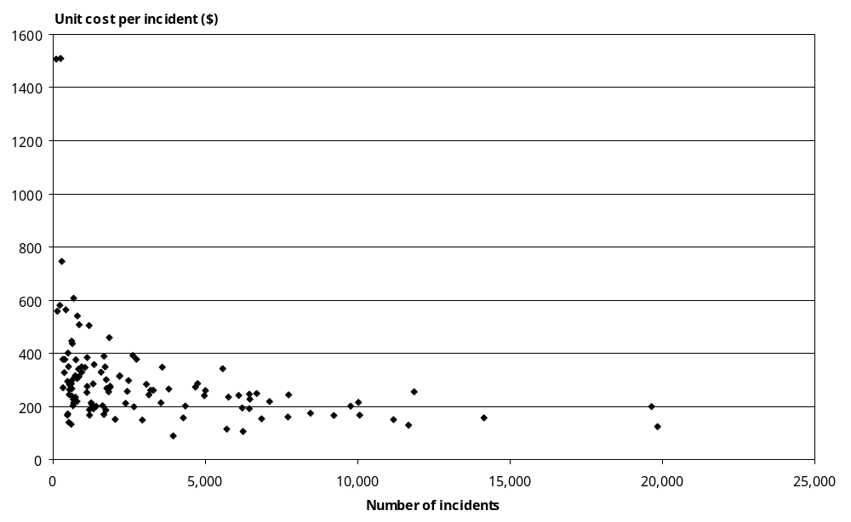

Utilisation and cost
The next most important cost driver to population is use of ambulances. As may be expected, the more work done by each unit of resource, the lower the average cost of service. Figures 6 and 7 show this, first, in relation to all stations and, second, in relation to stations entirely operated by volunteers (this avoids issues of service level classification).

Figure 6: Unit cost versus utilisation
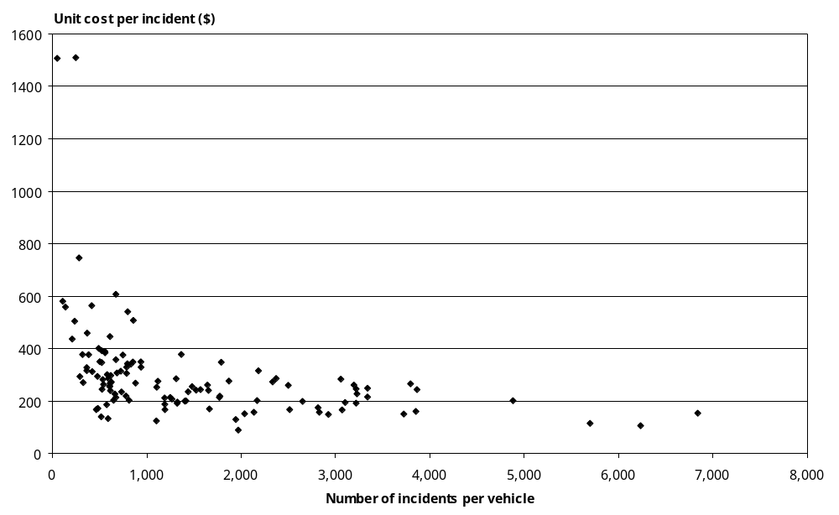

Figure 7: Unit cost versus utilisation (volunteer-only stations)
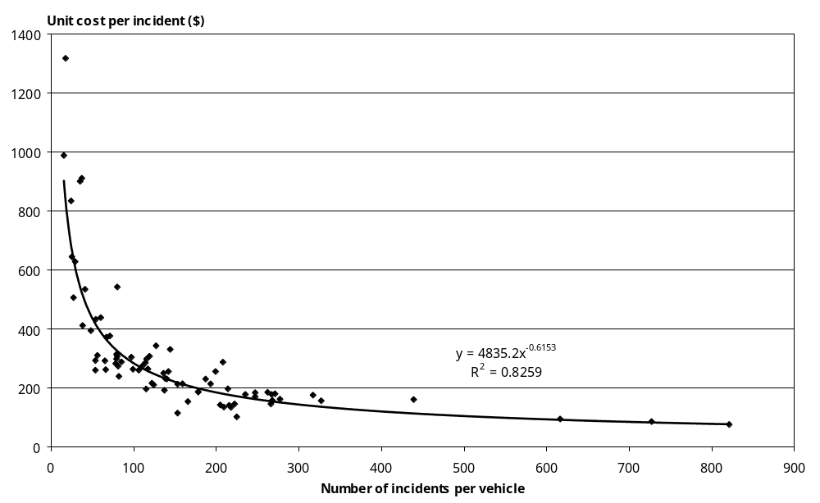

Volume mix and cost
Emergency ambulance activity requires significantly more resource than non-emergency activity, as the former needs to have capacity in place for immediate response. Non-emergency activity can be scheduled or delayed when emergencies occur. An impact on station cost from the mix of activities that make up its overall volume was, therefore, anticipated.

Statistical tests of station costs and volumes defined into emergency incidents, inter-hospital transfers, and other incidents produces relative cost weights for these groups of 1:0.52: 0.30 or, in dollar terms, $247 for an emergency incident, $127 for an inter-hospital transfer and $75 for ‘other’ activity. Other activity includes private hire, stand-by at public events and stand-by at other emergencies such as armed offender alerts and fires. As the mix of each activity differs according to station, much of the remaining variation in station cost is explained by this cost differential.

Service coverage case studies
Figure 8 shows total station costs and total numbers of incidents for stations of service levels 5 and 6. Together with Table 5, it is intended as an illustration of importance of some of the factors discussed above.

These stations form a tight pattern (R² of 80%) about a line with a slope of 164.11 and an intercept of 301,978. Lines indicating one standard deviation either side of that ‘best fit’ line are also indicated and stations that fall outside of the range, the ‘outliers’, are named. In Table 5, the peculiar features associated with this outlier status are postulated as an illustration of the mix of factors associated with cost.

Figure 8: Examples of outlier stations
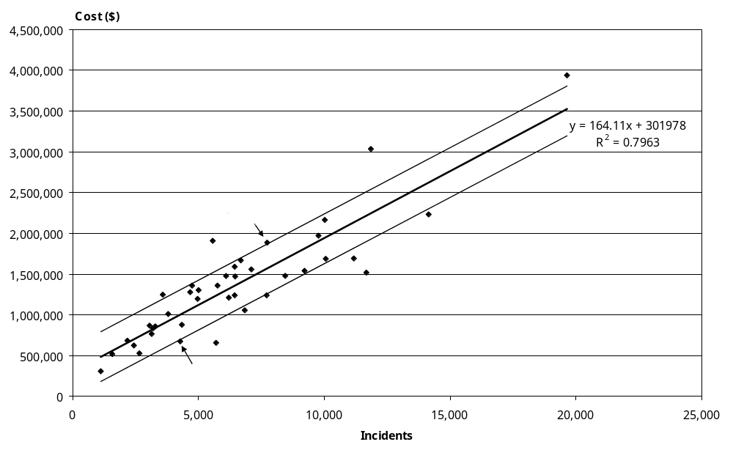

Table 5: Outlier stations explained
Station name | High or low outlier | Utilisation (incidents per vehicle) | Volume mix (emergency incidents as % of total) | Volunteer input  (total volunteer hours as % of total hours)
Hamilton | Low | 2829 | 74 | 21
Lower Hutt | Low | 3725 | 57 | 18
Newtown | Low | 1945 | 36 | 25
Palmerston North | Low | 3854 | 63 | 19
St Albans | Low | 6841 | 89 | 0
Paraparaumu | Low | 5699 | 50 | 42
Wigram | Low | 2137 | 89 | 50
Christchurch Central | High | 1403 | 64 | 32
Dunedin | High | 1481 | 61 | 13
West Auckland | High | 3865 | 95 | 0
Invercargill | High | 795 | 62 | 11
Silverdale | High | 1790 | 94 | 0

Shown in bold numerals are the factors that have the greatest influence on each station being classed as an outlier. Those factors which would influence the station positively but are insufficient to result in their being within the bounds are shown in italics. (The selection process was whether or not the station was in the top 50 percent of stations for that factor.)

Provider cost function
After all other factors have been considered, there appears to be something in the cost function of providers that remains unexplained. Figure 9 shows this by plotting station cost against total incidents for the main road ambulance service providers. While the trend lines on the provider information have a similar slope for four providers (185.33 to 203.41), two are quite divergent. The R² on each of the provider’s trend lines are each individually quite significant with Order of St John’s Northern region (OSJN) having the least significant trend as a result of having dedicated patient transport services.

This situation implies that there is an element (perhaps full crew levels) in the providers’ cost structure that has yet to be explained. It also arises from utilisation being such a significant driver of costs that differs between providers in ways that the available data cannot explain. Such variances may be best explained with the benefit of analysis and experience by providers themselves.

Figure 9: Cost differences by provider
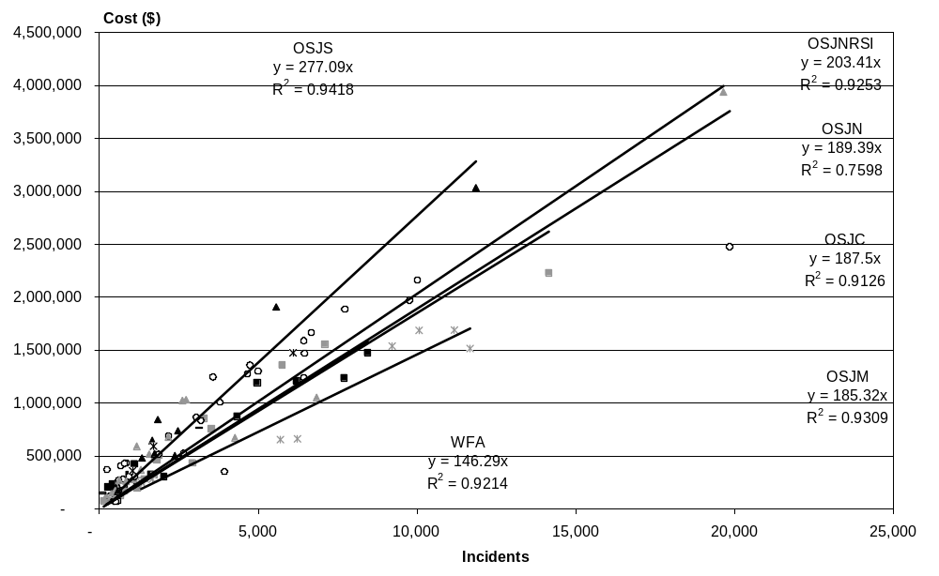

The information on emergency volume cost weights ($247 per incident) can be brought to the provider level and extrapolated to match total reported provider costs. This does not change the total costs as reported by each provider but does produce different cost-weights for emergency activity for each provider. Table 6 indicates the scaling factors and the resulting cost-weights for emergency and non-emergency incidents for each provider.

Table 6: Provider cost-weights
Provider | Scaling factor | Average emergency costs per incident
Nelson Marlborough DHB | 1.14 | $282
St John Central | 1.08 | $268
St John Midland | 1.02 | $252
St John Northern | 1.12 | $276
St John Northern (SI) | 1.14 | $281
St John Southern | 1.51 | $373
Taranaki DHB | 1.23 | $305
Wairarapa DHB | 1.17 | $290
Wellington Free | 0.82 | $203

Air ambulance services
Information collected from air ambulance operators is considered to be representative of the sector although not to be complete in all respects. There are at least 32 aircraft providing over 9500 flying hours for over 7000 missions of ambulance activity.

Air ambulance operators differ significantly from their road counterparts in that the direct funding from providing these services is a relatively small portion of their revenue. Direct funding (from ACC, the Ministry (via road ambulance operators) or DHBs) accounts for about 15 percent of revenue for operators with helicopters only (no fixed wing aircraft) and about 35 percent for other operators.

Analysis shows reasonable cost curves can be generated for helicopters (fixed costs about $500,000 and variable costs of $1500 per hour for single-engine aircraft and about $2200 per hour for twin-engine aircraft). Even the busiest helicopters are not breaking even on the ACC hourly charge rates let alone the average DHB rates, as they are not well used. A similar cost curve is not available for pressurised fixed wing although average cost per mission seems to be about $2400. The cost curve for non-pressurised fixed wing is based on $42,000 fixed costs (which appears low) and variable costs of $754 per hour.

The maximum number of flying hours for pressurised fixed wing aircraft is over 800 hours in the year and 600 hours for non-pressurised fixed wing aircraft, the averages are 300 and 150 respectively. Based on the above, aircraft usage appears to be an issue.

Charge rates vary according to type of mission but these variations are as expected given the different services such as paramedic crew that are included in different contracts.

There is variation in the mix of missions flown by different types of aircraft. Inter-hospital transfer missions are the mainstay of fixed wing air ambulances but a significant number of missions are flown by twin-engine rotary aircraft. Missions flown by helicopters include a mix of all types of activity. Trauma related missions are mainly served by single-engine rotary but the twin-engine helicopters tend to do longer missions. Search and rescue operations are a significant activity, in terms of flying hours, for single-engine helicopters even though these are only 1 percent of missions.
Part A:
Road Ambulance Services; Technical Report
Contents
1 Introduction 40
2 Technical Background 41
2.1 Theoretical background 41
2.1.1 Costing and pricing methodology 41
2.1.2 Cost drivers 42
2.1.3 Assumptions 43
2.1.4 Regression models 44
2.2 Analysis process 45
2.3 Data collection and reconciliation 46
3 Financial Situation 48
3.1 Total organisational financial performance 48
3.2 Financial performances for road ambulance services 54
4 Fundamental Analysis 58
4.1 Stations at service level 58
4.2 Geographic information 59
4.3 Volume analysis 62
4.3.1 Volume information 62
4.3.2 Volume proxies 65
4.3.3 Volume structure 66
4.4 Resource utilisation analysis 71
4.4.1 Vehicle utilisation analysis 72
4.4.2 Labour utilisation analysis 73
4.5 Costing analysis 75
4.5.1 Cost structure 75
4.5.2 Staff hour rates 77
4.6 Quality information 80
4.6.1 Response times 80
4.6.2 Qualification levels 84
4.6.3 Full crew levels 85
5 Cost Driver Analysis 88
5.1 Population, volume and cost 88
5.1.1 Population drives volume 89
5.1.2 Volume drives cost 93
5.1.3 Cost versus population 95
5.2 Cost function 96
5.3 Economies of scale: average cost versus volumes 98
5.4 Volunteer input effect 99
5.5 Average cost versus resource utilisation 101
5.6 Cost relativity analysis 103
5.6.1 Rationale 103
5.6.2 Multicollinearity 104
5.6.3 Sensitivity analysis 106
5.7 Case study 1: Level 5 and 6 stations 110
5.8 Case study 2: Metropolitan stations 111
6 Pricing and Funding Analysis 117
6.1 Efficiency analysis 117
6.2 Funding analysis 121
6.3 Volunteer replacement impact 122
6.4 Costing of full crew requirement 123
7 Summary 126
7.1 Financial situation 126
7.2 Fundamental analysis 127
7.3 Cost driver analysis 128
7.4 Pricing and funding analysis 129
Appendices 130
Appendix 1: Data collection format 130
Appendix 2: Data format notes 131
Appendix 3: Abbreviations 136
References 138

1 Introduction
The Sustainable Funding Review was initiated to analyse funding for both road and air ambulance services. This technical report relates only to the road component, and presents detailed analysis and results based upon extensive information submitted by road ambulance providers. The quantified information in this report will be useful for the stakeholders to understand the drivers of cost and cost relativities within the road ambulance sector and is intended to assist decision-making.

This technical report is structured as follows.

Section 2 introduces the theoretical background on which the analysis is based, such as costing and pricing methodology, cost drivers, and regression models. It also describes the modelling process and briefs on data collection and reconciliation.

Section 3 outlines the financial performance at individual provider organisational level from annual report information, and at road ambulance service level from data reported.

Section 4 contains the fundamental analysis process. These analyses are the summaries or combinations of different data categories in the data collection format, such as station level, geographic information, resources, volume, cost, and quality. The analysis itself provides useful information for the sector, raises some immensely practical questions, and should form the starting point for further analysis and benchmarking exercises.

Section 5 tries to find significant cost drivers in a step-by-step fashion. The first step is to investigate total cost drivers, followed by identification of factors incurring average cost variances between providers or stations, and finally presenting two case studies as a form of reality check.

Section 6 tries to integrate issues of efficiency and significant cost drivers into a pricing and funding analysis framework. With more time, this section could be extended to confirmation of the important findings in the cost-driver analysis, possibly with the input of further research.

Section 7 summarises the findings of the review and raises implications for future policy development.

2 Technical Background
This section introduces the theoretical background on which the analysis is based, such as costing and pricing methodology, cost drivers, and regression models. It also describes the modelling process and discusses data collection and reconciliation.

2.1 Theoretical background
2.1.1 Costing and pricing methodology
A major component of the sustainable funding review for road ambulance services is a cost and price modelling exercise to identify significant relationships between road ambulance service volumes and the costs they incur. From a technical costing point of view, road ambulance services operate in a similar way to other services. This analysis will link inputs and outputs to identify robust relationships between them.

For costing purposes, either a top-down approach or a bottom-up approach can be used.

A top-down approach allocates costs from the general ledger down to activities (in this instance volumes) in the same service through a series of allocation processes. Alternatively it allocates aggregate cost to volumes at service level through various robust methods.

A bottom-up approach measures the costs of each service provided at an individual activity level (ie, incident, trip or patient), so that the total cost incurred by each individual activity is obtained. Alternatively it averages the costs of individual activities to allow the estimation of the average cost of the related service.

Most of the collected data applied in this analysis, such as volume, cost and quality, is reported at station level but in aggregate. In other words, no information could be used to identify direct links between an activity and its resource consumption. Instead, regression models have been used to identify how resources should be allocated to activities in this analysis. In essence, this costing exercise uses a top-down approach, but used a ‘bottom-up’ data collection method.

For pricing purposes, the methodological options are marginal cost pricing, average cost pricing and two-part tariffs.

The most familiar pricing principle is that of marginal cost pricing. In terms of economics theory, if the price were set at marginal cost given perfect competition, then the market, both demand and supply, would achieve allocative efficiency. As road ambulance providers benefit from economies of scale with increasing returns and as average costs exceed marginal costs, this pricing approach implies that the providers require a lump-sum subsidy to prevent them operating at a loss.

If such subsidies are ruled out, there is the additional constraint from the viewpoint of sustainability that prices should be sufficiently high for providers to cover their relevant costs and to break even. Therefore, average cost pricing is a pragmatic option for the sustainable funding review. It is anticipated that not all providers are operating at the same quality on an efficient production frontier. The mechanism of public funding allocation should encourage providers to improve their production efficiency and quality. This means that an efficiency analysis or benchmarking process should be combined with an average pricing approach.

Two-part tariffs set the prices at a fixed component A to provide any service volume and a marginal price P per unit, as shown in Equation 1. This pricing approach could coincide with a belief that road ambulance services had significant fixed costs. However, if the analysis shows that the fixed cost component could be spread evenly over volumes, for example in a stepwise relationship between volume increases and cost, this approach would be equivalent to average cost pricing.
Equation 1 Total cost = A + P × Volume

2.1.2 Cost drivers
An underlying requirement of the review is to understand the factors that influence cost from both forecasting and equity of funding perspectives. Two key issues in costing analysis are the identification of cost drivers and the allocation of overhead costs. Cost driver analysis is a core component of this technical report.

Theoretically there are different definitions for cost drivers. From the perspective of economic theory, cost drivers could be any factor of demand and supply, or of consumption and production. In this report, a cost driver is defined as any factor that causes a change in the cost of an activity.

On the demand side, cost drivers could include population, population density, remoteness, distance to emergency department, deprivation, and so on.

On the production side, there are two groups of cost drivers: structural and operational. Structural cost drivers derive from an organisation’s choice about its underlying economic structure, which includes features such as scale, scope, experience, technology and complexity. Operational cost drivers depend on a organisation’s ability to operate effectively, which includes workforce involvement, capacity utilisation, total quality management, product configuration and linkages with suppliers and customers.

Figure 2.1 gives a simplified version of a model between cost drivers, service delivery process and resource utilisation.

Figure 2.1: Cost drivers and service delivery process
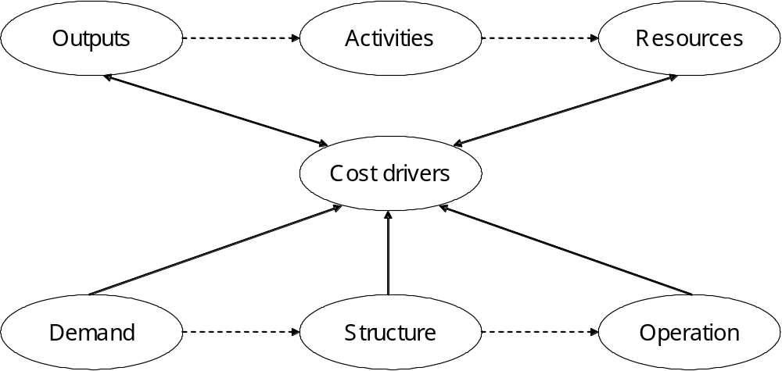

2.1.3 Assumptions
Any analysis framework or economic model must have certain fundamental assumptions or hypotheses. In this analysis, the fundamental assumption is that the current providers’ environment and their performance would not change significantly in the short term. The explicit expression of this hypothesis is that there would not be high variances of costs and volumes in terms of both absolute and relative values between adjacent years. This hypothesis has also been supported by empirical evidence in this analysis and other relevant analyses.

As shown in Section 3.1, the total costs for the sector and for the providers increase at a stable rate. This could result from either an inflationary or a volume impact or both. However as shown in Section 4.5.1, cost structures were stable. For example, personnel costs were always around 60 percent of total organisational costs. Deloittes also confirmed this hypothesis in its report.

On the volume issue, there were no direct annual volume data or explicit evidence to support the hypothesis of stable volumes. However, the strong relationships between population and emergency volumes would imply this hypothesis would be reasonable. As shown in Section 4.3.3, medical emergency volumes are significantly and consistently 2.3 times that of ACC emergency volumes at both provider and station level. And as shown in Section 5.1.1, emergency volumes are significantly and consistently correlated with population. Note also that emergency services predominantly determine resource allocation and drive costs. The population is stable between adjacent years therefore, emergency volumes should be stable and total volumes would not change greatly. This hypothesis could be supported logically and statistically by the reasoning that the strong relationships between these three dimensions, medical emergency volumes, ACC volumes and population, are unlikely to radically alter over the short to medium term.

2.1.4 Regression models
Regression models, linear or non-linear are used in this analysis for various tasks, such as testing significant cost drivers, estimating cost functions, and identifying cost relativities.

Theoretically, regression models can measure the relationship between one or more ‘independent’ variables and a ‘dependent’ variable, but they cannot tell whether the variables have a ‘cause and effect’ relationship, especially if there was no expectation of such a link. However, if the data set used is real, meaningful and of good quality, the cause and effect relationship derived by regressions can be supported and have conclusions drawn on with confidence.

The above cause and effect argument is also valid to correlation analysis, another statistical technique used in this analysis.

Given linear regression models as in Equation 1, it is possible to explain how to interpret regression results in the following way.

The coefficient of determination R² is a measure of the fit of the model or a measure of predictive ability of the model. The closer R² is to one, the greater is the predictive ability (precision) of the model over the sample observations, and the estimated regression is said to be a ‘good fit’. The R² value represents how precisely the model can predict. If R² = 0.90 calculated for the model, it means that 90 percent of the variation in Total cost can be explained by the model, and only 10 percent is left unexplained.

Either R² or R² can also be used as a device for model selection, or selection of the appropriate set of explanatory variables.

Adjusted R² (R²) is often used to compare models with differing numbers of regressors (explanatory variables) as R² does not always increase when additional regressors are added. Using R² to compare models that have a different number of regressors is not strictly valid because adding a regressor always increases R² even if that regressor is irrelevant.

The fixed cost A or variable (marginal) cost P can be concluded to be statistically significant when its t-stat is greater than 1.96, or insignificant when less than 1.96 at the 95 percent confidence level. A 95 percent confidence interval for a parameter may be also used to work out its upper bound and lower bound.

There are two particular issues when applying regression to which we need to pay attention. The first is multicollinearity and the other is heteroskedasticity.

Multicollinearity or collinearity can be viewed as an imprecision in the estimation of regression parameters caused by correlation between the variables in a multiple regression. It is worth noting that collinearity is not a violation of any basic assumption of the linear statistical model. The least squares estimator is still the best linear unbiased estimate. The problem is that the best linear unbiased estimator may be too imprecise to yield useful results.

A rule of thumb to identify a potentially harmful collinear relationship is when a correlation coefficient between two explanatory variables is greater than 0.8 or even 0.9. Another symptom of multicollinearity could be when regression coefficients may have high standard errors and low significance levels even though they are jointly significant and the R² for the regression is quite high.

A possible remedy for the multicollinearity problem is to add structure by introducing non-sample information in the form of linear restrictions on the parameters. However, the restricted estimator is biased unless the restrictions are exactly true. Thus it is important to use good non-sample information, so that the reduced sampling variability is not bought at a price of large estimator biases.

In regression models, the error term is assumed to be random, or the error variance to be constant. Inconstancy of the error variance is a characteristic of property known as heteroskedasticity. When the errors are heteroskedastic, the least squares estimator is still unbiased, but it is no longer efficient. The standard errors usually computed for the estimator are no longer appropriate, and hence confidence intervals and hypothesis tests that use these standard errors may be misleading. In this analysis, heteroskedasticity should not affect the precision of the regressions, as data points are distributed evenly around their regression line.

2.2 Analysis process
The final products of the analysis have to be intuitively understandable and technically robust. Figure 2.2 shows the analysis framework, which details and guides the whole analysis process.

There are two main stages in the process: data collection and reconciliation, and analysis. Each stage is theoretically composed of several components in sequence. Note that this modelling process is not always in a definite sequence, but rather is iterative. The structure of this technical report reflects this iterative process and groups the results into four sections: financial situation, fundamental analysis, cost driver analysis, and pricing and funding analysis. Note that this analysis is conducted at both provider level and station level.

Figure 2.2: The process of SFR analysis
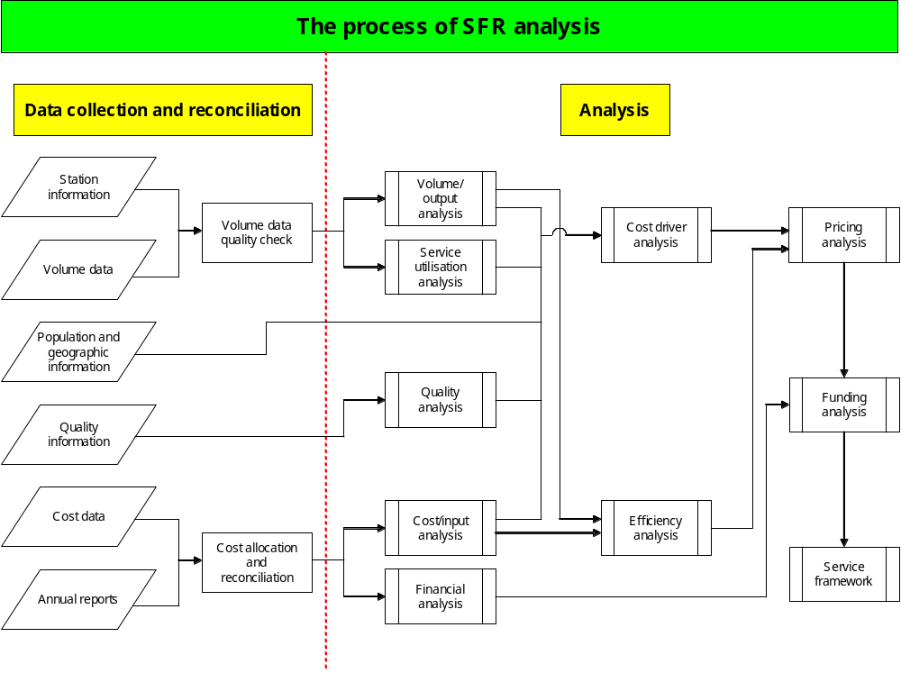

2.3 Data collection and reconciliation
Data collected for the review includes information on the following areas at station level:
- station information
- geographic information
- volume
- cost
- quality.

The data collection format and the related notes are in Appendices 1 and 2 respectively.

Training and revenue information were collected at the provider level. The six non-governmental organisation (NGO) providers’ annual reports were collected for five years from the 1998/99 to the 2002/03 financial year.

The nine providers responded with almost complete information. Before data could be assessed properly it was checked for consistency. This process was iterative, involving providers and peer reviewers where relevant. The general process involved:
- converting explanatory notes and text to quantitative information
- converting quantitative information into standard units
- converting non-standard templates to fit the standard template
- querying gaps in the data or additions to the template that are unclear and back-filling answers from those queries into the spreadsheets
- performing logic tests and querying outliers
- migrating the data on to a single file and aligning station information on a single sheet
- performing further tests comparing basic parameters at the provider level.

As the analysis has also considered cost drivers at a provider level, the station data has been aggregated at that level.

Based on the data reconciliation, the eleven stations listed below are excluded from the data sample for the reasons outlined in the comments column of Table 2.1. There are 211 stations across the country. The resulting sample size is 200 stations in the station-level analysis.

Table 2.1: Stations excluded from the station level analysis
Provider | Station name | Service level | Comments
OSJC | Mahia FRU |  | No value
OSJM | Mokau | 2 | Cost information problem
OSJN | Waiheke Island | 3 | Island station
OSJNRSI | Chatham Islands | 1 | No volume
OSJNRSI | Franz Josef FRU | 2 | No volume
OSJNRSI | Pleasant Point FRU | 0 | No volume
OSJNRSI | Runanga FRU | 2 | No volume
OSJS | Glenorchy | 1 | No value
OSJS | Riversdale | 1 | No value
OSJS | Stewart Island | 1 | No volume, vehicle
WFA | Wellington Airport |  | No volume

3 Financial Situation
All road ambulance providers have a wider range of activities with which they are engaged than ambulance services alone. For the three DHB providers, ambulance services are an addition to the wide range of health-related activities undertaken by all DHBs. The six non-governmental organisation providers have a range of charitable and commercial activities, which feature significantly in their total operations. Most road ambulance providers are profitably expanding their non-ambulance businesses. These activities include:
- alarm monitoring
- servicing events
- first aid supplies
- training (internally and externally)
- youth groups
- caring callers
- paramedics for air operators
- gaming.

These non-governmental organisation providers may also have assets available to them that are recorded against other entities, making a thorough financial assessment difficult. An example is where St John area committees purchase assets for ambulance use for which a rental of some description may or may not be charged to the regional organisation. It is impossible to accurately separate out the impact of these activities from the annual accounts.

As such, organisational financial performance and financial performance for road ambulance services are discussed in two sections respectively.

3.1 Total organisational financial performance
Table 3.1 records non-governmental organisation providers’ 2002/03 financial performance as noted in their annual reports. Four providers are in surplus and two in deficit at an organisational level. However, given the scope of operations, this deficit is not of a significant order of magnitude to raise concern. Order of St John–Midland’s (OSJM) deficit of $0.13 million equates to 0.72 percent of total revenue, and 2002/03 is the first year that they have run a deficit in the five years the review has data for. Wellington Free Ambulance’s (WFA) deficit equates to 1.01 percent of total revenue, and the 2002/03 financial results show a remarkable improvement on performance compared with 2000/01 and 2001/02. Diversification of WFA’s revenue gathering operations in the last two years seems to have been financially rewarding. This trend can be seen across other providers, who have also markedly improved their financial performance compared with reported 2001/02 financial results. Collectively, non-governmental organisation providers had a surplus of $6.69 million in 2002/03.

Table 3.1: 2002/03 NGO providers’ financial performances ($ million)
Providers | Total revenue | Total expense | Surplus/deficit
OSJC | 13.43 | 13.34 | 0.09
OSJM | 18.01 | 18.14 | -0.13
OSJN | 51.93 | 47.50 | 4.43
OSJNRSI | 18.18 | 16.23 | 1.96
OSJS | 13.29 | 12.84 | 0.45
WFA | 8.87 | 8.97 | -0.09
Subtotal | 123.72 | 117.02 | 6.69

Table 3.2 records five years’ financial performances at aggregate level for the six non-governmental organisation providers. Total revenue is the sum of revenue from operational and other incomes (interest and donations, etc). Figure 3.1 plots the comparison between non-governmental organisation providers’ aggregated revenue and expense.

Table 3.2: Five years’ financial performances ($ million)
 | 2002/03 | 2001/02 | 2000/01 | 1999/2000 | 1998/99
Revenue from operations | 117.98 | 106.72 | 96.23 | 86.45 | 77.87
Other income | 5.74 | 5.31 | 6.06 | 6.00 | 5.41
Total revenue | 123.72 | 112.03 | 102.29 | 92.45 | 83.29
Expense | 117.02 | 108.70 | 98.01 | 89.49 | 78.51
Net surplus/deficit | 6.69 | 3.33 | 4.28 | 2.96 | 4.77

Figure 3.1: NGO providers’ financial performance
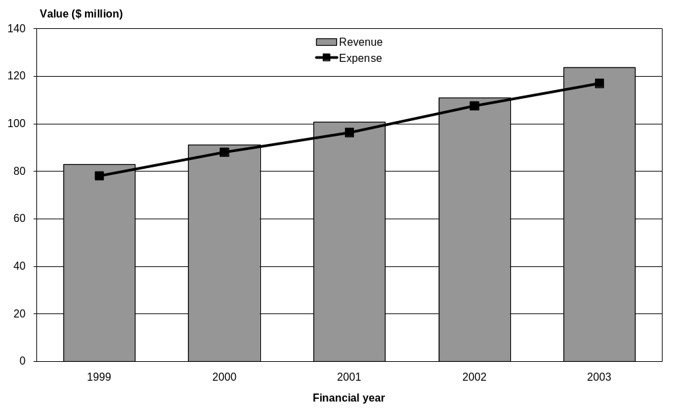

Based on the 1998/99 financial year to the 2002/03 financial year, annual growth rates for Revenue from operations, total revenue, and total expenses are 10.94 percent, 10.40 percent, and 10.49 percent respectively. In addition, other incomes are steady at around $5–6 million, which has steadily decreased to 4.64 percent of total revenue in 2002/03 from 6.50 percent in 1998/99. Even though providers have successfully grown other revenue streams, Crown funding has grown at an even faster rate, which has increased the Crown’s position as the dominant funder of ambulance services.

Figures 3.2–3.7 plot each individual non-governmental organisation provider’s financial performance for the five years for which the review has data.

Figure 3.2: OSJC financial performance
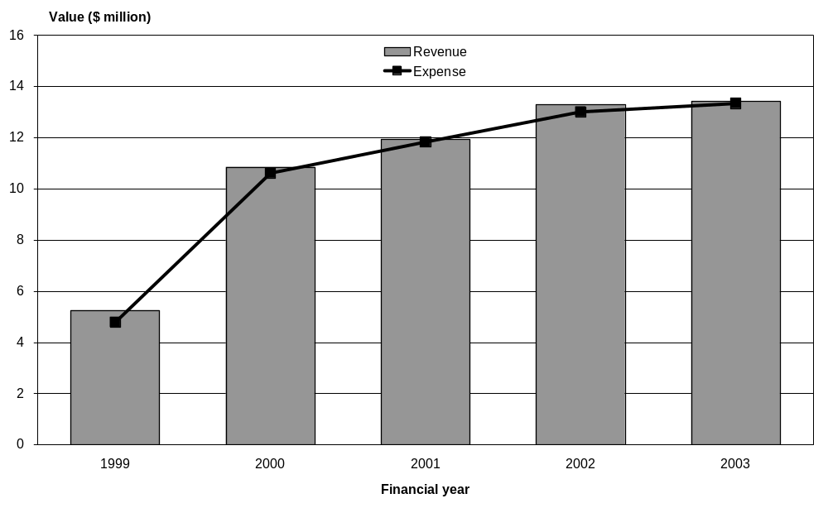

Figure 3.3: OSJM financial performance
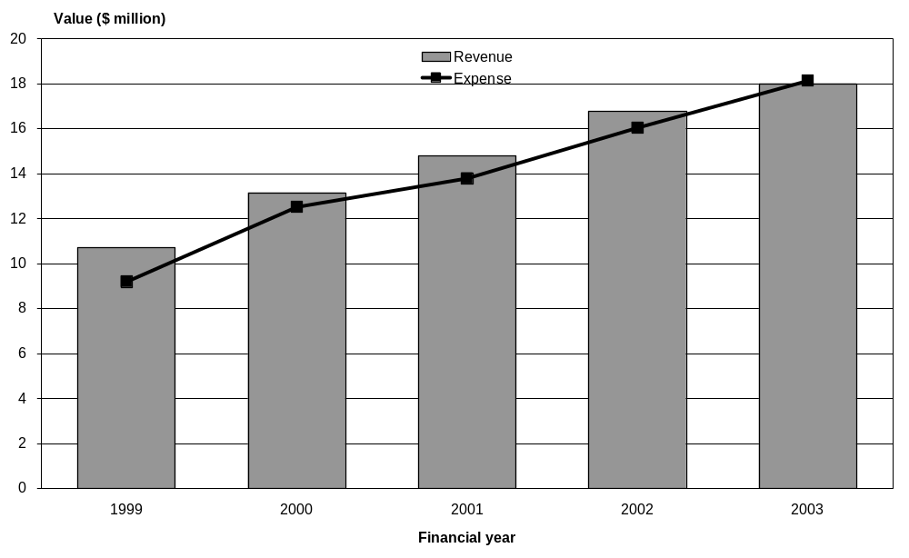

Figure 3.4: OSJN financial performance
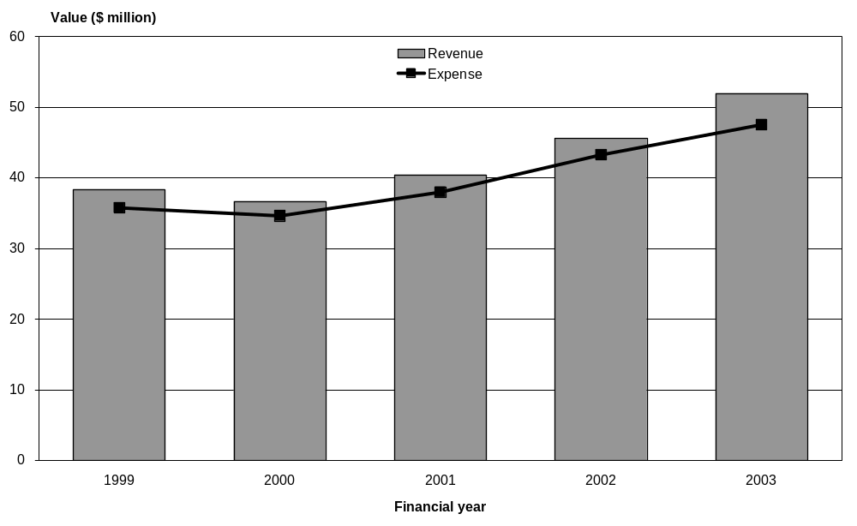

Figure 3.5: OSJNRSI financial performance
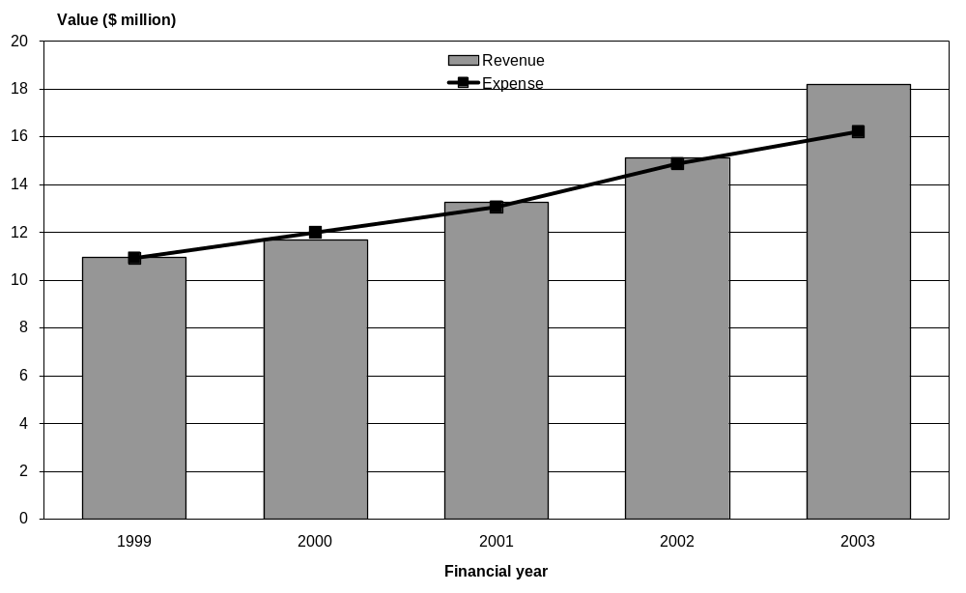

Figure 3.6: OSJS financial performance
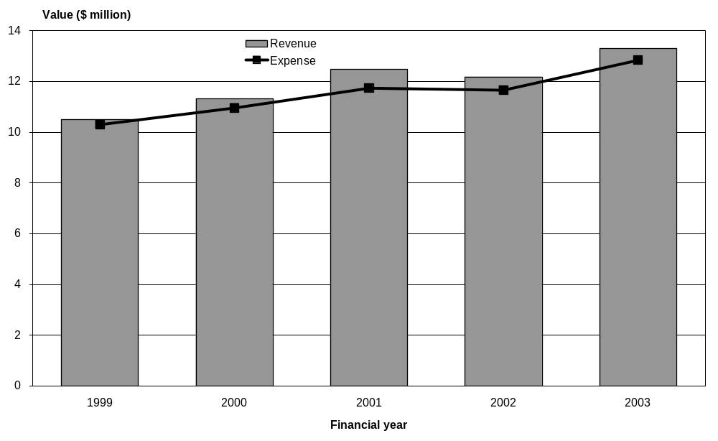

Figure 3.7: WFA financial performance
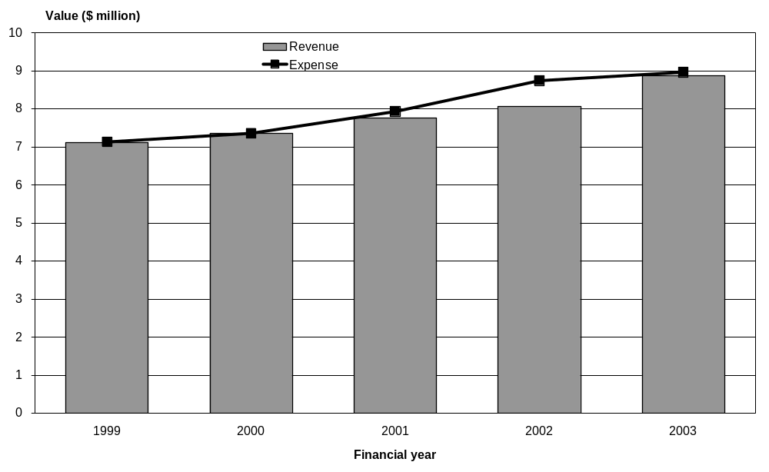

3.2 Financial performances for road ambulance services
Table 3.3 records 2002/03 financial performances for road ambulance services from the data reported.

Of the three DHB providers, two are in surplus and one is in deficit. For the six non-governmental organisation providers, three are in surplus and three in deficit. Collectively, the data reports a $0.86 million deficit on ambulance services operations, which equates to 0.73 percent of ambulance services revenue. This represents a collective financial position at almost break-even.

Cost allocation over ambulance and non-ambulance service activities should not be performed in an arbitrary fashion. Generally, for the purposes of analysis, we would expect that the relative percentage of costs and revenues for any given activity should be quite close. That is, if 70 percent of revenue arises from a particular activity, then roughly 70 percent of costs should be attributed to that activity (the exception being super-profitable activities). For road ambulance providers, the task of cost allocation is sensitive because much the same asset base is used for both ambulance and non-ambulance related services.

For this reason, Table 3.3 compares the relative percentages (ie, revenue reported as a percentage of total revenue and costs reported as a percentage of total costs). This is acknowledged as a fairly rough measure of the reasonableness of data reported. As DHB providers have no annual reports, these percentages are only for the six non-governmental organisation providers.

Collectively, for six non-governmental organisation providers, road ambulance services revenue equates to 67 percent of the total revenue reported in annual reports, and the related expense equates to 72 percent of the total expense reported in annual reports.

If a 6–7 percent difference (such as that between the OSJN and OSJNRSI annual reports and data) between these two percentages could be considered to be tolerable or reasonable, then the 18.5 percent difference for WFA data should be regarded as an outlier. The implication is that there may be cost allocation issues with WFA’s data.

Table 3.3: 2002/03 financial performances from data reported ($ million)
Providers | Revenue | Expense | Surplus/ deficit | Revenue % (DR/AR) | Expense % (DR/AR) | % difference
NMDHB | 0.79 | 0.66 | 0.13
OSJC | 9.12 | 9.50 | -0.38 | 68 | 71 | 3.29
OSJM | 13.89 | 12.72 | 1.17 | 77 | 70 | -7.04
OSJN | 29.93 | 30.72 | -0.79 | 58 | 65 | 7.04
OSJNRSI | 13.23 | 12.88 | 0.35 | 73 | 79 | 6.61
OSJS | 10.69 | 9.99 | 0.70 | 80 | 78 | -2.64
TDHB | 2.45 | 2.79 | -0.34
WDHB | 1.11 | 1.07 | 0.04
WFA | 6.61 | 8.35 | -1.74 | 74 | 93 | 18.59
Total | 87.83 | 88.68 | -0.86 | 67 | 72 | 4.44
Note that the expenses in Table 3.3 do not include nominal rents, as they do not represent actual expenditure. The concept of estimated nominal rents was instigated as an attempt to balance the providers’ varying positions with respect to capital, rather than actual costs. Total nominal rent in the data reported is $2.15 million. Table 3.4 is also attached for reference, which is similar to Table 3.3 but with inclusion of nominal rents in expense.

Table 3.4: 2002/03 financial performance with nominal rents in expense ($ million)
Providers | Revenue | Expense | Surplus / deficit | Revenue % (DR/AR) | Expense % (DR/AR) | % difference
NMDHB | 0.79 | 0.66 | 0.13
OSJC | 9.12 | 9.56 | -0.44 | 68 | 72 | 3.76
OSJM | 13.89 | 13.00 | 0.90 | 77 | 72 | -5.51
OSJN | 29.93 | 31.53 | -1.59 | 58 | 66 | 8.73
OSJNRSI | 13.23 | 13.44 | -0.21 | 73 | 82 | 8.77
OSJS | 10.69 | 10.39 | 0.30 | 80 | 81 | 0.46
TDHB | 2.45 | 2.84 | -0.38
WDHB | 1.11 | 1.07 | 0.04
WFA | 6.61 | 8.35 | -1.74 | 74 | 93 | 18.59
Total | 87.83 | 90.83 | -3.00 | 67 | 74 | 6.24

Table 3.5 records revenue components in the data reported, and also works out each component’s share of the revenue pool. Public funding from Vote: Health and ACC comprises 85 percent of total revenue. Others include providers’ other services revenue, and so on, and is about 4 percent of total revenue. However, it is not clear whether these other services used resources from road ambulance services resources.

Table 3.5: Revenue data reported ($ million)
Provider | Vote: Health | Part charge | ACC | Private hire | Donation | Others | Total
NMDHB | 0.47 | 0.05 | 0.26 |  |  | 0.01 | 0.79
OSJC | 4.53 | 0.95 | 3.16 | 0.07 | 0.00 | 0.41 | 9.12
OSJM | 6.21 | 1.33 | 5.61 | 0.13 | 0.06 | 0.55 | 13.89
OSJN | 15.12 | 3.40 | 9.65 | 0.50 | 0.14 | 1.12 | 29.93
OSJNRSI | 6.47 | 1.15 | 4.91 | 0.19 |  | 0.52 | 13.23
OSJS | 5.53 | 0.65 | 3.27 | 0.10 | 0.08 | 1.06 | 10.69
TDHB | 1.16 | 0.19 | 0.99 |  | 0.01 | 0.11 | 2.45
WDHB | 0.61 | 0.07 | 0.42 |  | 0.01 |  | 1.11
WFA | 3.46 | 0.06 | 2.93 |  |  | 0.16 | 6.61
Total | 43.55 | 7.85 | 31.20 | 0.99 | 0.30 | 3.94 | 87.83
Proportion (%) | 49.59 | 8.94 | 35.52 | 1.13 | 0.34 | 4.48 | 100

Figure 3.8 shows the relative importance of various revenue streams for non-DHB ambulance providers, graphically emphasising the role of the Crown in funding ambulance services in New Zealand. Figure 3.9 emphasises the relative scale of each of the providers.

Figure 3.8: Revenue structure by income sources
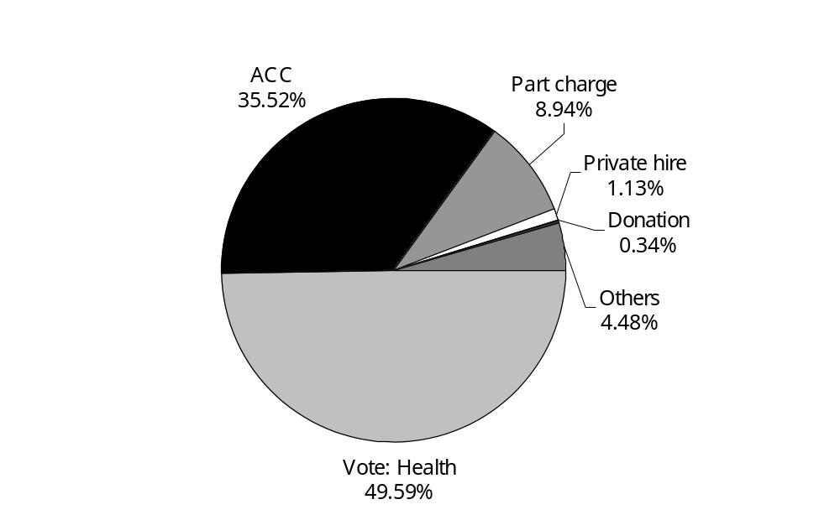

Figure 3.9: Revenue structure by providers
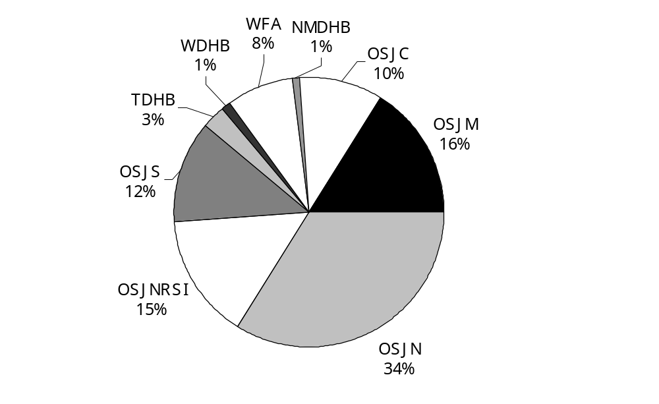

Table 3.6 splits revenue components in the data reported, and also works out each component’s share of the total revenue pool. Of the total revenue pool 85 percent is provided through public funding from Vote: Health and ACC. A further 1.13 percent is provided by private hire, 0.34 percent through donations, and 4.48 percent through provider’s other activities.

Table 3.6: Health revenue data reported ($ million)
Provider | EAS | PTS | Prime | Air | Others | Total
NMDHB | 0.37 | 0.06 |  | 0.04 |  | 0.47
OSJC | 4.44 |  |  | 0.10 |  | 4.53
OSJM | 4.51 | 0.95 | 0.61 | 0.14 |  | 6.21
OSJN | 12.83 | 1.25 | 0.30 | 0.46 | 0.28 | 15.12
OSJNRSI | 5.11 | 0.66 | 0.40 | 0.10 | 0.20 | 6.47
OSJS | 4.48 | 0.55 | 0.29 | 0.21 |  | 5.53
TDHB | 1.14 |  |  | 0.02 |  | 1.16
WDHB | 0.33 | 0.27 |  | 0.01 |  | 0.61
WFA | 3.35 | 0.11 |  |  |  | 3.46
Total | 36.55 | 3.85 | 1.60 | 1.07 | 0.49 | 43.55
Proportion (%) | 83.93 | 8.83 | 3.68 | 2.45 | 1.11 | 100

Figure 3.10 shows the activities to which Vote: Health funding is put in the ambulance sector. Emergency ambulance services (EAS) are the dominant use to which Vote: Health funding of ambulances is put. Note that an accurate division between the EAS and patient transport services (PTS) is not available for OSJC and TDHB.

Figure 3.10: Health revenue structure
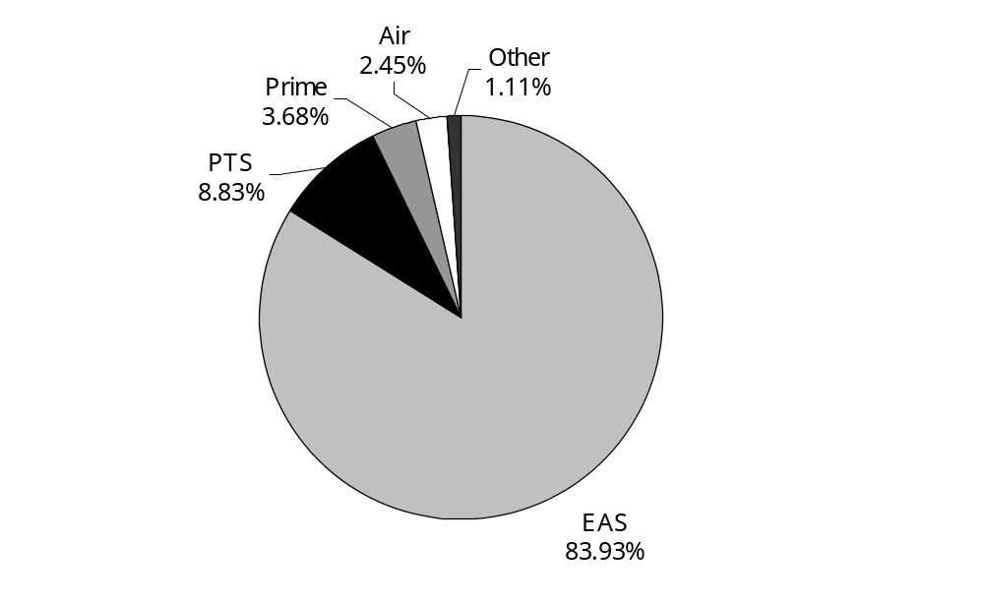

4 Fundamental Analysis
This section includes data reconciliation and directly works on the data in each area of the data collection format. The information presented here provides a fundamental description of the ambulance service environment.

4.1 Stations at service level
Service levels describe the mix of service capability found in any ambulance station in terms of crewing, class of ambulance and availability of support (see Appendix B: Service levels, main report). Table 4.1 gives the distribution of stations by service level for each provider, and Figure 4.1 shows the proportion of stations at each level.

Table 4.1: Station distribution at service level
Provider | L 6 | L 5 | L 4 | L 3 | L 2 | L 1 | L 0 | Subtotal
NMDHB |  | 1 |  |  | 1 |  |  | 2
OSJC | 3 | 2 |  | 10 | 4 | 3 | 1 | 23
OSJM | 3 | 1 | 5 | 16 | 11 | 3 |  | 39
OSJN | 16 |  |  | 15 | 12 | 4 | 4 | 51
OSJNRSI | 3 | 2 | 1 | 11 | 20 | 8 | 2 | 47
OSJS | 2 |  | 2 | 4 | 17 | 3 |  | 28
TDHB |  | 1 | 2 |  | 3 | 1 |  | 7
WDHB |  | 1 | 1 |  | 3 |  |  | 5
WFA | 3 | 2 | 3 |  |  |  | 1 | 9
Total | 30 | 10 | 14 | 56 | 71 | 22 | 8 | 211
Proportion (%) | 14 | 5 | 7 | 27 | 34 | 10 | 4 | 100

Figure 4.1: National station distribution at service level
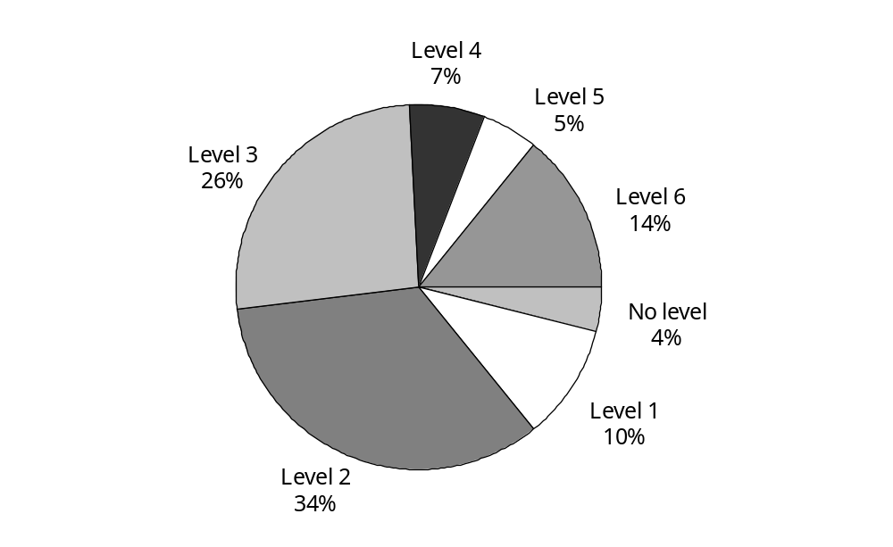

There are 211 stations across the country. The distribution of stations according to service level varied among providers. Most of the stations at Level 1 and Level 2 are fully run by volunteers. The majority of road ambulance services are provided by the 19 percent of stations at Level 5 and Level 6.

In general, any station should be in one of 6 level groups. However there are eight stations that have no level indication (Level 0).

Note that four stations at Level 0 for OSJN are PTS stations, which provides an interesting and important clue for the analysis of cost relativities. The other Level 0 stations are a PTS vehicle based at Wellington Airport and three first response unit (FRU) stations (Mahia, Arthurs Pass and Pleasant Point).

4.2 Geographic information
The data collection reports each station’s coverage areas. This information has been linked to 2001 census data and various estimations have been done given the station coverage area: size of the area, population, population density, and NZDep (a deprivation measure) (see Table 4.2).

A general assumption for geographic information is that the population in a station coverage area is served by its local station. However, it is not true that local stations confine their activities to their coverage areas. A typical example of this is the metropolitan stations, where their capacities, rather than local population, drive volumes. Also, this geographic information does not account for the dynamic characteristics of the population, such as holidaymakers. Although geographic information has some disadvantages, it does provide some useful indicators.

Table 4.2: Geographic statistics at provider level
Provider | Population | Area (km²) | Population density  (per km²) | Average distance to medical centre (km)* | Average NZDep decile
NMDHB | 40,197 | 12,493 | 3 | N/A | 4.87
OSJC | 359,418 | 29,273 | 12 | 16.36 | 6.51
OSJM | 590,274 | 44,925 | 13 | 3.96 | 6.54
OSJN | 1,349,154 | 22,351 | 60 | N/A | 5.81
OSJNRSI | 593,073 | 74,467 | 8 | N/A | 4.99
OSJS | 277,383 | 66,370 | 4 | 18.96 | 5.02
TDHB | 101,931 | 7,948 | 13 | 21.49 | 6.03
WDHB | 38,217 | 5,936 | 6 | 34.74 | 5.76
WFA | 375,279 | 1,663 | 226 | 0.05 | 4.79
Aggregate | 3,724,926 | 265,427 | 14
* This is a population-weighted average distance from census area unit (CAU) to the nearest appropriate delivery point. Data on average distance from CAU to emergency department or medical centre is of variable quality and is not considered reliable.

Figure 4.2 indicates the relative size in terms of population coverage of providers and, within providers, the relative size of the Northern region of St John (OSJN).

Figure 4.2: Population proportion at provider level
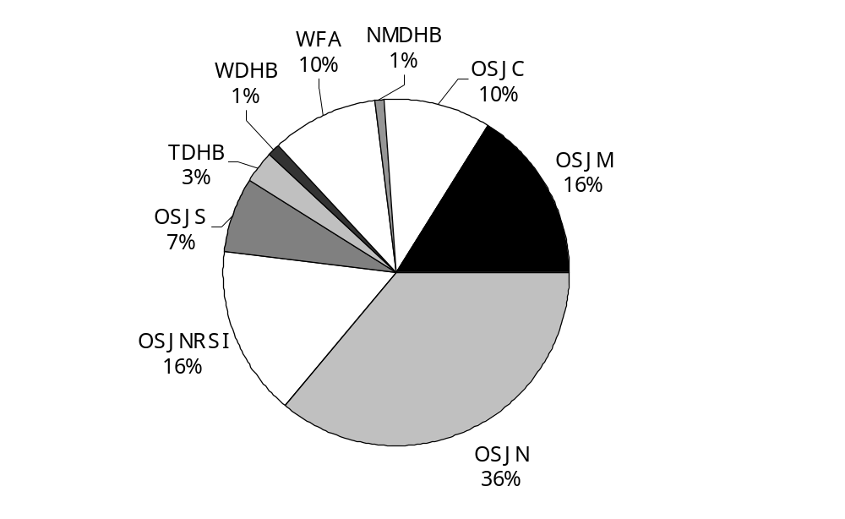

Figure 4.3 gives an indication of the spread of stations around their main delivery points, the emergency departments. However, it is not a good indicator of access to services, for example, Marlborough’s main station is at Wairau Hospital but will respond to calls throughout the Wairau valley. The Northern Region (SI) result excludes the distance between the Chathams and Wellington, the OSJN result excludes the four PTS stations, and the WFA stations exclude that based at Wellington Airport for similar reasons. All other information is as provided to the review with no independent testing.

Figure 4.3: Average distance from station to emergency department at provider level
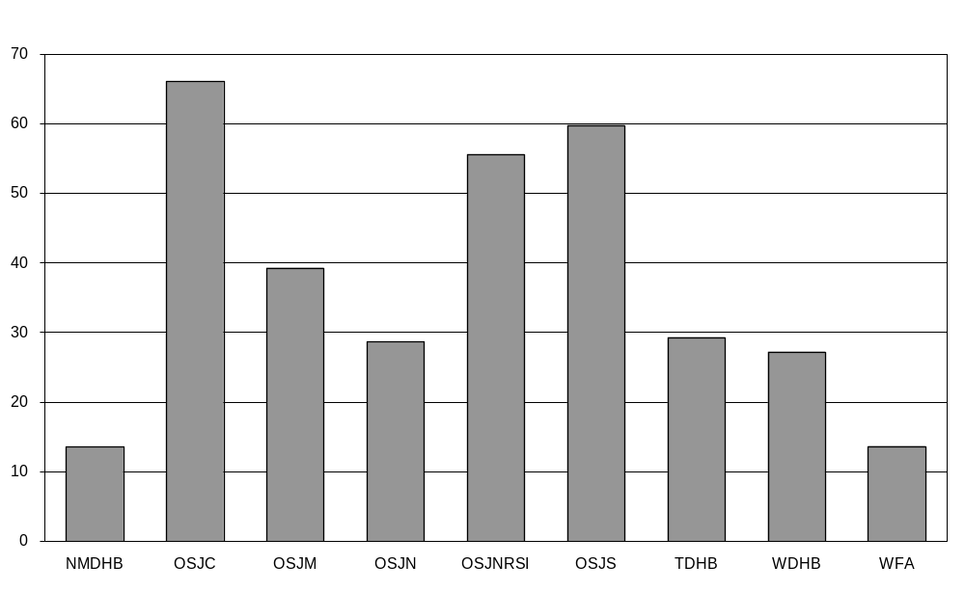

Figure 4.4 shows similar information except exchanging distance for travel time. In this graph, travel time to islands is excluded. These are Waiheke, Stewart and Chatham Islands.

Figure 4.4: Average travel time from station to emergency department at provider level
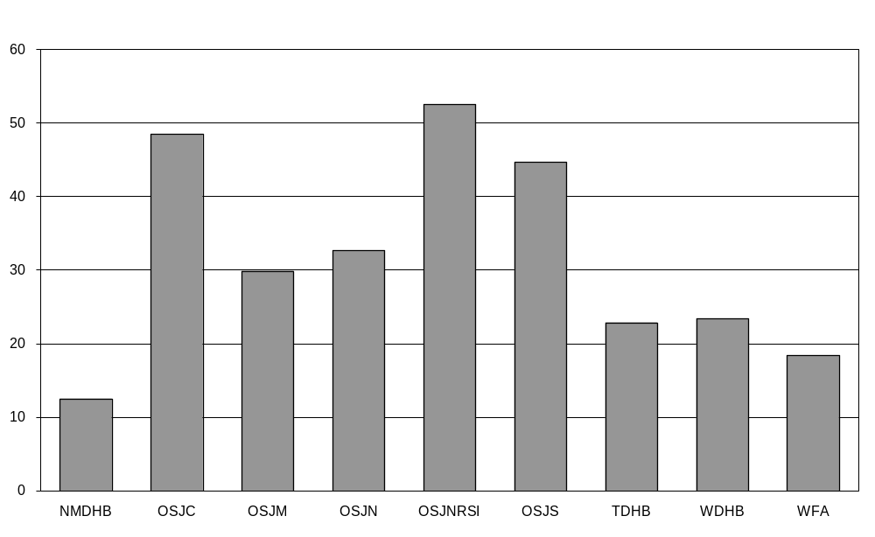

4.3 Volume analysis
An understanding of volumes is central to the understanding of unit costs. Ideally, volumes would be counted according to a standard of resource use within categories of similar production. The ideal resource use standard would relate to the time each ambulance is unavailable for the next urgent assignment. Service levels, at face value, appear to be ideal for categorising levels of production.

4.3.1 Volume information
Five categories of volume information have been collected (see Appendix 2 for details):
- travel time
- service time
- number of incidents
- number of dispatches
- number of patients.

Some providers did not provide data in all categories. When required, we manipulated data with reference to national or peer information, and so on.

Ratio tests between these volume categories at provider level and station level have been applied to identify data problems and have also been used to fill the data gaps. In the following tables, ratios that are outside of one standard deviation from the mean are shown in red.

Table 4.3 indicates the time (decimal hours) required for the average incident in each of six categories of activity. These six categories of activity are indicated by the case code recorded on the computer aided dispatch. The ranges of case codes that constitute each category are noted with the brief description of the category.

Table 4.3: Travel time (h) per incident at provider level
Provider | 100–199 Hospital authorised | 200–299 Private hire* | 400–599 Accident | 600–699 Non-hospital authorised | 700–799 Medical | 800–999 Other | Subtotal
NMDHB | 0.92 | 3.55 | 0.86 | 0.50 | 0.76 | 0.79 | 0.85
OSJC | 4.59 | 5.08 | 3.10 | 5.41 | 2.71 | 4.15 | 3.40
OSJM | 3.37 | 5.30 | 1.00 | 2.35 | 0.94 | 0.23 | 1.51
OSJN | 1.42 | 0.95 | 1.27 |  | 1.29 | 0.63 | 1.27
OSJNRSI | 2.75 | 3.06 | 1.05 | 1.19 | 1.02 | 1.21 | 1.41
OSJS | 4.99 | 2.67 | 2.57 | 3.12 | 2.41 | 1.75 | 2.62
TDHB | 1.76 | 1.76 | 1.27 | 0.11 | 1.23 | 0.02 | 1.17
WDHB | 2.14 | 3.65 | 2.15 |  | 1.02 | 1.01 | 1.60
WFA | 1.61 | 1.56 | 1.11 |  | 1.29 | 0.72 | 1.16
Average | 1.41 | 1.59 | 1.51 | 3.16 | 1.46 | 0.61 | 1.30
* Note that private hire includes standby at events.

Travel time is not directly available from individual computer aided dispatch systems. Where time an ambulance is detained handing over a patient at hospital is not known, the default assumption was that this takes 20 minutes. The job cycle time (service time) was doubled, increased by time at hospital and decreased by the time at scene. The robustness of this calculation needed to be tested. Testing travel time per incident showed OSJS and OSJC were consistently at the upper end of the scale, at more than one standard deviation above the average for almost all categories. Average times for the emergency categories of over 2.4 hours indicated that the travel time calculation was not robust for those regions.

Table 4.4: Number of dispatches per incident at provider level
Provider | 100–199 Hospital authorised | 200–299 Private hire* | 400–599 Accident | 600–699 Non-hospital authorised | 700–799 Medical | 800–999 Other | Subtotal
NMDHB | 1.00 | 1.00 | 1.00 | 1.00 | 1.00 | 1.00 | 1.00
OSJC | 1.01 | 1.00 | 1.07 | 1.01 | 1.00 | 1.05 | 1.02
OSJM | 1.02 | 1.05 | 1.14 | 0.55 | 1.10 | 1.13 | 1.08
OSJN | 1.09 | 1.11 | 1.15 |  | 1.13 | 1.12 | 1.12
OSJNRSI | 1.03 | 1.02 | 1.10 | 1.02 | 1.05 | 3.84 | 1.17
OSJS | 1.00 | 1.00 | 1.00 | 1.00 | 1.00 | 1.00 | 1.00
TDHB | 1.00 | 1.00 | 1.00 | 1.00 | 1.00 | 1.67 | 1.06
WDHB | 1.00 | 1.00 | 1.72 |  | 2.26 | 0.24 | 1.66
WFA | 1.02 | 0.57 | 1.15 |  | 0.87 | 0.88 | 0.93
Average | 1.04 | 1.02 | 1.12 | 0.78 | 1.07 | 1.13 | 1.08

The dispatch to incident ratio was expected to be slightly over one for all but the ‘other’ category. (The ‘other’ category is largely standby at events that may or may not be classified as an incident.) There are also difficulties with some computer aided dispatch systems in counting routine repetitive work, such as some private hire activity. Wairarapa DHB had particularly high numbers of dispatches (or low numbers of incidents) for its emergency categories that may result from its relatively simple data collection systems.

Table 4.5: Number of patients per incident, at provider level
Provider | 100–199 Hospital authorised | 200–299 Private hire* | 400–599 Accident | 600–699 Non-hospital authorised | 700–799 Medical | 800–999 Other | Subtotal
NMDHB | 1.00 | 1.00 | 1.02 | 1.00 | 1.01 | 1.00 | 1.01
OSJC | 1.00 | 1.00 | 1.07 | 1.01 | 1.00 | 1.05 | 1.02
OSJM | 1.07 | 1.07 | 1.07 | 1.07 | 1.05 | 0.25 | 1.03
OSJN | 1.07 | 1.07 | 1.07 |  | 1.05 | 0.94 | 1.06
OSJNRSI | 1.01 | 0.91 | 0.96 | 1.21 | 0.97 | 1.00 | 0.97
OSJS | 1.37 | 0.91 | 1.00 | 1.00 | 0.97 | 0.54 | 0.93
TDHB | 1.85 | 1.00 | 0.88 | 1.01 | 0.96 | 1.00 | 1.10
WDHB | 1.31 | 0.65 | 0.99 |  | 0.98 | 1.00 | 1.06
WFA | 1.07 | 0.89 | 0.87 |  | 0.94 | 0.07 | 0.71
Average | 1.10 | 1.01 | 1.01 | 1.05 | 1.01 | 0.51 | 0.98

The data request included numbers of patients associated with incidents. The expectation was that any patient treated at the scene or transported would be counted, with the ratio of patients to incidents being always greater than one. It would seem from the ratios shown above that this is not the way the data was presented. The columns with significant volumes are the hospital authorised transports, accidents and medical emergencies.

Table 4.6: Ratio of travel time to service time at provider level
Provider | 100–199 Hospital authorised | 200–299 Private hire* | 400–599 Accident | 600–699 Non-hospital authorised | 700–799 Medical | 800–999 Other | Subtotal
NMDHB | 1.04 | 1.00 | 1.14 | 1.00 | 1.15 | 1.07 | 1.12
OSJC | 3.52 | 4.51 | 1.23 | 4.44 | 1.01 | 0.43 | 0.89
OSJM | 1.92 | 7.53 | 1.42 | 2.52 | 1.40 | 1.81 | 1.79
OSJN | 0.61 | 0.45 | 1.75 |  | 1.87 | 2.76 | 1.20
OSJNRSI | 2.46 | 4.88 | 1.50 | 1.73 | 1.50 | 2.28 | 1.90
OSJS | 3.35 | 4.62 | 2.05 | 2.28 | 2.16 | 1.82 | 2.33
TDHB | 1.73 | 1.73 | 1.69 | 0.74 | 1.92 | 0.83 | 1.79
WDHB | 1.14 | 1.00 | 1.22 |  | 1.79 | 1.79 | 1.32
WFA | 1.32 | 1.25 | 1.23 |  | 1.22 | 0.94 | 1.18
Average | 1.41 | 1.59 | 1.51 | 3.16 | 1.46 | 0.61 | 1.30

Travel time is the nearest available variable to the ideal resource use standard. For reasons relating to the calculation of travel time (see Table 4.3 above), for emergency incidents at least, travel time should be around twice the service time (job cycle time). This assumes that time spent at the scene is roughly equivalent to time spent at hospital. For emergency incidents, the overall average ratio was around 1.5, indicating that travel time was not a reliable variable.

4.3.2 Volume proxies
Table 4.7 shows the correlations between volume proxies. Numbers of incidents, dispatches and patients have a very close relationship in that they can replace one another with little impact on final analytical results.

Table 4.7: Correlation coefficients between volume proxies
 | Number of incidents | Number of dispatches | Number of patients | Travel time
Number of dispatches | 0.99
Number of patients | 0.98 | 0.98
Travel time | 0.78 | 0.77 | 0.77
Service time | 0.74 | 0.72 | 0.76 | 0.74

Ideally, it would be better to apply travel time as volume proxy in the analysis as it applies an element of standardisation between incidents. However, volume ratio checks show that providers did not report data consistently. The correlations in Table 4.7 above support this conclusion.

The correlation coefficient between total cost and number of incidents is 0.94 at station level, indicating a strong link between cost and number of incidents (see Table 5.1). The correlation coefficient between total cost and total travel time is 0.81. We also went through the analysis with travel time. However, those results were not as consistent as the results presented in this report based on number of incidents.

In the following analysis, number of incidents has been chosen as the volume proxy as it is the most consistently reported measure. That is, volume is equivalent to number of incidents.

4.3.3 Volume structure
Ambulance activity is counted according to six categories as in Tables 4.3 to 4.6 above. These categories are indicated in the tables below and the values represent numbers or proportions of incidents.

Table 4.8: Volume data
Provider | 100–199 Hospital authorised | 200–299 Private hire* | 400–599 Accident | 600–699 Non-hospital authorised | 700–799 Medical | 800–999 Other | Subtotal
NMDHB | 463 | 33 | 715 | 2 | 1,353 | 19 | 2,585
OSJC | 4,699 | 1,251 | 7,849 | 1,057 | 20,144 | 8,509 | 43,509
OSJM | 9,134 | 2,011 | 13,907 | 1,843 | 29,178 | 1,843 | 57,916
OSJN | 21,703 | 8,402 | 26,654 |  | 67,058 | 2,668 | 126,485
OSJNRSI | 7,946 | 2,533 | 10,908 | 294 | 26,110 | 1,995 | 49,786
OSJS | 3,682 | 2,052 | 7,443 | 26 | 12,678 | 6,622 | 32,503
TDHB | 1,905 | 285 | 2,543 | 578 | 4,884 | 1,083 | 11,278
WDHB | 1,081 | 17 | 1,222 |  | 1,840 | 328 | 4,488
WFA | 9,100 | 1,870 | 9,556 |  | 20,544 | 15,967 | 57,037
Average | 59,713 | 18,454 | 80,797 | 3,800 | 183,789 | 39,034 | 385,587

When incident information was unavailable it has been replaced with dispatch information. There is a very close relationship between these variables.

The volume structure indicated in Table 4.9 shows the relative shares of activity between the six major categories. True zeros are shown as blanks whereas 0% indicates a value rounded to zero.

Table 4.9: Volume structure among six categories
Provider | 100–199 Hospital authorised | 200–299 Private hire* | 400–599 Accident | 600–699 Non-hospital authorised | 700–799 Medical | 800–999 Other | Subtotal
NMDHB | 18% | 1% | 28% | 0% | 52% | 1% | 100%
OSJC | 11% | 3% | 18% | 2% | 46% | 20% | 100%
OSJM | 16% | 3% | 24% | 3% | 50% | 3% | 100%
OSJN | 17% | 7% | 21% |  | 53% | 2% | 100%
OSJNRSI | 16% | 5% | 22% | 1% | 52% | 4% | 100%
OSJS | 11% | 6% | 23% | 0% | 39% | 20% | 100%
TDHB | 17% | 3% | 23% | 5% | 43% | 10% | 100%
WDHB | 24% | 0% | 27% |  | 41% | 7% | 100%
WFA | 16% | 3% | 17% |  | 36% | 28% | 100%
Average | 15% | 5% | 21% | 1% | 48% | 10% | 100%

Concentrating further on the ‘emergency’ categories, case codes 400–599 and 700–799, gives a view on the difference in activity at provider level.

Table 4.10 shows medical volumes average 2.3 times that of accident volumes but range between 1.5 times for WDHB and 2.6 times for OSJC.

Table 4.10: Emergency volume proportions between accident and medical
Provider | 400–599 Accident | 700–799 Medical | Ratio of medical to accident
NMDHB | 35% | 65% | 1.9
OSJC | 28% | 72% | 2.6
OSJM | 32% | 68% | 2.1
OSJN | 28% | 72% | 2.5
OSJNRSI | 29% | 71% | 2.4
OSJS | 37% | 63% | 1.7
TDHB | 34% | 66% | 1.9
WDHB | 40% | 60% | 1.5
WFA | 32% | 68% | 2.1
Average | 31% | 69% | 2.3

Figure 4.5: Medical versus ACC emergency volume at provider level
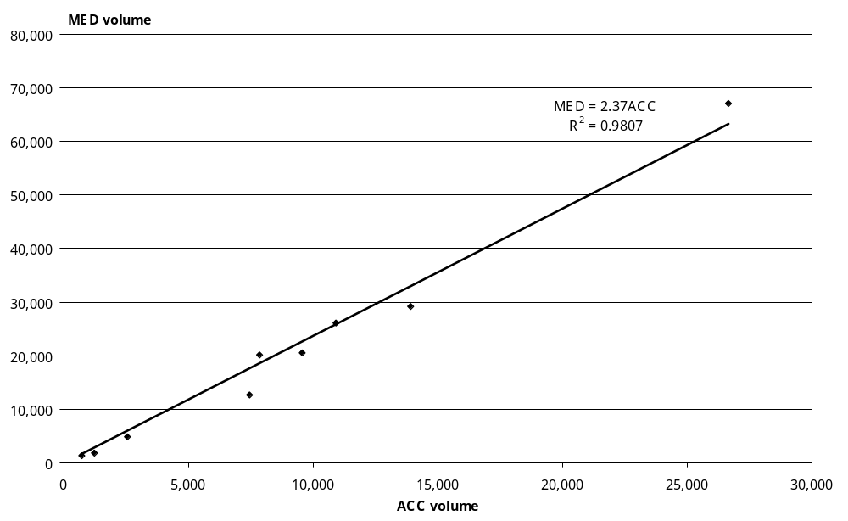

Figure 4.6: Medical versus ACC emergency volume at station level
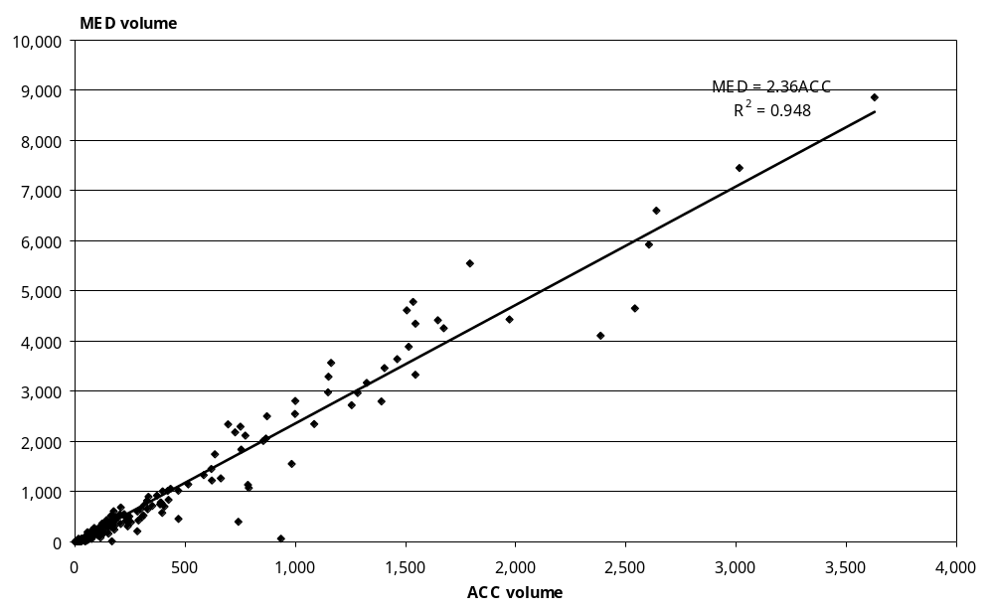

Figure 4.7: Volume proportion among six categories
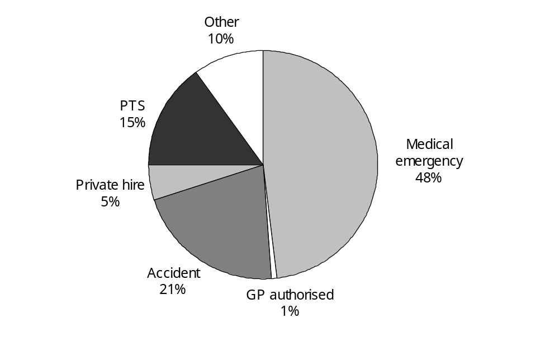

Figure 4.8 indicates that incidents funded from Vote: Health, medical emergencies and patient transports, account for almost two-thirds of the volume. It also shows a similar picture of provider size to Figure 4.2. The major difference seems to arise from WFA’s high non-emergency volumes.

Figure 4.8: Volume proportion among providers
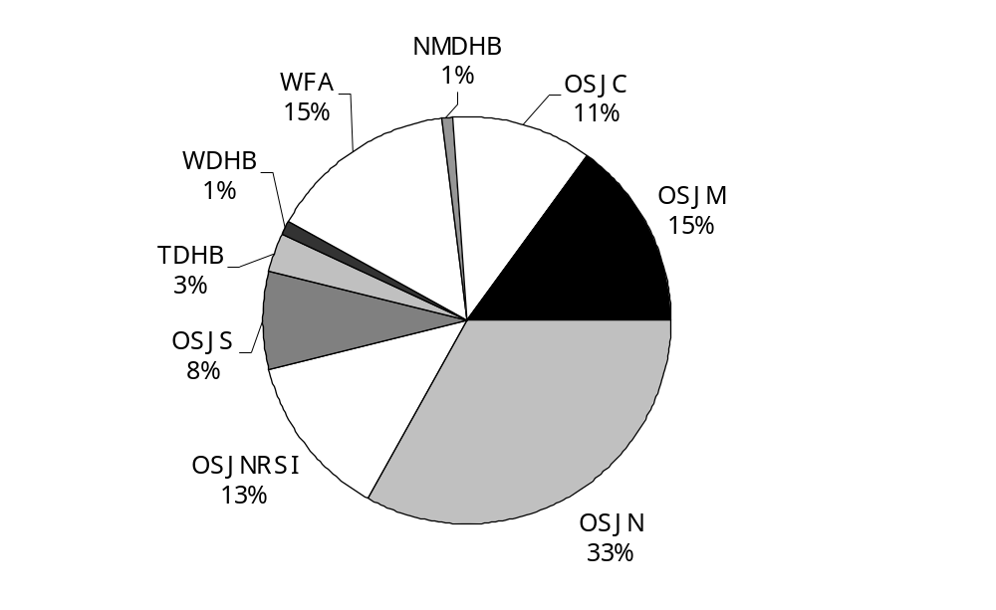

Table 4.11 indicates that the bulk of activity is provided by stations with more complex service levels. Service level five and six stations combined respond to two-thirds of all incidents.

Table 4.11: Volume proportion at station service level
Provider | L6 | L5 | L4 | L3 | L2 | L1 | L0 | Subtotal
NMDHB | 0% | 94% | 0% | 0% | 6% | 0% | 0% | 100%
OSJC | 51% | 21% | 0% | 26% | 1% | 0% | 0% | 100%
OSJM | 47% | 6% | 17% | 27% | 4% | 0% | 0% | 100%
OSJN | 67% | 0% | 0% | 10% | 2% | 0% | 20% | 100%
OSJNRSI | 62% | 8% | 5% | 14% | 9% | 2% | 0% | 100%
OSJS | 54% | 0% | 15% | 20% | 11% | 0% | 0% | 100%
TDHB | 0% | 54% | 24% | 0% | 11% | 11% | 0% | 100%
WDHB | 0% | 70% | 2% | 0% | 28% | 0% | 0% | 100%
WFA | 53% | 30% | 16% | 0% | 0% | 0% | 0% | 100%
Aggregate | 55% | 12% | 8% | 14% | 4% | 1% | 6% | 100%

Figure 4.9 shows the percentage of overall volume provided from stations of each service level. Level 0 stations are the four stations in OSJN that are dedicated to patient transport services and, therefore, do not fit neatly within the service level framework.

Figure 4.9: Volume proportion at station level
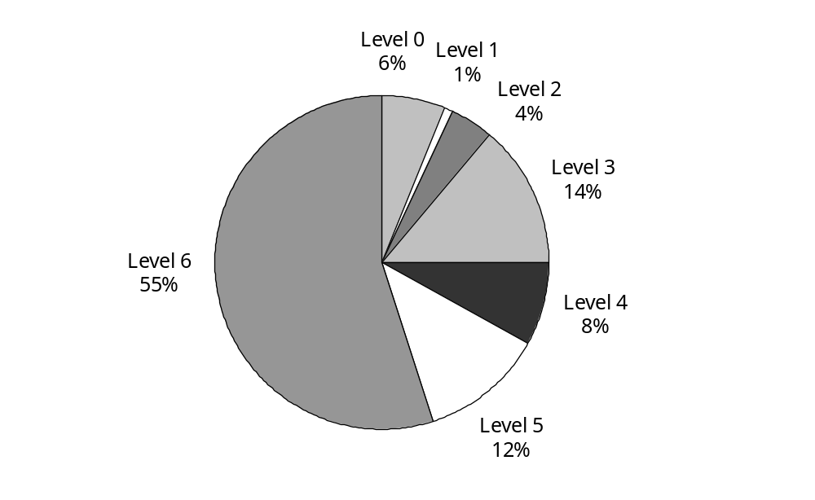

Table 4.12: Emergency volume proportion at station level
Provider | L6 | L5 | L4 | L3 | L2 | L1 | L0 | Subtotal
NMDHB | 0% | 93% | 0% | 0% | 7% | 0% | 0% | 100%
OSJC | 52% | 21% | 0% | 26% | 1% | 0% | 0% | 100%
OSJM | 47% | 4% | 15% | 29% | 5% | 0% | 0% | 100%
OSJN | 84% | 0% | 0% | 11% | 3% | 0% | 1% | 100%
OSJNRSI | 61% | 7% | 5% | 15% | 9% | 3% | 0% | 100%
OSJS | 53% | 0% | 15% | 17% | 15% | 0% | 0% | 100%
TDHB | 0% | 54% | 23% | 0% | 13% | 10% | 0% | 100%
WDHB | 0% | 63% | 3% | 0% | 34% | 0% | 0% | 100%
WFA | 59% | 24% | 17% | 0% | 0% | 0% | 0% | 100%
Aggregate | 62% | 10% | 7% | 15% | 5% | 1% | 0% | 100%

Figure 4.10 illustrates that the bulk of the emergency volume is met from Level 5 and 6 stations.

Figure 4.10: Emergency volume proportion at station level
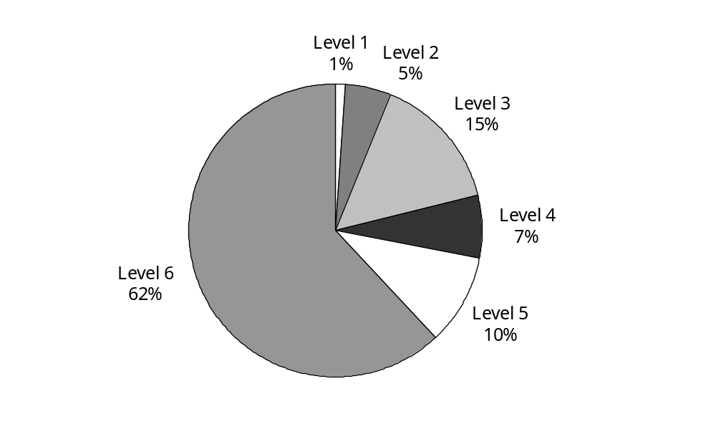

4.4 Resource utilisation analysis
As the ambulance service is one in which access to the service is the priority and spare capacity is therefore important, it is anticipated that there is a strong relationship between utilisation and cost.

4.4.1 Vehicle utilisation analysis
Table 4.13 gives the vehicle mix for each provider. The total number of vehicles in data reported = DR total. The total number of ambulance and operational vehicles in OSJ’s collective annual report = AR total. The difference should be the vehicles that are irrelevant to road ambulance services. However, the differences are too great to be true, which could occur for several reasons. From the comparison of vehicle fixed cost data between DR and AR, DR total and AR total should be very close.

Table 4.13: Road ambulance vehicles available
Provider | EAS | FRU | PTS | DR total | AR total | Difference
NMDHB | 4 | 1 |  | 5
OSJC | 28 | 3 |  | 31 | 77 | 46
OSJM | 48 |  | 10 | 58 | 115 | 57
OSJN | 56 | 5 | 22 | 83 | 126 | 43
OSJNRSI | 54 | 18 | 9 | 81 | 105 | 24
OSJS | 52 | 4 |  | 56 | 75 | 19
TDHB | 7 | 2 | 3 | 12
WDHB | 6 | 1 |  | 7
WFA | 10 | 6 | 5 | 21
Total | 277 | 42 | 54 | 373

Table 4.14 gives the vehicle rostered hours for each provider. Table 4.15 calculates vehicle utilisation rate in terms of rostered hours and the vehicle utilisation rate in terms of volume, or how efficiently an average vehicle operates.

Table 4.14: Vehicle rostered hours
Provider | EAS | FRU | PTS | Total
NMDHB | 21,900 | 13,140 |  | 35,040
OSJC | 229,220 | 26,280 |  | 255,500
OSJM | 390,624 |  | 2,080 | 392,704
OSJN | 454,060 | 43,800 | 64,240 | 562,100
OSJNRSI | 394,200 | 91,615 | 16,625 | 502,440
OSJS | 302,220 | 17,520 |  | 319,740
TDHB | 102,336 | 29,952 | 25,792 | 158,080
WDHB | 22,152 |  |  | 22,152
WFA | 67,580 | 35,040 | 8,330 | 110,950
Total | 1,984,292 | 257,347 | 119,147 | 2,358,706

Table 4.15 indicates hours for which vehicles of various types are rostered as available compared with the ratio between the total number of incidents and the total number of vehicles (volume per vehicle). The range in rostered vehicle hours per incident is wide; from 1.9 hours to 14.0 hours per incident overall and from 3.4 hours to 17.8 hours per incident for emergency incidents and the EAS/FRU vehicles.

Table 4.15: Vehicle utilisation
Provider | Average rostered hours per vehicle |  |  |  | Volume per vehicle
Provider | EAS | FRU | PTS | Total | Volume per vehicle
NMDHB | 5,475 | 13,140 |  | 7,008 | 517
OSJC | 8,186 | 8,760 |  | 8,242 | 1,404
OSJM | 8,138 |  | 208 | 6,771 | 999
OSJN | 8,108 | 8,760 | 2,920 | 6,772 | 1,524
OSJNRSI | 7,300 | 5,090 | 1,847 | 6,203 | 615
OSJS | 5,812 | 4,380 |  | 5,710 | 580
TDHB | 14,619 | 14,976 | 8,597 | 13,173 | 940
WDHB | 3,692 |  |  | 3,165 | 641
WFA | 6,758 | 5,840 | 1,666 | 5,283 | 2,716
Total | 7,164 | 6,127 | 2,206 | 6,663 | 1,089

Some problems seem to remain with WDHB data, as its rostered hours per vehicle and volume per vehicle are consistently much lower than the others. The high utilisation for WFA vehicles is investigated elsewhere in this report.

4.4.2 Labour utilisation analysis
An important cost element is labour. Table 4.16 reports labour resource utilisation from different perspectives. Data was collected for direct on-duty and on-call available hours for both paid and volunteer staff at three levels of qualification. Staff hours are the sum of on-duty and on-call staff hours. One shift is assumed to be 12 hours. Nationally, one on-duty staff shift delivers services to 2.43 incidents.

Table 4.16: Labour utilisation
Provider | Volumes per on-duty staff shift | Travel time per vehicle rostered hour | Staff hours per vehicle rostered hour | Staff hours per vehicle
NMDHB | 2.36 | 6% | 1.08 | 7,592
OSJC | 2.73 | 58% | 1.37 | 11,280
OSJM | 2.28 | 22% | 1.63 | 11,057
OSJN | 2.76 | 29% | 1.64 | 11,075
OSJNRSI | 1.77 | 14% | 1.80 | 11,161
OSJS | 1.52 | 27% | 1.85 | 10,558
TDHB | 1.98 | 8% | 0.71 | 9,343
WDHB | 2.39 | 33% | 2.57 | 8,134
WFA | 4.19 | 60% | 1.47 | 7,771
Total | 2.43 | 27% | 1.60 | 10,666

In Table 4.16, 2.57 staff hours per vehicle rostered hour for WDHB means an average of more than two ambulance officers in one vehicle at any one time and supports the conclusion mentioned in the last subsection that vehicle rostered hours data for WDHB may not be accurate. WDHB’s travel time per vehicle rostered hour is similar to other providers, implying that there remain problems with WDHB’s travel time data.

Table 4.17 records full crew information for emergency services. Providers reported the numbers of emergency incidents to which they responded with either a full or single crewed vehicle and separately reported the number of emergency incidents. It is not known whether the differences between these numbers of incidents imply the number of incidents to which the provider dispatched multiple vehicles or some other data difficulty.

Staff hours per vehicle rostered hour can also indicate the extent of full crewing on the assumption that two rostered staff hours for each rostered vehicle hour means a full crew. At the provider level, the data from five OSJ providers shows some correlation between full crew percentage and staff hours per vehicle hours, although this is not supported at the station level.

Table 4.17: Full crew for emergency services
Provider | Staff hours per vehicle rostered hour | Single crew | Full crew | Full crew (%) | Emergency volume | Difference
NMDHB | 1.08 | 0 | 2,585 | 100 | 2,068 | 517
OSJC | 1.37 | 9,866 | 18,699 | 65 | 27,993 | -9,293
OSJM | 1.63 | 14,201 | 28,884 | 67 | 43,085 | -14,201
OSJN | 1.64 | 18,649 | 80,477 | 81 | 93,712 | -13,235
OSJNRSI | 1.80 | 0 | 58,031 | 100 | 37,018 | 21,013
OSJS | 1.85 | 3,708 | 32,182 | 90 | 20,121 | 12,061
TDHB | 0.71 | 653 | 5,393 | 89 | 7,427 | -2,034
WDHB | 2.57 | 125 | 3,182 | 96 | 3,062 | 120
WFA | 1.47 |  |  |  | 30,100
Total | 1.60 | 47,203 | 229,433 | 83 | 264,586

4.5 Costing analysis
The purpose of the costing analysis is to warrant provider costs as accurately as possible so that any performance analysis is robust.

4.5.1 Cost structure
To conduct costing analysis properly, irrelevant costs have first to be excluded. Irrelevant costs are those costs that are not actually incurred by road ambulance services.

Air related costs and PRIME have been excluded from the cost pool because they are not incurred by road ambulance service. Bad debts are excluded from revenue and cost. The total of irrelevant costs is $3.37 million, or 3.81 percent of total actual costs reported. Nominal rents are also left out of the actual cost pool and amount to $1.75 million.

‘Relevant costs’ left in this costing analysis may still include other irrelevant costs, as there is no clear method to separate or allocate actual cost between road ambulance services and other services precisely.

Another important data reconciliation is to allocate overheads costs and control room costs into the station cost pool based on patients attended by that station as a proportion of all patients attended by that provider. On the advice from the working group, patients rather than incidents were used in this instance. This is a more appropriate variable and as the correlation with incidents is practically one-to-one.

The cost information was then grouped into six components:
- direct staff costs, including direct paid staff costs and volunteer costs
- clinical cost
- vehicle cost, including vehicle fixed costs and running costs
- financial cost, apart from vehicle fixed costs
- control room cost
- other costs, including actual rent, training costs and overheads.

Table 4.18 and Figure 4.11 record the operating cost structure by these six components. OSJC and NMDHB have higher proportions of direct staff cost, whereas WFA has a lower proportion.

Table 4.18: Operating cost structure by cost component
Provider | Direct staff | Clinical | Vehicle | Financial | Control room | Others
NMDHB | 62.18% | 5.72% | 12.63% | 0.23% | 0.00% | 19.25%
OSJC | 62.60% | 3.97% | 8.56% | 2.33% | 9.29% | 13.25%
OSJM | 51.55% | 5.21% | 14.25% | 2.63% | 10.36% | 16.00%
OSJN | 55.41% | 4.06% | 8.20% | 2.72% | 9.87% | 19.75%
OSJNRSI | 52.52% | 4.81% | 11.25% | 1.28% | 13.87% | 16.26%
OSJS | 52.37% | 4.03% | 12.28% | 0.22% | 9.40% | 21.95%
TDHB | 52.87% | 10.30% | 8.11% | 0.00% | 2.93% | 25.79%
WDHB | 53.31% | 2.79% | 13.43% | 0.76% | 0.52% | 29.19%
WFA | 42.13% | 4.81% | 14.54% | 0.00% | 10.07% | 28.45%
Total | 53.50% | 4.59% | 10.71% | 1.79% | 9.99% | 19.42%

Figure 4.11: Operating cost structure at national level
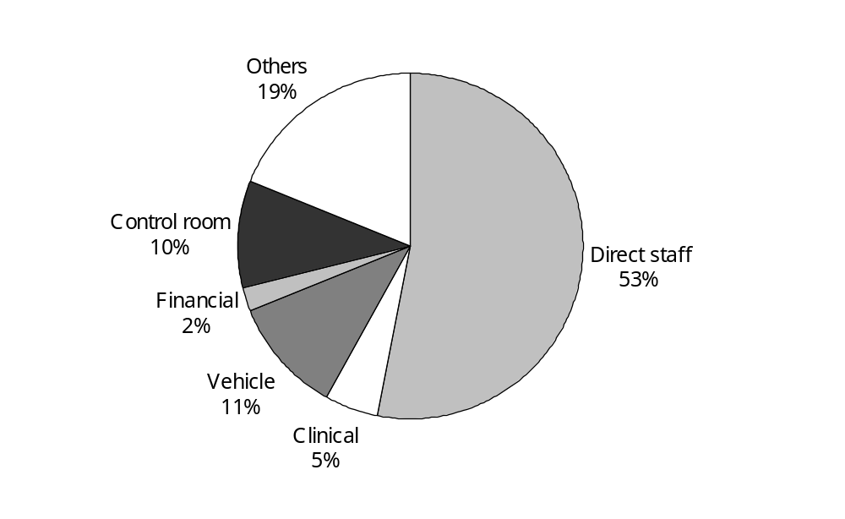

Some of the annual reports gave cost structure information. Although these are not exactly comparable to the data collection format, comparison between them is useful.

In Table 4.19, the proportions for three providers are from their annual reports, and the proportions for Sector are extracted from the Deloitte report. Generally the proportions between adjacent years are stable.
Table 4.19: Personnel cost proportion over total cost
 | 2003 | 2002 | 2001 | 2000 | 1999 | 1998 | 1997
OSJM | 56.86% | 56.83% | 59.41% | 61.20% | 65.39%
OSJNRSI | 56.61% | 55.38% | 58.77% | 60.28% | 59.58% | 61.55%
OSJS | 62.43% | 64.55% | 58.92% | 57.65% | 59.62%
Sector |  |  |  | 63.67% | 62.61% | 64.44% | 65.95%

Personnel costs for OSJ and WFA in their annual reports are 61 percent and 67 percent separately, but direct staff costs in their data reported are around 55 percent and 42 percent. This means that 6 percent of total cost for OSJ and 25 percent for WFA could be indirect staff cost. But it also implies that OSJ and WFA may have applied different cost allocation criteria to each other.

The sum of vehicle costs and financial costs for OSJ and WFA in their annual reports are 13.47 percent and 16.87 percent separately, but the sum in their data reported are 12.43 percent and 14.54 percent. These figures in data reported are consistently less than the figures in the annual reports. These comparisons may suggest that providers could have allocated ‘other’ costs at higher proportions into the road ambulance cost pool than to non-ambulance activities.

4.5.2 Staff hour rates
Because the data reported paid staff on-duty and on-call hours, and related personnel costs, paid staff hour rates (ie, the total personnel cost per hour) could be derived.

Table 4.20 shows paid staff hour rates based on raw data for each qualification level, on-duty and on-call separately.

Table 4.20: Paid staff hour rates based on raw data
Provider | Direct personnel cost per on-duty hour |  |  | Direct personnel cost per on-call hour |  |  | On-duty hour rate | On-call hour rate
Provider | National Certificate | National Certificate IV | Advanced paramedic | National Certificate | National Certificate IV | Advanced paramedic | On-duty hour rate | On-call hour rate
NMDHB | 20.76 | 21.32 |  | 10.38 | 10.66 | 11.40 | 20.95 | 10.70
OSJC | 32.74 | 27.11 | 40.67 |  | 16.37 |  | 31.92 | 16.37
OSJM |  |  | 168.50 |  |  |  | 34.14
OSJN | 25.90 | 28.81 | 34.75 |  | 33.66 | 30.81 | 29.89 | 30.05
OSJNRSI | 29.82 | 32.90 | 32.95 |  | 1.27 | 0.21 | 32.84 | 0.85
OSJS | 33.63 | 32.32 | 42.91 |  |  |  | 35.14
TDHB | 32.19 | 23.01 | 44.83 | 3.78 | 3.78 |  | 31.39 | 3.78
WDHB |  | 25.27 | 22.24 |  |  | 10.64 | 21.96 | 7.94
WFA |  |  | 36.06 |  |  |  | 26.72
Aggregate | 20.87 | 24.00 | 47.32 | 1.18 | 9.60 | 12.84 | 31.16 | 8.01

Some of the hourly rates, shown in red, do not make sense.
- For OSJC, the hourly rate for staff with National Certificate IV is $27.11, which is less than the hourly rate of $32.74 for staff with National Certificate.
- OSJM did not split personnel costs between different qualification levels, and also did not report staff hours for the two lower levels of qualification.
- For OSJN, the on-call hourly rate is greater than its on-duty hourly rate.
- WFA did not split personnel costs between different qualification levels.

To reflect the expected assumption that staff costs should reflect qualifications, paid staff hour rates were adjusted as follows.

The first assumption is that staff with higher qualifications should be paid at a higher rate across all providers. OSJNRSI and OSJS reported hourly rates by qualification level. Based on these two sets in Table 4.21, weighted average rates between qualification levels have been calculated as hourly rate relativities.

Table 4.21: Actual hour rates ($)
Provider | National Certificate | National Certificate IV | Advanced paramedic
OSJNRSI | 20.51 | 21.06 | 22.52
OSJS | 19.61 | 20.65 | 21.83
Average | 20.06 | 20.86 | 22.18

The second assumption is that on-duty hourly rates should be higher than on-call hourly rates. For OSJN, paid hourly rates for on-call and on-duty hours are assumed to be the same. So its on-duty and on-call hours are combined together as on-duty hours.

The third assumption is that the data on available staff hours is more reliable. If total paid staff costs are correct, it follows that the staff hourly rates should be reasonable once corrected.

Based on these assumptions, Table 4.22 shows the recalculated paid staff hourly rates. It shows that, on average, nationally, the on-duty staff rate is $30.37 and the on-call staff rate is $8.85. Note that these are total personnel costs whereas Table 4.21 above is staff salary rates only.

Table 4.22: Paid staff hour rates recalculated
Provider | Direct personnel cost per hour on-duty |  |  | Direct personnel cost per hour on-call |  |  | On-duty staff | On-call staff
Provider | National Certificate | National Certificate IV | Advanced paramedic | National Certificate | National Certificate IV | Advanced paramedic | On-duty staff | On-call staff
NMDHB | 20.67 | 21.49 |  | 10.33 | 10.74 | 11.42 | 20.95 | 10.70
OSJC | 30.08 | 31.28 | 33.25 |  | 16.37 |  | 31.92 | 16.37
OSJM | 27.06 | 28.14 | 29.92 | 8.09 | 8.41 | 8.94 | 28.32 | 8.33
OSJN | 28.91 | 31.33 | 36.30 |  |  |  | 29.90
OSJNRSI | 31.04 | 32.27 | 34.32 |  | 0.83 | 0.88 | 32.84 | 0.85
OSJS | 33.27 | 34.59 | 36.78 |  |  | 10.99 | 35.04 | 10.99
TDHB | 29.85 | 31.03 | 32.99 | 3.70 | 3.85 |  | 31.39 | 5.04
WDHB | 20.83 | 21.66 | 23.03 | 7.36 |  | 8.13 | 21.96 | 7.94
WFA | 24.69 | 25.67 | 27.29 |  |  |  | 26.76
Aggregate | 28.00 | 30.43 | 31.35 | 7.74 | 10.21 | 6.58 | 30.37 | 8.85

Table 4.22 shows the paid staff hour proportions by qualification levels for both on-duty and on-call available hours. From these projected on-duty staff hourly rates (the sum product of on-duty proportions and average actual hourly rates in Table 4.21) can be worked out. Based on a national average, the on-duty staff hourly rate should be $21.18.

Ratio, the last column in Table 4.23, is equal to the on-duty staff hourly rate calculated in Table 4.22 divided by the projected on-duty staff hourly rate. The national average ratio is 1.43. This means that the extra personnel cost beyond salary, used to compensate annual leave, holiday pay, superannuation, ACC levy, uniform, and so on, equates to 43 percent of salary costs. This appears excessive, and implies that either providers over-reported direct paid personnel costs, or underestimated staff hours available.

Another interesting finding is for OSJC, which has a higher direct staff cost, 62.60 percent of the total cost as shown in Table 4.23. The other OSJ providers’ proportions are near the national average at 53.42 percent. If OSJC’s cost data was scaled down to the national average, its on-duty staff hourly rate becomes $26.94.

Table 4.23: Paid staff hour structure
Provider | On-duty staff available hours |  |  | On-call staff available hours |  |  | Projected on-duty staff rate ($) | Ratio
Provider | National Certificate | National Certificate IV | Advanced paramedic | National Certificate | National Certificate IV | Advanced paramedic | Projected on-duty staff rate ($) | Ratio
NMDHB | 67% | 33% | 0% | 50% | 25% | 25% | 20.33 | 1.03
OSJC | 3% | 63% | 34% | 0% | 100% | 0% | 21.28 | 1.50
OSJM | 17% | 63% | 20% | 48% | 37% | 15% | 20.99 | 1.35
OSJN | 24% | 43% | 33% | 0% | 0% | 0% | 21.10 | 1.42
OSJNRSI | 2% | 68% | 29% | 0% | 61% | 39% | 21.22 | 1.55
OSJS | 8% | 66% | 26% | 0% | 0% | 100% | 21.13 | 1.66
TDHB | 20% | 50% | 30% | 50% | 50% | 0% | 21.10 | 1.49
WDHB | 10% | 62% | 28% | 25% | 0% | 75% | 21.15 | 1.04
WFA | 11% | 14% | 74% | 0% | 0% | 0% | 21.74 | 1.23
Aggregate | 15% | 51% | 34% | 31% | 53% | 16% | 21.18 | 1.43

4.6 Quality information
Information indicating the quality of output was collected from providers. The intent of this collection was that it would allow assessment of the provider effectiveness. This information includes:
- response time achievement
- qualification levels of the ambulance officers
- full crew levels.

Each of these was reviewed as a separate indicator of quality. Where appropriate, a quantitative index was developed from the information provided.

4.6.1 Response times
Response times are measured from the time when sufficient information is received from the caller to activate an ambulance to the time an ambulance officer arrives at the incident location (ie, the time excludes initial call processing). Not all situations require an urgent response so contracts specify that only those cases in the more urgent category, ‘priority one’, need to be measured against the relevant targets. The targets are understood to have been set with international (mainly United Kingdom) norms in mind and recognise the reality that sparse populations cannot support the service expected in more densely populated areas. There are difficulties, however, in establishing best achievable practice when translating targets set for the United Kingdom to a country of one-fifteenth of the population density and quite different terrain and quality of roads. Also, as the review has information on total incidents rather than the various priorities of incidents, we are comparing two different sets of information; performance for priority one dispatches versus total dispatches. Effectively, the following commentary assumes that priority one activity is representative of all emergency ambulance work. There is no evidence to support such a conclusion, although it does not seem unreasonable.

In monitoring of the contracts, performance is measured at the level of the organisation as a whole and recognises there will be variations in performance. The review requested information on response times at the level of individual stations, as stations are the unit of service in this exercise.

The response time targets in the contracts have varied from region to region, but have recently been standardised on that which applied in the St John Northern region. The targets differ, however, from that adopted by the ambulance service itself in the Standards document they have drafted. The review is not aware of any analytical work supporting either set of targets as appropriate for, or achievable in, New Zealand.

The current targets for priority one calls are indicated in Table 4.24 where the times are the targets within which the relevant percentage of incidents are to have a response. The Standards follow a similar structure but the targets relate to different percentile levels as indicated below.

Table 4.24: Response time targets
Source document | Percentile | Urban | Rural | Remote rural
Contract | 80% | 10 min | 16 min | 30 min
Contract | 95% | 20 min | 30 min | 60 min
Standards | 50% | 8 min | 12 min | 25 min
Standards | 95% | 20 min | 30 min | 60 min

Questions of the cost of meeting the Standards are, therefore, quite difficult to answer from the existing information, as they require broad assumptions about the pattern of response times. For example, is it more or less stringent a target to get to 50 percent of priority one incidents in 8 minutes than 80 percent in 10 minutes?

A major issue in the study of response times is that of the geographic categories used. These need to be unequivocal. The definition for urban areas is clear: any population centre of 15,000 people or more is included. At least one of the other two categories needs to be equally well defined, with the last category being everything not covered elsewhere. The problem is that the medium populated area definition is not clear. Such areas are defined as: ‘Rural areas surrounding urban cities, or non-remote rural areas, or minor urban/provincial town centres <15,000 population’. Looseness in this definition makes comparison of performance across providers on these two categories very difficult.

Reporting against these targets to the Ministry is inconsistent both in terms of gaps in individual providers’ records and in comparison with each other. Information collected for this review is equally inconsistent with some quite rural areas reporting against urban, rural and remote targets. The data collected for the review seems to indicate providers tend to overstate the urban nature of the station coverage areas. This will give a false impression of poor performance, as they will be measured against a target they are not required to meet.

A review of all 210 stations reveals that 47 have coverage areas that correlate to all three of the geographic response time targets against which they are reporting. Information relating to these stations is noted below under ‘triple match’. It is likely that these stations will provide a more accurate view on response times.

There is a tendency for providers to simplify their reporting to a single geographic category that most represents the coverage area of each station. They disregard the point that response times will be adversely influenced by longer responses to the surrounding areas. Table 4.25 shows that there are 116 stations for which response time performance is provided for the main category of the coverage area (urban, rural or remote) and where that category matches with an external assessment of the nature of that coverage area. Those 116 stations include the 47 that correlate with all three geographic categories. There are 46 urban stations, 29 rural stations and 41 remote stations in this group. These 116 stations are noted as ‘main category’ stations. The related percentage of total service level populations is given for both the total population of the main category subset and for the largest or dominant population group in those stations’ coverage areas. An explanatory example follows the table.

Table 4.25: Station level response performance information
Service level | Stations |  |  | Population % of service level total
Service level | Overall | Triple match | Main category match | Total population | Triple match | Main category (total) | Main category (dominant)
1 | 29 | 8 | 8 | 32,094 | 39% | 39% | 39%
2 | 71 | 19 | 39 | 181,761 | 25% | 57% | 52%
3 | 56 | 6 | 23 | 516,258 | 6% | 52% | 39%
4 | 14 |  | 10 | 279,723 | 0% | 79% | 68%
5 | 10 | 1 | 8 | 342,330 | 20% | 86% | 75%
6 | 30 | 13 | 28 | 2,320,434 | 50% | 97% | 93%
Total | 210 | 47 | 116 | 3,672,600 | 36% | 86% | 79%

Example
Station | Stated area type | Area types reported against | Populations
Station | Stated area type | Area types reported against | Urban | Rural | Remote | Total | Dominant
Mt Maunganui | Urban | Urban only | 30,537 |  | 1,797 | 32,334 | 30,537

The service level for which the relevant populations are least representative is Level 3. At this level, the sample stations represent 52 percent of the population covered by Level 3 stations. However, the population within that sample, covered by the relevant targets, is only 39 percent of the total population covered by Level 3 stations.

The response time information available from most of these 116 stations is not as accurate as for the 47 stations with a consistent match between population and performance reporting. A brief look at the overall impact of accepting these stations shows a more negative view of performance.

The available data for response times has been converted to an index for each station. This index uses the ratio between the difference in the actual and target performance and the target, all weighted for the proportion of the station’s coverage area population to which that target would apply.

The reliability of the response time index is dependent on the match between the population characteristics of the station coverage areas and the categories the operators have nominated for their performance to be assessed against. As indicated above, the nominated categories are not consistently applied. Note that as the number of stations included in the benchmark sample is increased, the number being assessed against inappropriate targets also increases.

Across the 47 stations with a consistent match between population and performance reporting, the index shows an overall performance 2.1 percent below target (an index of 979 cf a base of 1000). Weighted standard deviation is 62.9 and inter-quartile range is 98.

Across the 116 stations with a looser match between population and performance, the index shows an overall performance of 5.4 percent below target (an index of 946). Weighted standard deviation is 90.9 and inter-quartile range is 105. The additional 69 stations in the sample from those with the ‘triple’ match have an index of 923 with a weighted standard deviation of 100.3 and an inter-quartile range of 109.5.

This implies we can use the larger sample of stations (116) but should scale the indices for the non-’triple’ match stations by 979/923 to account for the mis-representation of performance.

Based on a response time index value of 1000 (meaning that the average for the 80 percent and 95 percent performance values equals the target performance), the performance for stations of varying categories can be anticipated (scaling as described in the previous paragraph applies) as shown in Table 4.26. (The urban, rural, remote classification presented here is based on a best attempt at consistency. The self-declared categories lowered the expected performance for the remote category to 72 percent and 86 percent for the 80 percent and 90 percent targets respectively.) The four cities with multiple ambulance stations are presented with their reported performance combined to compensate for the impact of dynamic deployment.

Table 4.26: Estimated response time performance
 | Weighted mean | Expected performance on 80% target | Expected performance on 95% target
Overall | 979 | 78% | 93%
Urban | 988 | 79% | 94%
Rural | 889 | 71% | 84%
Remote | 949 | 76% | 90%
Auckland | 983 | 79% | 93%
Wellington | 1074 | 86% | 102%
Christchurch | 930 | 74% | 88%
Dunedin | 1001 | 80% | 95%

It is interesting that better response times are found in areas known to have lower full crew levels and that very high unit hour utilisation rates reflect this. Such data as is available seems to support this conclusion. Wellington has high utilisation of vehicles whereas rural, remote and southern areas are understood to have higher levels of full crewing. No correlation was found between higher proportions of staff time being on-duty rather than on-call and better response times.

4.6.2 Qualification levels
An early intention of the review was to identify the proportion of road ambulance responses where an advanced paramedic attended. Lack of benchmarks for such an indicator meant that this changed to a comparison of the overall qualification levels in each station.

Improved ambulance officer qualification levels should mean better patient outcomes, if there is an acceptance that officer triage and treatment is the best option. Qualification levels expressed in the Standards relate to a classification of ambulances that was not collected in the data for this review. It was expected that there would still be the possibility of establishing benchmarks for an appropriate qualification mix for each service level, but that has not eventuated.

Qualification levels effectively determine the capability of the ambulance. Emergency ambulance crews are defined as Basic Life Support (BLS), Intermediate Life Support (ILS) or Advanced Life Support (ALS). Both BLS and ILS crews need backup from ALS. However, BLS crews are generally qualified at the entry level to ambulance officer status whereas ALS crews tend to be at the more experienced end of the spectrum with at least one officer generally being qualified to National Diploma in Ambulance Paramedic standard.

The Standards document does not provide an easily quantifiable ideal for the mix of ALS, ILS and BLS ambulances and the review did not collect information on that basis. The operator that provides a greater proportion of its service through ALS crews is seen, however, as providing a higher quality service, although this should not be pushed to the extreme, as it would detract from the ability of ALS crews to maintain skills. The information was, therefore, analysed at service level.

A measure of the service quality relating to the qualification mix of ambulance officers may be obtained at a station level by reviewing the weighted staff cost per hour compared with the national average. Weights can be established for qualification levels by relating the paid personnel cost of those categories to the paid staff hours. A weight for the pre-hospital emergency care level may be created by comparing the training cost of that qualification with the marginal cost of the next highest qualification. Comparing the weighted cost per staff hour of any station with that of a national average gives a qualification ratio for each station. Multiplication by 1000, as is traditional with indices, gives a range from 573 to 2286. Table 4.27 shows the output from this process.

Table 4.27: Qualification mix
Service level | Minimum | Maximum | Mean
1 | 573 | 767 | 604
2 | 573 | 1566 | 664
3 | 573 | 1566 | 917
4 | 818 | 2286 | 1294
5 | 861 | 1595 | 1276
6 | 983 | 2286 | 1522

The degree of overlap between index values by service level and the apparent inconsistency between values for service levels 4 and 5 does not support the use of this method to determine a cost for moving those stations below a benchmark (eg, an average for the service level, to that benchmark). Assessment of the value of such an index should be reviewed if a more objective definition of service level were to be made.

4.6.3 Full crew levels
Full crewing is defined in the Standards document as having, ‘two suitably qualified ambulance officers’, with the desired outcome that, ‘all ambulance vehicles are fully crewed and capable of dealing with the known, or suspected consumer/patient-status condition, of persons involved in a particular incident’. The Standards refer to the purpose of the ambulance service as including, ‘inter-hospital emergency clinical care’.

Contractually, however, emergency responses and inter-hospital transfers are managed under different specifications. Emergency responses are covered by a service specification common to both ACC and Ministry contracts whereas DHB arrangements cover inter-hospital transfers. The emergency response specification asks for full crews on intermediate and advanced life support ambulances and at least one crew member on the basic life support ambulances. DHB practice, particularly in Auckland where there is a mostly dedicated patient transport service, seems mostly to limit crewing of such inter-hospital transports to single crewed vehicles as the hospital provides the clinical support for the patient.

Calculating the current full crew levels based on 2002/03 data is difficult and requires certain broad assumptions. Although current data systems have the ability to track actual crewing levels, there was no need for them to do so in the past and the information is considered to be incomplete. There was expected to be a strong correlation between the attendance of single-crewed vehicles at emergency incidents and staff-to-vehicle ratios. No such correlation, however, is apparent from the reported data.

With volunteer officers, there is an informality and flexibility about the way in which vehicles are crewed. The available data is understood to largely miss volunteers that are acting as the second crew member on an ambulance. The reporting of single crew responses in areas with volunteer input is, therefore, considered to be unreliable. For the purposes of this review, stations that are totally reliant on volunteers were regarded as fully crewed. There are 88 such stations.

In the reports provided to the review, 20 stations report all their available staff hours as paid (excludes three stations reporting all patient transport vehicles). Of these, three stations report more than 10 percent of accident or medical emergencies are responded to with single crewed vehicles (Te Puia Springs on the East Coast with 62 percent, a station at Auckland International Airport at 41 percent and a station on the outskirts of north Auckland, Silverdale, at 15 percent). A further 13 stations have between 3 percent and 6 percent single crew responses. Wellington Free Ambulance did not provide information on crewing levels but its two all-paid staff stations have sufficient staff hours to only provide a single crewed response at any hour of the day. Silverdale has sufficient staff hours available to put two staff on for each rostered vehicle hour but rostering will not necessarily match demand.

At face value, this implies that the Te Puia Springs station requires about another 0.75 full-time equivalents (FTEs) and Auckland International Airport requires about another 0.6 FTEs. Silverdale and the other stations may be at the level of natural risk that occurs in workforce planning for a demand driven service, or this result may be a symptom of overload owing to demographic changes. Further information would be required from the WFA stations before any comment could be made on the need for additional staff, although this does appear possible with their two all-paid staff stations. One WFA station is in an outlying area whereas another is near enough to the metropolitan area for its apparent lack of staff to be covered by neighbouring stations (ie, that vehicle may be acting as a first response unit).

There is a difficulty in relating apparent staff-to-vehicle ratios with the level of single crewing reported in major cities. In such areas it is common for staff to change base frequently. To get around this ‘pooling’ effect, numbers relating to all the stations in a city may be combined. Such a calculation shows the overall potential level of single crewing to be moderate in Auckland, low in Dunedin, and not an issue in Christchurch and Wellington (noting that WFA’s main crew difficulties appear to lie with outlying stations).

There are 102 stations that report a mix of paid and volunteer staff. For these stations we could calculate a maximum level of single crewing based on a maximum of either that reported or a third of the vehicle rostered hours during the week, with the weekends assumed to be fully crewed (a third being a rough estimate for the period of the working day for which there are no volunteers available). Such an estimate would be highly unreliable.

The following points summarise crewing levels.
- Calculating the level of single crewing based on vehicle rostered hours and staff available does not appear to give a reliable result based on the reported single crew rates of the small sample of stations with all paid officers.
- The sample of stations with all paid officers is too small to be used as the base of any extrapolation for an index of quality.
- For the large number of stations that are totally reliant on volunteers, an assumption must be made that these only respond when full crews are available, rendering either the rostered hours or the staff hours incorrect and making a quality index irrelevant.
- Almost half the number of stations operate on a mix of paid and volunteer staff making any data on which an index would be based, unreliable.

As a result, no index for the quality aspect of full crewing will be created.

5 Cost Driver Analysis
This section tries to find significant cost drivers in a step-by-step fashion. First to investigate total cost drivers, then to identify factors incurring average cost variances between providers or stations, and finally to presents two case studies as a form of reality check.

Factors significantly affecting average costs include:
- volume
- economies of scale
- resource utilisation
- volunteer input
- volume mix.

5.1 Population, volume and cost
Rationally, population size, volume and cost should have close relationships with each other for road ambulance services. Table 5.1 strongly supports this assumption and shows that all of the correlations are very high.

Table 5.1: Correlations among the factors at station level
 | Cost | Population | No. of incidents
Population | 0.88
No. of incidents | 0.94 | 0.81
No. of emergency incidents | 0.92 | 0.95 | 0.88

As shown in Table 5.1:
- the correlation between population and emergency volume is the highest (0.95), and the one between population and total volume is the lowest (0.81). This implies that population predominantly drives emergency volumes and non-emergency volumes could be driven also by other factors. For example, PTS volumes would be driven not population and also by hospital locations, services provided at those hospitals, station vehicle functions, and so on. This may be supported by a relatively low correlation between total volume and emergency volume (0.88)
- the correlations between cost and volumes (0.94, 0.92) are consistently higher than between cost and population (0.88). This implies that costs are driven by volumes, rather than by population
- potentially, the correlations between population and the other two variables could be better understood if the age distribution of patients were known. However age is not well captured by providers and was not requested for this review.

In terms of cause and effect, these correlations imply that population predominantly drives emergency volumes, and total volumes dominantly drive total costs.

Table 5.2 gives key statistics between population, volume, and cost at provider level as a reality check.

Table 5.2: Key statistics between population, volume, and cost at provider level
Provider | Total volume per 1000 populations | Emergency volume per 1000 populations | Emergency volume proportion  (%) | Cost per 1000 populations  ($) | Average cost per volume  ($)
NMDHB | 64 | 51 | 80 | 16,013 | 249
OSJC | 121 | 78 | 64 | 25,572 | 211
OSJM | 98 | 73 | 74 | 20,992 | 214
OSJN | 94 | 69 | 74 | 21,938 | 234
OSJNRSI | 84 | 62 | 74 | 20,029 | 239
OSJS | 117 | 73 | 62 | 34,411 | 294
TDHB | 111 | 73 | 66 | 26,876 | 243
WDHB | 117 | 80 | 68 | 27,655 | 235
WFA | 152 | 80 | 53 | 22,179 | 146
Aggregate | 104 | 71 | 69 | 22,918 | 221

5.1.1 Population drives volume
The correlation analysis in Table 5.1 shows a close relationship between population and volume, and an even more significant relationship between population and emergency volume.

Regression analysis has been used to prove this statement at both provider and station level.

Table 5.3 and Figures 5.1 and 5.2 show the regression results of total volume (TV) on population (P) at both provider and station level. The coefficient values for the constant, when not set to zero, are not significant. It is, therefore, appropriate to set the constant to zero.

All of these indicate that the national average intervention rate is about 95 incidents per 1000 population (97.8 at the provider level and 93.7 at station level), with an upper bound of 110 and lower bound of 86. However the R²s are relatively low, 0.82 and 0.65 for provider and station respectively.

Table 5.3: Regressions of total volume on population
Regression description | Variable | Coefficient | t stat | Lower 95% | Upper 95% | R²
Provider constant ≠ 0 | Constant | 5057 | 1.22 | -4779 | 14,893 | 0.95
Provider constant ≠ 0 | Population | 0.0913 | 12.42 | 0.0739 | 0.1087 | 0.95
Provider constant = 0 | Constant | 0 |  |  |  | 0.82
Provider constant = 0 | Population | 0.0978 | 18.96 | 0.0859 | 0.1097 | 0.82
Station constant ≠ 0 | Constant | 260 | 1.64 | -53 | 572 | 0.66
Station constant ≠ 0 | Population | 0.0896 | 19.47 | 0.0805 | 0.0987 | 0.66
Station constant = 0 | Constant | 0 |  |  |  | 0.65
Station constant = 0 | Population | 0.0937 | 24.07 | 0.0860 | 0.1013 | 0.65

Figure 5.1: Total volume versus population at provider level
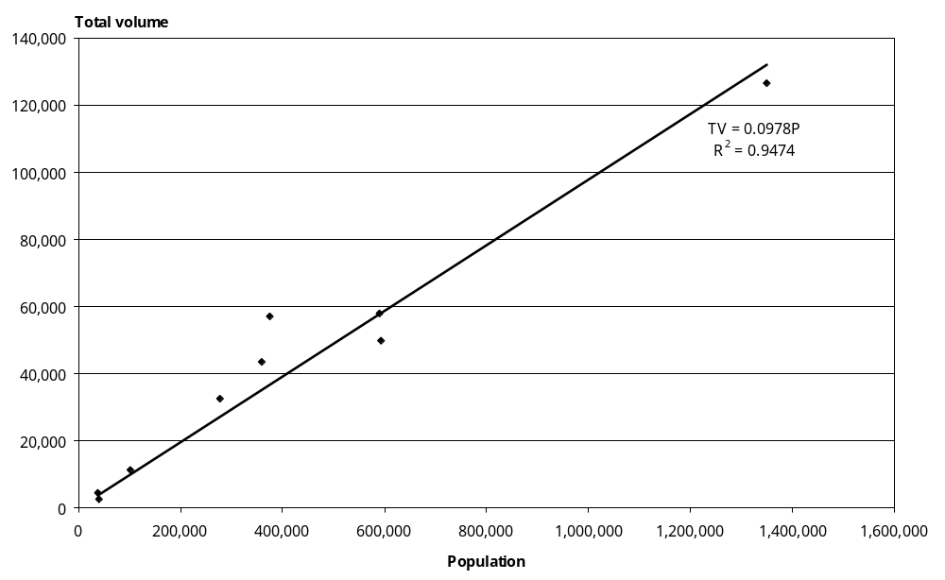

Figure 5.2: Total volume versus population at station level
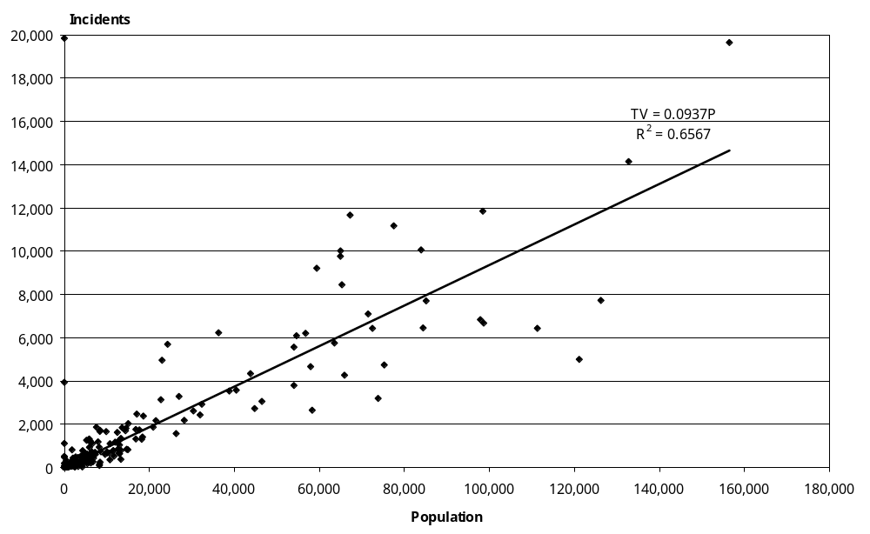

Table 5.4 and Figures 5.3 and 5.4 show the regression results of emergency volume (EV) on population (P) at both provider and station level.

All of these indicate that the national average emergency intervention rate is about 69 incidents per 1000 population, with an upper bound of 72 and a lower bound of 66. However the R²s are consistently higher, 0.87 or 0.89, than those in Table 5.2.

Table 5.4: Regressions of emergency volume on population
Regression description | Variable | Coefficient | t stat | Lower 95% | Upper 95% | R²
Provider constant ≠ 0 | Constant | 900 | 0.73 | -2014 | 3814 | 0.99
Provider constant ≠ 0 | Population | 0.0689 | 31.61 | 0.0637 | 0.0740 | 0.99
Provider constant = 0 | Constant | 0 |  |  |  | 0.87
Provider constant = 0 | Population | 0.0700 | 48.59 | 0.0667 | 0.0733 | 0.87
Station constant ≠ 0 | Constant | 50 | 0.89 | -61 | 161 | 0.90
Station constant ≠ 0 | Population | 0.0683 | 41.69 | 0.0651 | 0.0716 | 0.90
Station constant = 0 | Constant | 0 |  |  |  | 0.89
Station constant = 0 | Population | 0.0691 | 50.10 | 0.0664 | 0.0718 | 0.89

Figure 5.3: Emergency volume versus population at provider level
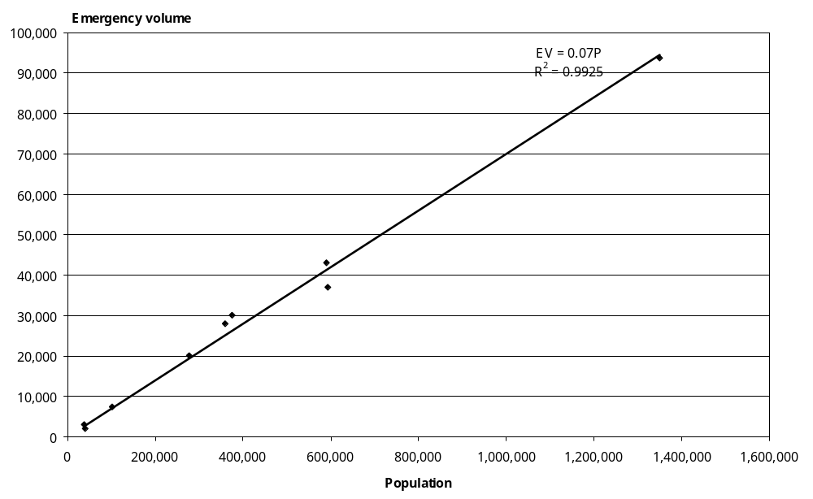

Figure 5.4: Emergency volume versus population at station level
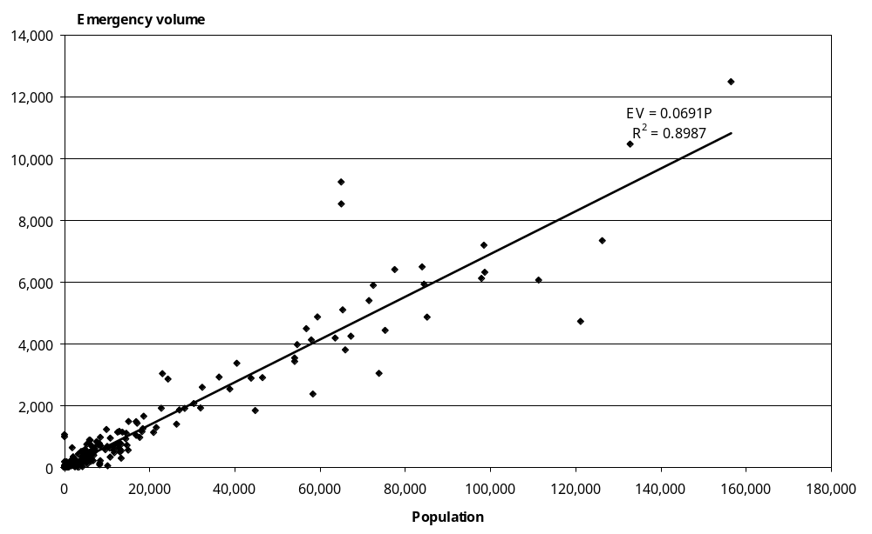

Figure 5.4 further confirms that the demand for emergency ambulance services is consistent between providers, and is directly related to population coverage at a station level. The outliers further away from trend line are the stations in Auckland and are more representative of the difficulty in assigning an appropriate population than of real variance from the trend line. Two stations with volumes between 8000 and 10,000 and about 65,000 population are Mt Wellington and Auckland Central, whereas the station with about 120,000 population and about 4700 volumes is Mt Roskill. This could be called ‘city impact’. Ambulances from these stations will routinely operate within each others’ coverage areas.

To minimise city impact and to demonstrate the relationship more clearly, Figure 5.5 shows only those stations that are not in one of the four main cities or Hamilton.

Figure 5.5: Emergency volume versus population at station level (excluding cities)
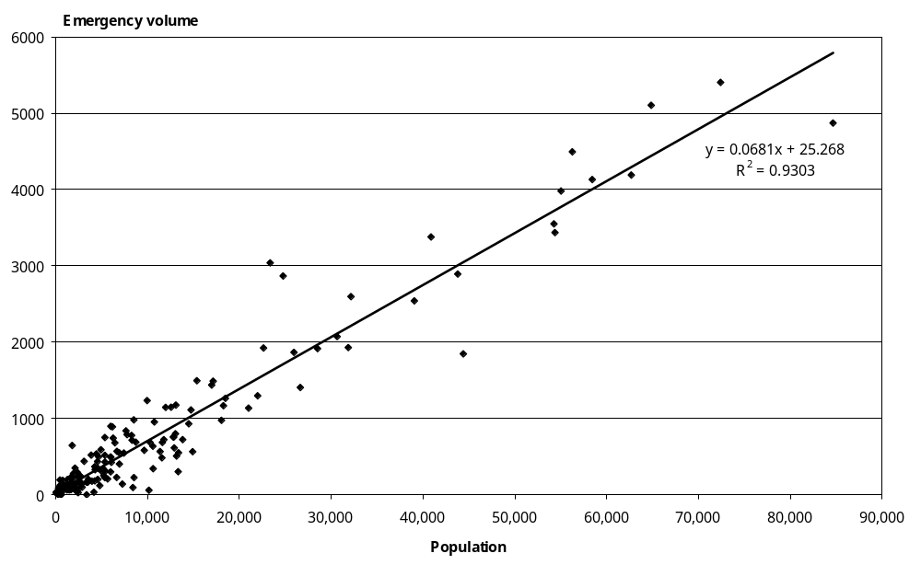

Therefore, the conclusion is that population is the most important determinant of volume for road ambulance services, and this is particularly true of emergency volumes.

5.1.2 Volume drives cost
As predicted by the correlation analysis, costs should be more closely related to volume than to population.

Table 5.5 and Figures 5.6 and 5.7 show the regression results of cost (TC) on total volume at both provider and station level.

Table 5.5: Regressions of cost on total volume
Regression description | Variable | Coefficient | t stat | Lower 95% | Upper 95% | R²
Provider constant ≠ 0 | Constant | -125,591 | -0.12 | -2,561,348 | 2,310,166 | 0.95
Provider constant ≠ 0 | Population | 224 | 12.19 | 181 | 268 | 0.95
Provider constant = 0 | Constant | 0 |  |  |  | 0.83
Provider constant = 0 | Population | 223 | 20.01 | 197 | 248 | 0.83
Station constant ≠ 0 | Constant | 78,306 | 4.65 | 45,080 | 111,533 | 0.89
Station constant ≠ 0 | Population | 179 | 40.26 | 170 | 188 | 0.89
Station constant = 0 | Constant | 0 |  |  |  | 0.87
Station constant = 0 | Population | 190 | 46.91 | 182 | 198 | 0.87

Figure 5.6: Cost versus total volume at provider level
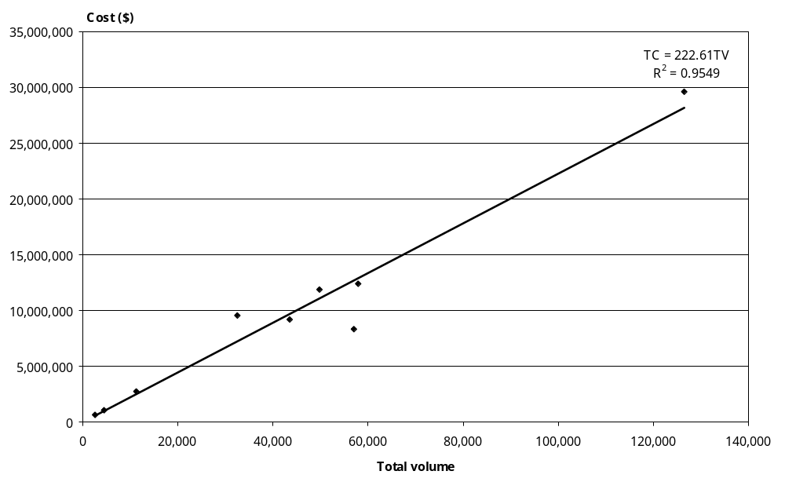

Figure 5.7: Cost versus total volume at station level
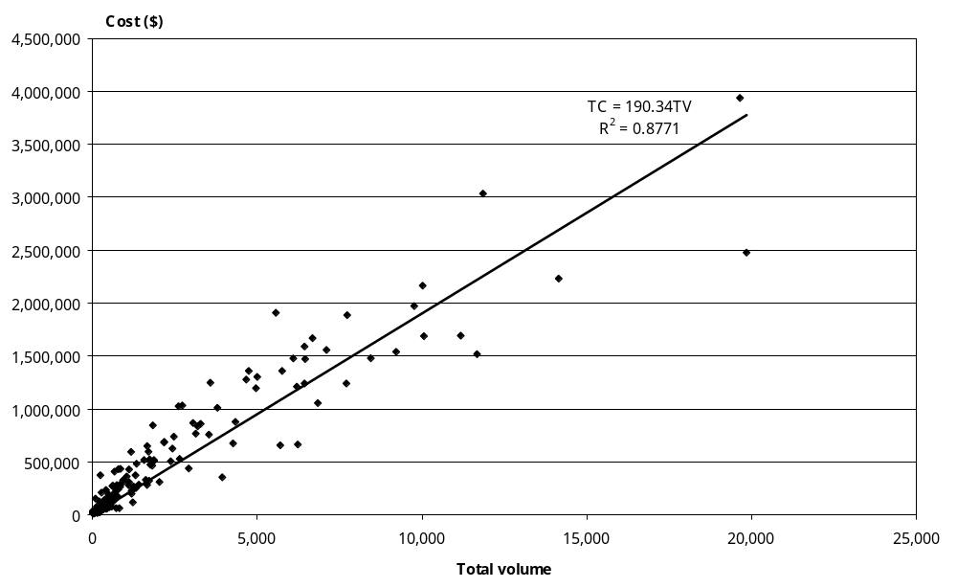

In Table 5.5, all of the R²s are greater than 0.83, which means that the volume data can explain 83 percent of the cost variation. This would strongly support the conclusion that volume drives cost.

5.1.3 Cost versus population
Correlation analysis has shown that cost has a close relationship with population. Table 5.6 shows the regression results of cost (TC) on population (P) at both provider and station level.

At provider level, the R²s are greater than those derived by the regressions of cost on total volume in Table 5.5. But at station level, the R²s are smaller. This implies that a population-based funding formula could be reliable at provider level, rather than at station level.

Table 5.6: Regressions of cost on population
Regression description | Variable | Coefficient | t stat | Lower 95% | Upper 95% | R²
Provider constant ≠ 0 | Constant | 713,982 | 1.06 | -886,232 | 2,314,197 | 0.98
Provider constant ≠ 0 | Population | 21 | 17.72 | 18 | 24 | 0.98
Provider constant = 0 | Constant | 0 |  |  |  | 0.85
Provider constant = 0 | Population | 22 | 26.93 | 20 | 24 | 0.85
Station constant ≠ 0 | Constant | 81,924 | 3.28 | 32,602 | 131,246 | 0.76
Station constant ≠ 0 | Population | 18 | 25.35 | 17 | 20 | 0.76
Station constant = 0 | Constant | 0 |  |  |  | 0.75
Station constant = 0 | Population | 20 | 31.44 | 18 | 21 | 0.75

However, demand factors, such as population or the impact of geography, do not determine all costs incurred by a provider. Before considering a population-based funding model, account must be taken of supply side factors, such as production efficiency, capacity utilisation and management efficiency. Variances in average costs between providers in Table 5.2 should be explored further.

5.2 Cost function
The previous section focuses on why population drives volume and volume drives cost. This section will give a fuller description of cost functions at the national level and the provider level.

Economic theory suggests that the total cost could be split into fixed and variable components as in Equation 1. The fixed cost, the constant, may be set to zero if it is zero and its t-stat is insignificant or if its value is close to zero and its t-stat is significant. Note that, in terms of economic theory, a zero constant does not mean there is no fixed cost, but implies that fixed cost can be spread evenly over volumes.

In Table 5.5, the constants could be assumed to be zero at both the provider and station levels, as cost and volume have a strong linear relationship across all volumes. At the provider level, the national average unit cost is estimated to be $223, which is similar to that in Table 5.2 ($221). But at the station level, the national average unit cost is predicted to be $190.

It would be very useful to be able to explain why there is a $33 cost gap. The gap may imply that the proportion of the stations that have low average costs is higher than the proportion of the providers that have low average costs or that the allocation of costs to stations will be less accurate than total provider costs. Statistically, the average cost at station level is less strongly predicted than that at provider level.

Figure 5.8 illustrates this by plotting station cost against volumes for the six non-governmental organisation road ambulance service providers. Although the trend lines on the provider information have a similar slope for four providers (185.32–203.41), two are quite divergent. The R² on each of the provider’s trend lines are each individually quite significant with OSJN having the least significant trend as a result of having dedicated patient transport services. Table 5.7 provides information on the underlying statistics for Figure 5.8.

Table 5.7: Provider cost functions
Regression description | Variable | Coefficient | t stat | Lower 95% | Upper 95% | R²
OSJC stations constant ≠ 0 | Constant | 121,055 | 3.14 | 38,366 | 203,744 | 0.95
OSJC stations constant ≠ 0 | Population | 165 | 16.09 | 143 | 186 | 0.95
OSJC stations constant = 0 | Constant | 0 |  |  |  | 0.85
OSJC stations constant = 0 | Population | 187 | 20.80 | 168 | 207 | 0.85
OSJM stations constant ≠ 0 | Constant | 82,007 | 2.88 | 23,379 | 140,634 | 0.95
OSJM stations constant ≠ 0 | Population | 172 | 21.38 | 155 | 188 | 0.95
OSJM stations constant = 0 | Constant | 0 |  |  |  | 0.89
OSJM stations constant = 0 | Population | 185 | 25.23 | 170 | 200 | 0.89
OSJN stations constant ≠ 0 | Constant | 248,060 | 4.13 | 126,030 | 370,090 | 0.83
OSJN stations constant ≠ 0 | Population | 158 | 13.48 | 134 | 182 | 0.83
OSJN stations constant = 0 | Constant | 0 |  |  |  | 0.73
OSJN stations constant = 0 | Population | 189 | 17.69 | 168 | 211 | 0.73
OSJNRSI stations constant ≠ 0 | Constant | 179,384 | 2.52 | 24,210 | 334,559 | 0.95
OSJNRSI stations constant ≠ 0 | Population | 187 | 15.29 | 160 | 213 | 0.95
OSJNRSI stations constant = 0 | Constant | 0 |  |  |  | 0.85
OSJNRSI stations constant = 0 | Population | 203 | 16.80 | 177 | 230 | 0.85
OSJS stations constant ≠ 0 | Constant | 154,073 | 1.65 | -66,238 | 374,385 | 0.95
OSJS stations constant ≠ 0 | Population | 254 | 12.66 | 206 | 301 | 0.95
OSJS stations constant = 0 | Constant | 0 |  |  |  | 0.82
OSJS stations constant = 0 | Population | 277 | 17.65 | 241 | 313 | 0.82
WFA stations constant ≠ 0 | Constant | -24,901 | -0.17 | -375,383 | 325,580 | 0.91
WFA stations constant ≠ 0 | Population | 149 | 8.41 | 106 | 192 | 0.91
WFA stations constant = 0 | Constant | 0 |  |  |  | 0.78
WFA stations constant = 0 | Population | 146 | 18.86 | 128 | 165 | 0.78

Figure 5.8: Cost function differences by provider

5.3 Economies of scale: average cost versus volumes
Economies of scale explain that as a business increases its output, it becomes more efficient with a downward-sloping average cost curve. This results from spreading fixed costs over more units of output.

Road ambulance services operate at station level. The economies of scale concept for road ambulance services would anticipate that average cost would decrease with increasing volumes provided the same core services were provided and the same resources were used. Differences arise particularly with the increased use of paid staff in higher service level stations. In general, however, the higher volume a station, the lower the average cost.

Figure 5.9 shows how average costs decrease with increasing volumes at station level. The general trend of average costs appears to be a downward-sloping curve.

Figure 5.9: Economies of scale: average cost versus volume at station level
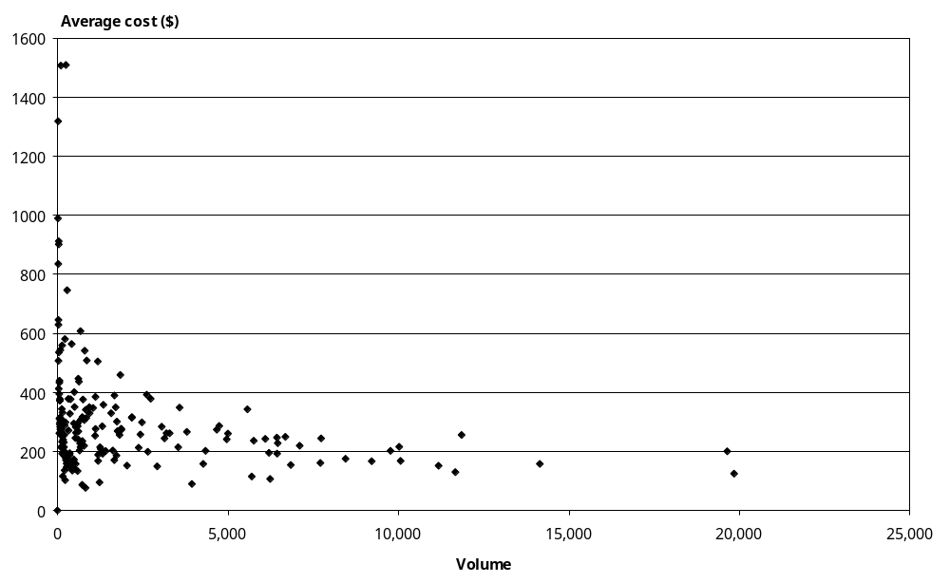

The points at low volumes seem to obscure the identification of economies of scale. This will be addressed in the next section, volunteer input effect.

Therefore, economies of scale have the most important effect on average costs as average cost rapidly reduces with the increasing volumes. The effect of economies of scale also implies that a volume increase to some extent requires a similar proportion of resource increase. In other words, the marginal cost is much smaller than the average cost. This allows providers to absorb some volume increase without increasing overall costs.

Economies of scale expect providers to set up bigger stations, covering greater areas, to deliver more volumes. But volumes, particularly emergency volumes, are determined by population. The location of stations to maximise individual station volumes is an important issue. This asset optimisation exercise is beyond the scope of this funding review and needs to be carried out as part of future work.

5.4 Volunteer input effect
Volunteers are used in most levels of road ambulance service provision. In particular, they are the mainstay of stations that have low utilisation. These stations exist because of the value of timely access to health services in an emergency, even where the demand is low due to sparse population.

Figure 5.10 shows that stations run totally by volunteers have a typical average cost curve. There are 80 stations in this group. The R² for the trend line is 0.83, which provides more evidence to support the conclusion that economies of scale are an important predictor of cost.
Figure 5.10: Average cost versus volume for volunteer-run stations
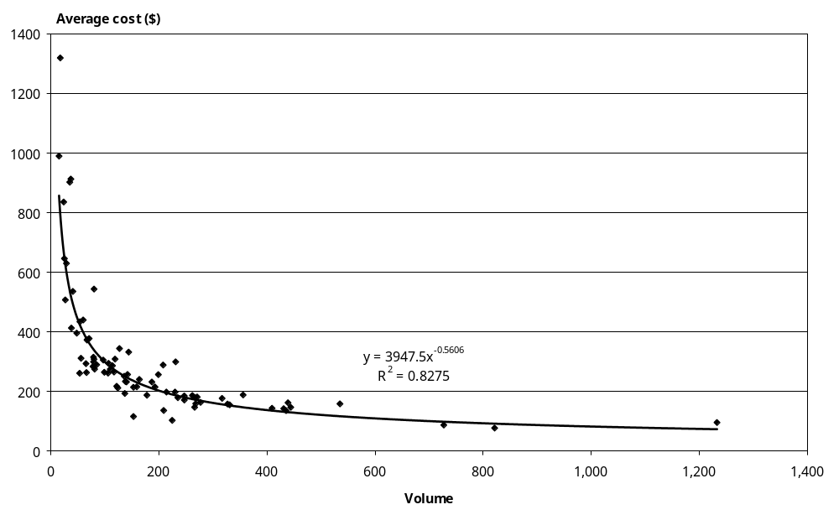

After excluding the volunteer-run-stations group and further excluding two stations, whose average costs are higher than $1500, Figure 5.9 has been re-plotted in Figure 5.11, in which all average costs are under $800.

Figure 5.11: Average cost versus volume with exclusion
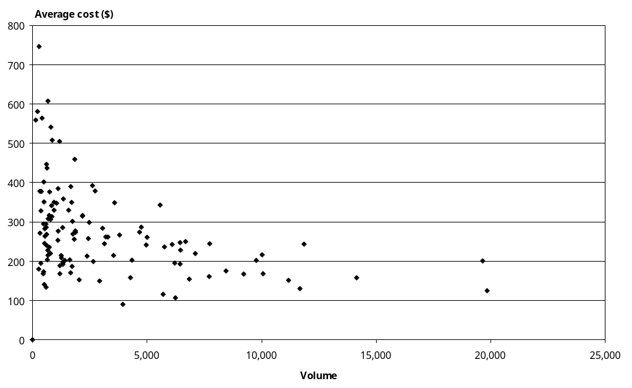

As indicated in Figure 5.8, all of the non-governmental organisation providers have ‘good-fit’ cost functions, but significantly different average costs. That is why the points at lower volumes in Figure 5.11 could not show a typical average cost curve. Note that Figure 5.11 only excluded entirely volunteer-run stations, but did not remove volunteer input impact for those stations which are less than 100 percent reliant on volunteer input. This is another reason why the average costs vary at lower volumes.

The next two sections will explore why average costs vary between providers.

5.5 Average cost versus resource utilisation
This section explains why average costs vary between providers in terms of vehicle utilisation.

Figures 5.12–5.14 give the relationship between average costs and vehicle utilisation rates at the provider level, for volunteer-run stations. For the stations with the same exclusion as Figure 5.11, these are given separately. The vehicle utilisation rate is defined as the number of incidents divided by total vehicles available.

All of these figures show the trend that average cost decreases with more efficient vehicle utilisation. That is, efficient vehicle utilisation drives cost down. In particular, the stations staffed entirely by volunteers exhibit a strong relationship between average cost and vehicle utilisation.

Figure 5.14 does not show as a pronounced a relationship as the other two graphs, probably because several cost drivers are acting to varying degrees.
Figure 5.12: Average cost versus vehicle utilisation rate at provider level
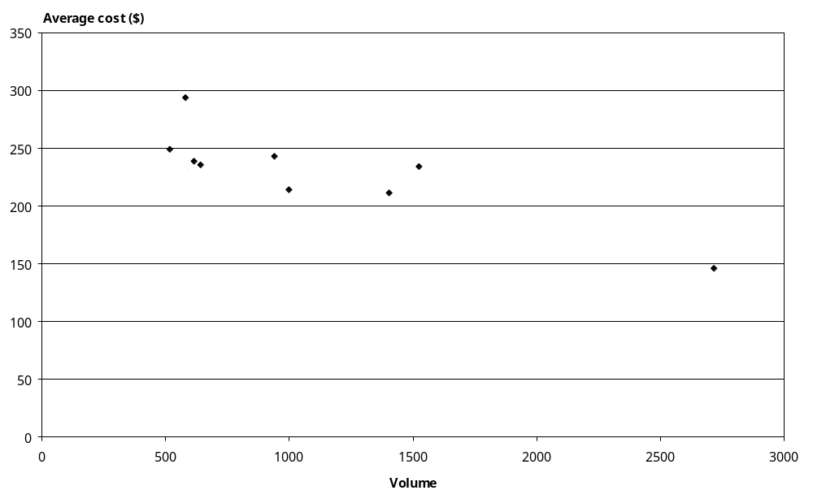

Figure 5.13: Average cost versus vehicle utilisation for volunteer-run stations
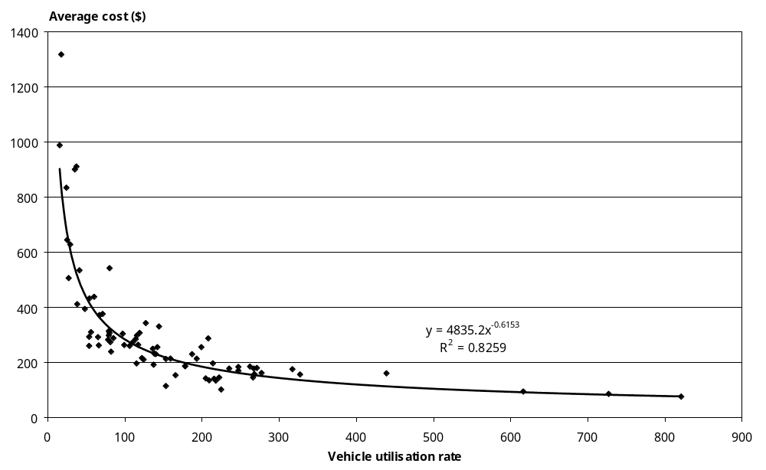

Figure 5.14: Average cost versus vehicle utilisation with exclusion criteria
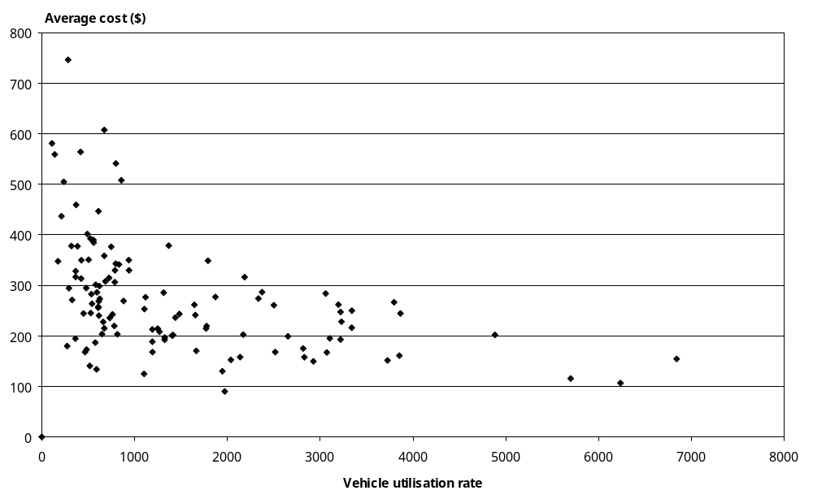

Labour resource utilisation, such as direct staff hour utilisation and the proportion of full crewing must have an impact on average costs. As higher vehicle utilisation rates also partially imply higher staff hour utilisation rates, the application of vehicle utilisation as a cost driver should partially cover the impact from direct staff hour utilisation. The proportion of full crewing could have similar impact but in an opposite direction to direct staff hour utilisation.

5.6 Cost relativity analysis
This section explains why average costs vary between providers in terms of their different mix of categories of activity between which cost relativities can be found.

If there are consistent cost differences between different services, cost relativity analysis or cost weight analysis becomes essential because service volume mix differences would be another cost driver.

In this analysis, overheads are incurred by both the EAS and PTS. It would be unrealistic to assume that either could continue without the corporate support implied in the overheads and inequitable to apply all of these costs to either service.

5.6.1 Rationale
In principle, the funding policy should be based on a set of unit prices for different categories of activity. This requires identifying cost relativities between different categories of activity.

The ‘top-down’ costing approach also requires cost relativity analysis. Cost relativities between services could be used to determine service prices once a robust benchmark price is identified.

The Northern Region of OSJ operates its PTS activity with greater separation from EAS than occurs with other providers to the extent of having separate stations for the services. EAS stations mainly provide emergency services and PTS stations mainly provide patient transfer services. Preliminary investigation of actual costs between EAS stations and PTS stations in OSJN shows that average costs per incident between EAS and PTS stations are significantly different.

Table 5.8: OSJN case study of cost relativities between EAS and PTS stations
Station | Number of incidents | Total cost | Average cost | Cost relativity
EAS Kaitaia | 939 | 309,484 | 330 | 1
EAS Kawakawa | 610 | 272,266 | 446 | 1
EAS Whangarei | 4669 | 1,278,248 | 274 | 1
PTS Kaitaia | 482 | 83,307 | 173 | 0.52
PTS Kawakawa | 517 | 72,680 | 141 | 0.31
PTS Whangarei | 3941 | 355,270 | 90 | 0.33

As shown in Table 5.8, the average costs in the group of EAS stations or in the group of PTS stations are relatively close, but the average costs between these two groups are significantly different. In terms of cost relativities, if the cost weight per EAS volume were set as 1, the average cost per PTS volume for that location would be between 0.3 to 0.5.

Such a result empirically suggests that cost relativities exist between EAS and PTS, and could exist between six categories of volumes.

Following the clue given by the OSJN stations, regression models have been used to identify cost relativities. However as discussed in Section 2.1.3, very highly correlated relationships between explanatory variables could result in multicollinearity problems when they are used in a regression. The following process seeks to identify whether this is an issue and uses an alternative method to effectively conduct cost relativity analysis.

Two samples have been used in the following analysis. One includes all (200) stations and the other includes (44) Level 5 or Level 6 stations (including four PTS only stations; referred to as ‘Level 6_5_PTS stations’).

5.6.2 Multicollinearity
First, Equation 2 is applied to estimate cost relativities between these six categories of volumes. Equation 2 is a variant of Equation 1 in Section 2.1.1. Where the volumes and prices are specific to the six categories of activity.
Equation 2 Total cost = α + α₁V_{PTS} + α₂V_{PH} + α₃V_{ACC} + α₄V_{NPTS} α₅V_{MED} + α₆V_{Other}

Table 5.9 gives a full set of correlation coefficients between these six categories of volumes for the sample of (200) stations; and shows PTS and private hire (PH), and ACC and MED are highly correlated.

Table 5.9: Correlation coefficients for all of stations with Equation 2
 | PTS | Private hire | ACC | Non-PTS | MED
Private hire | 0.93
ACC | 0.39 | 0.32
Non-PTS | 0.07 | 0.04 | 0.15
MED | 0.28 | 0.22 | 0.97 | 0.15
Other | 0.27 | 0.21 | 0.56 | 0.07 | 0.49

As shown in Table 5.10, the R²s for the regressions are very high, over 0.93; but t stats for PTS and MED are insignificant since PTS is highly correlated with private hire and MED is highly correlated with ACC. Based on the commonly used rule of thumb to identify multicollinearity described in Section 2.1.4, these regressions have the typical symptom of a multicollinearity problem. Thus these results could be too imprecise to be applied.

Note that Other is insignificant, not because of multicollinearity, but because of its real insignificance as a cost driver.

Table 5.10: Estimation of cost weights for six categories of volumes
Regression description | Variable | Coefficient | t stat | R²
200 stations constant = 0 | Constant | 0 |  | 0.93
200 stations constant = 0 | PTS | 32 | 1.13 | 0.93
200 stations constant = 0 | Private hire | 271 | 3.71 | 0.93
200 stations constant = 0 | ACC | 759 | 7.58 | 0.93
200 stations constant = 0 | Non-PTS | 554 | 3.26 | 0.93
200 stations constant = 0 | MED | 50 | 1.32 | 0.93
200 stations constant = 0 | Other | 2 | 0.08 | 0.93
200 stations constant ≠ 0 | Constant | 38,226 | 2.92 | 0.94
200 stations constant ≠ 0 | PTS | 32 | 1.13 | 0.94
200 stations constant ≠ 0 | Private hire | 278 | 3.88 | 0.94
200 stations constant ≠ 0 | ACC | 693 | 6.87 | 0.94
200 stations constant ≠ 0 | Non-PTS | 475 | 2.81 | 0.94
200 stations constant ≠ 0 | MED | 66 | 1.74 | 0.94
200 stations constant ≠ 0 | Other | 5 | 0.20 | 0.94

Equation 3 tries to identify cost relativities between ACC and health where health is an aggregation of MED and PTS. V_{Health} is the volume including both MED emergency and PTS volumes. V_{Other3} is the sum of the private hire, non-PTS and other activities.
Equation 3 Total cost = α + α₁V_{ACC} + α₂V_{Health} + α₃V_{Other3}
Table 5.11 shows relatively higher correlations amongst Level 5 and 6 stations, between ACC and health in Equation 3. This is an expected result as MED emergency volume is highly correlated with ACC volume, and MED makes up the higher proportion of this combined health volume. In this and the next few tables, Other3 is the sum of the private hire, non-PTS and other activities.

Table 5.11: Correlation coefficients for Level 6_5_PTS stations with Equation 2
 | ACC | Health
Health | 0.75
Other3 | 0.35 | 0.62

As shown in Table 5.12, the R²s for the regressions are relatively high, over 0.83, but t stat for Other3 variable is insignificant. This implies that the regressions are likely to suffer from a multicollinearity problem. Thus Equation 3 is likely to be invalid in terms of identifying cost relativities between ACC, health and Other3 volume.

Table 5.12: Estimation of cost weights with Equation 3
Regression description | Variable | Coefficient | t stat | R²
Level 5 and 6 and PTS stations constant = 0 | Constant | 0 |  | 0.83
Level 5 and 6 and PTS stations constant = 0 | ACC | 567 | 7.11 | 0.83
Level 5 and 6 and PTS stations constant = 0 | Health | 113 | 3.98 | 0.83
Level 5 and 6 and PTS stations constant = 0 | Other 3 | 67 | 1.50 | 0.83
Level 5 and 6 and PTS stations constant ≠ 0 | Constant | 170,484 | 2.12 | 0.86
Level 5 and 6 and PTS stations constant ≠ 0 | ACC | 501 | 6.08 | 0.86
Level 5 and 6 and PTS stations constant ≠ 0 | Health | 103 | 3.71 | 0.86
Level 5 and 6 and PTS stations constant ≠ 0 | Other3 | 67 | 1.57 | 0.86

Without further bottom-up costing analysis it is not possible to either prove or disprove the robustness of the current levels of funding from the Ministry or ACC.

5.6.3 Sensitivity analysis
As indicated in the last section, multicollinearity problems incurred difficulties in directly identifying the cost relativities between ACC and MED volume with Equation 2, and between ACC and Health volume with Equation 3.

As also suggested in Section 2.1.4, a possible remedy for the multicollinearity problem is to add structure by introducing non-sample information in the form of linear restrictions on the parameters. That is, ACC and MED volume need to be aggregated in the form of a linear relationship before the regression analysis.

This section will show that, as cost relativities are changed between ACC and MED within a reasonable range, the predicted average cost and total cost pool for emergency volumes are always stable with Equation 4 and Equation 5. In other words, we are testing how sensitive the total cost pool is to variance of cost relativities between ACC and MED.
Equation 4 Total cost = α + α₁V_{E} + α₂V_{Other4}
Equation 5 Total cost = α + α₁V_{E} + α₂V_{PTS} + α₃V_{Other3}

In Equation 4 and Equation 5, V_{E} is the combination of ACC and MED volumes. V_{Other4} is the sum of the other four categories of activity.

To do this sensitivity analysis, three options for cost relativity between ACC and MED are chosen: 1:1, 1.5:1 and 2:1. The total emergency volume, V_{E}, is the aggregation of ACC and MED with the weights indicated by each of these three options.

If the results of regressions with the application of these three weighting options in Equation 4 and Equation 5 are statistically significant and consistent, they could be used to determine the cost relativities between the activities of Emergency, PTS and Others.

Table 5.13 shows correlation coefficients for the variables in Equation 4 (Emergency and Other4) are low and thus multicollinearity problems would not occur. In this and the next few tables, Other4 is the sum of the PTS, private hire, non-PTS and Other activities.

Table 5.13: Correlations for the variables in Equation 3
Sample | Variable | Emergency (Option 1) | Emergency (Option 2) | Emergency (Option 3)
Sector | Other4 | 0.42 | 0.44 | 0.44
Level 6_5_PTS | Other4 | 0.07 | 0.09 | 0.11

Table 5.14 shows correlation coefficients between Emergency volume and the other two variables in Equation 5 are relatively low, but the coefficient between PTS and Other3 is a little higher. However multicollinearity problems would be expected to have a limited impact.

Table 5.14: Correlations for the variables in Equation 5
Sample | Variable | Emergency (Option 1) | Emergency (Option 2) | Emergency (Option 3) | PTS
Sector | PTS | 0.31 | 0.32 | 0.33
Sector | Other3 | 0.52 | 0.53 | 0.53 | 0.73
Level 6_5_PTS | PTS | -0.01 | 0.01 | 0.02
Level 6_5_PTS | Other3 | 0.19 | 0.21 | 0.22 | 0.73

The following three tables give each option’s regression results with Equation 4 and Equation 5 and with two sets of samples separately.

Table 5.15: Option 1, ACC:MED = 1:1, regressions with Equations 4 and 5
Variable | Sector stations constant = 0 |  |  | Level 5 and 6 and PTS stations constant = 0
Variable | Coefficient | t stat | R² | Coefficient | t stat | R²
Emergency | 239 | 42.12 | 0.92 | 236 | 24.12 | 0.83
Other4 | 115 | 14.73 | 0.92 | 114 | 8.63 | 0.83
Emergency | 242 | 39.30 | 0.92 | 236 | 21.69 | 0.82
PTS | 130 | 8.04 | 0.92 | 115 | 3.85 | 0.82
Other3 | 88 | 3.33 | 0.92 | 113 | 2.21 | 0.82

Table 5.16: Option 2, ACC:MED = 1.5:1, regressions with Equations 4 and 5
Variable | Sector stations constant = 0 |  |  | Level 5 and 6 and PTS stations constant = 0
Variable | Coefficient | t stat | R² | Coefficient | t stat | R²
Emergency | 316 | 42.79 | 0.92 | 311 | 24.33 | 0.83
Other4 | 110 | 14.29 | 0.92 | 110 | 8.34 | 0.83
Emergency | 319 | 39.98 | 0.92 | 312 | 21.89 | 0.82
PTS | 128 | 8.06 | 0.92 | 114 | 3.87 | 0.82
Other3 | 79 | 3.02 | 0.92 | 102 | 2.01 | 0.82

Table 5.17: Option 3, ACC:MED = 2:1, regressions with Equations 4 and 5
Variable | Sector stations constant = 0 |  |  | Level 5 and 6 and PTS stations constant = 0
Variable | Coefficient | t stat | R² | Coefficient | t stat | R²
Emergency | 375 | 43.24 | 0.92 | 370 | 24.45 | 0.83
Other4 | 107 | 13.93 | 0.92 | 107 | 8.10 | 0.83
Emergency | 381 | 40.46 | 0.92 | 372 | 22.01 | 0.83
PTS | 127 | 8.06 | 0.92 | 114 | 3.87 | 0.83
Other3 | 72 | 2.78 | 0.92 | 94 | 1.86 | 0.83

These three tables show the following significant characteristics.
- All the regressions have high R²s, and almost all the t stats are significant. The exception is the t stat for Other3 in Table 5.17, which is a little less than 1.96 significance threshold.
- Within each equation, the coefficients are consistent between the two data samples.
- Within each data sample, the coefficients are consistent between the two equations.
- The coefficients derived from sector sample are consistently higher than those from Level 6_5_PTS sample, except for the Other3 variable as Level 6_5_PTS stations benefit from economies of scale.
For the coefficients of emergency to be comparable, we transform them into ‘emergency’ variable that is a simple sum of ACC and MED volumes. Table 5.18 shows the equivalent results transformed with different combinations of options and equations.

Table 5.18: Cost relativities estimated with Equations 4 and 5
 | Variable | Sector stations |  |  | Level 5 and 6 and PTS stations
 | Variable | Option 1 | Option 2 | Option 3 | Option 1 | Option 2 | Option 3
Equation 4 | ‘Emergency’ | 239 | 242 | 245 | 236 | 238 | 239
Equation 4 | ACC | 239 | 316 | 375 | 236 | 311 | 370
Equation 4 | MED | 239 | 210 | 188 | 236 | 207 | 185
Equation 4 | Other4 | 115 | 110 | 107 | 114 | 110 | 107
Equation 5 | ‘Emergency’ | 242 | 245 | 248 | 236 | 238 | 240
Equation 5 | ACC | 242 | 319 | 381 | 236 | 312 | 372
Equation 5 | MED | 242 | 213 | 190 | 236 | 208 | 186
Equation 5 | PTS | 130 | 128 | 127 | 115 | 114 | 114
Equation 5 | Other3 | 88 | 79 | 72 | 113 | 102 | 94
Equation 5 | ‘Other4’ | 109 | 103 | 99 | 114 | 109 | 104

Table 5.18 shows a most important characteristic: when an option and/or equation changes, the ‘emergency’ coefficients do not change much. This means that all of the estimations are insensitive to the change of cost relativities between ACC and MED volumes. In other words, the average costs of emergency volumes and total emergency costs are robust.

Another significant result is that the coefficients for PTS are robust.

We can, therefore, conclude that the cost relativities between ‘emergency’ and ‘non-emergency’ (Other4) would be around $245 and $103 respectively and that the cost relativities between ‘emergency’, PTS and Other3 would be around $245, $128, and $79 respectively. Similarly, when assessing city stations, it would be reasonable to apply the cost relativities from the second sample, ‘Level 5 and 6 and PTS stations’ (ie, $238 and $109 for ‘emergency’ and ‘non-emergency’ (Other4) and $238, $114 and $102 for ‘emergency’, PTS and Other3 respectively).

What is lacking for a sector average price schedule is a reasonable estimation of the cost relativities between ACC and MED, possibly using some bottom-up costing information.

In terms of the purpose of this analysis, we can safely conclude that service volume mix is a significant cost driver.

5.7 Case study 1: Level 5 and 6 stations
Figure 5.15 shows the total station costs and total numbers of incidents for stations at service levels 5 and 6. Together with Table 5.22, it is intended as an illustration of the importance of the factors identified in Sections 5.4, 5.5 and 5.6.

These stations form a tight pattern (R² of 0.80) about a line with a slope of 164 and an intercept of 301,978. Lines indicating one standard deviation either side of that ‘best fit’ line are also indicated and stations that fall outside of the range, the ‘outliers’, are named. In Table 5.19, the peculiar features associated with this outlier status are postulated as an illustration of the mix of factors associated with cost for those stations.

Figure 5.15: Examples of outlier stations
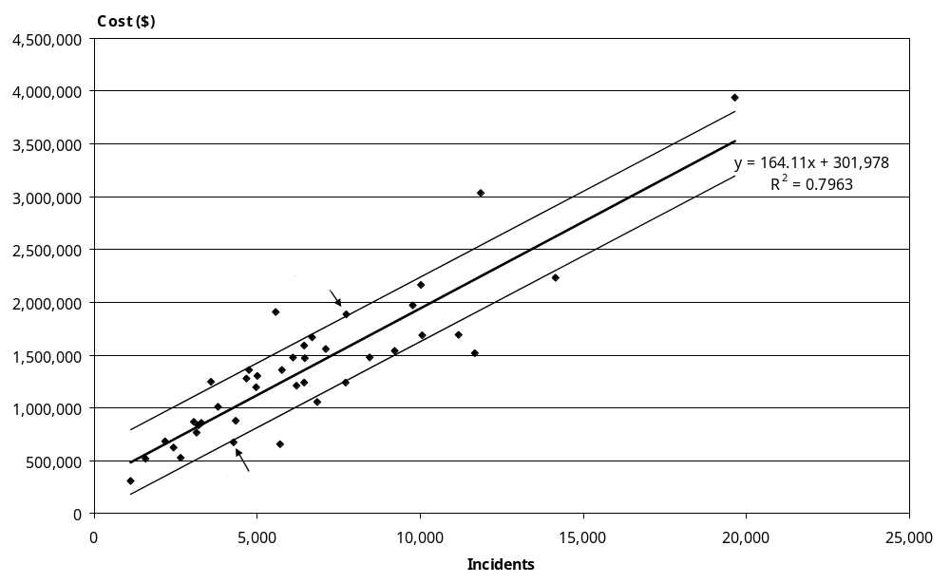

Table 5.19: Outlier stations explained
Station name | High or low outlier | Utilisation (incidents per vehicle) | Volume mix (emergency incidents as % of total) | Volunteer input (total volunteer hours as % of total hours)
Hamilton | Low | 2829 | 74 | 21
Lower Hutt | Low | 3725 | 57 | 18
Newtown | Low | 1945 | 36 | 25
Palmerston North | Low | 3854 | 63 | 19
St Albans | Low | 6841 | 89 | 0
Paraparaumu | Low | 5699 | 50 | 42
Wigram | Low | 2137 | 89 | 50
Christchurch Central | High | 1403 | 64 | 32
Dunedin | High | 1481 | 61 | 13
West Auckland | High | 3865 | 95 | 0
Invercargill | High | 795 | 62 | 11
Silverdale | High | 1790 | 94 | 0

Shown in bold numerals are the factors that have the greatest influence on each station being classed as an outlier. Those factors which would influence the station positively but are insufficient to result in their being within the bounds are shown in italics. (The selection process was whether or not the station was in the top 50 percent of stations for that factor.)

This case study clearly shows that every outlier has its own reason(s) to be described as such.

5.8 Case study 2: Metropolitan stations
As in Section 5.1.1, ‘city impact’ has been suggested as the reason population could not fully explain volume or even emergency volume. In investigating this point, metropolitan stations have been aggregated to assess the impact of the above cost drivers.

Table 5.20 shows which stations were combined within each of these metropolitan areas.

Table 5.20: Metropolitan stations
Auckland | Christchurch | Dunedin | Wellington
AIA  Central  Howick  Manukau  Mt Roskill  Mt Wellington  New Lynn  North Shore  Otara  PTS Auckland  Rosedale  St Heliers  Tamaki  West | Christchurch Central  St Albans  Wigram | Dunedin  Mosgiel | Headquarters Wellington  Lower Hutt  Newtown  Porirua  Upper Hutt  Wainuiomata

Table 5.21 gives the statistics for the combined stations in the four largest metropolitan areas.

Table 5.21: Metropolitan stations’ statistics
City | Population (1000) | Population density (km²) | No. of vehicles | Volume (1000) | Emergency volume (1000) | Total on-duty hours (1000) | Total cost ($ million)
Auckland | 1003 | 900 | 41 | 93 | 69 | 343 | 19.68
Christchurch | 321 | 270 | 17 | 31 | 22 | 131 | 5.67
Dunedin | 116 | 26 | 10 | 14 | 9 | 61 | 3.54
Wellington | 343 | 247 | 18 | 50 | 26 | 139 | 7.36
Subtotal | 1783 | 221 | 86 | 188 | 126 | 674 | 36.25

Figure 5.16 strongly relates emergency volumes to population. Combining each group of city stations into one unit gives an emergency volume per person clustered quite tightly around an average of 69 per 1000 (ranging from 68 to 76 per 1000).

Figure 5.16: Metropolitan: emergency volume versus population
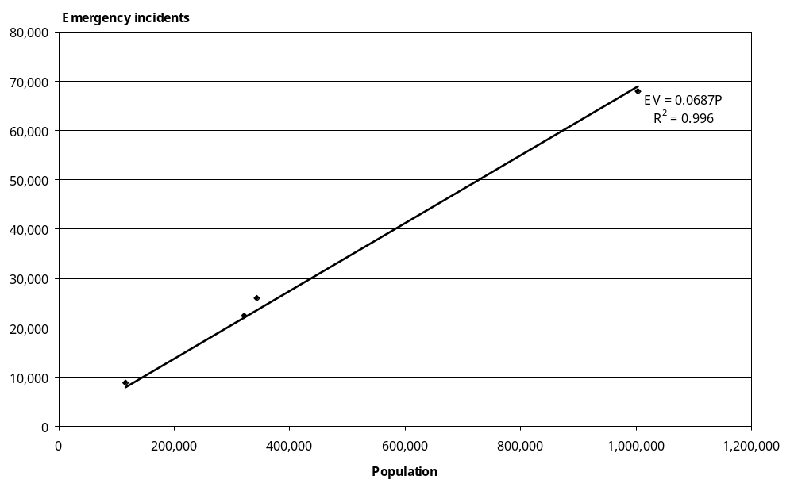

Table 5.22 calculates different indices relating to these metropolitan areas.

Table 5.22: Metropolitan stations’ indices
City | Average cost per capita | Volumes per 1000 population | Emergency volumes per 1000 population | Vehicle utilisation rate | Volumes per on-duty hour | Emergency volume proportion (%)
Auckland | 19.62 | 93 | 69 | 2272 | 0.27 | 74
Christchurch | 17.65 | 96 | 70 | 1809 | 0.24 | 73
Dunedin | 30.57 | 123 | 76 | 1423 | 0.23 | 62
Wellington | 21.45 | 145 | 76 | 2760 | 0.36 | 52
Subtotal | 20.33 | 105 | 71 | 2184 | 0.28 | 67

Table 5.23 projects the average cost to fully compensate volunteer input based on each provider’s recalculated National Certificate hourly rate. This removes the effect of differences in volunteer input.

Table 5.23: Volunteer costs projected
City | Average cost | On-duty volunteer hour proportion | Recalculated National Certificate hourly rate | Volunteer equivalent incremental average cost | Projected average cost | Projected total cost
Auckland | 211 | 0% | 28.91 | 0 | 211 | 19,678,896
Christchurch | 184 | 30% | 31.04 | 39 | 224 | 6,881,077
Dunedin | 249 | 23% | 32.27 | 33 | 281 | 4,004,319
Wellington | 148 | 19% | 24.69 | 13 | 162 | 8,028,213
Subtotal | 193 | 12% | 116.91 | 12 | 206 | 38,592,505

Table 5.24 projects cost-weighted volumes and related indices based on the emergency weights of $247 and the non-emergency weights of $101 (ie, counting non-emergency volumes as equivalent to 101/247 of actual volumes).

Table 5.24: Cost weighted volume projected
City | Total cost weighted volume | Projected average cost per weighted volume | Weighted volume per vehicle | Weighted volume per on-duty hour | On-duty staff hours per vehicle
Auckland | 78,775 | 250 | 1921 | 0.23 | 8368
Christchurch | 25,813 | 267 | 1518 | 0.20 | 7685
Dunedin | 11,046 | 363 | 1105 | 0.18 | 6132
Wellington | 35,641 | 225 | 1980 | 0.26 | 7735
Subtotal | 151,276 | 255 | 1759 | 0.23 | 7841

Figure 5.17 shows the relationship between average cost and vehicle utilisation rate at actual costs.

Figure 5.17: Metropolitan: average cost versus vehicle utilisation
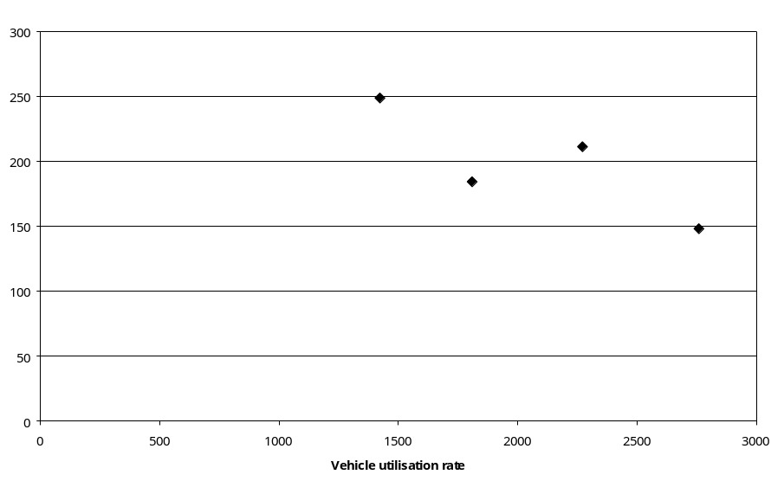
Figure 5.18 shows a much closer relationship between projected average cost per incident and the vehicle utilisation rate. Projected average cost is equal to actual average cost plus ‘paid’ volunteer equivalent incremental average cost; that is, it ensures that all staff time is equivalently recognised.

This explicitly indicates that both volunteer input and vehicle utilisation are important cost drivers.

Figure 5.18: Metropolitan: projected average cost versus vehicle utilisation
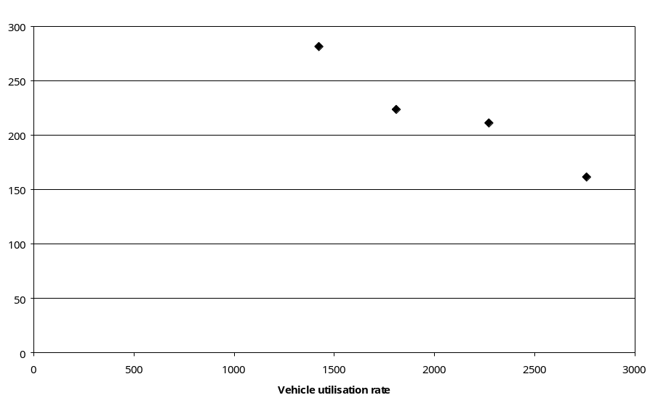

Figure 5.19 indicates the strong relationship between projected average cost per cost-weighted volume and cost-weighted volume per vehicle; that is, the cost-weighted version of the unit cost. Furthermore, Figure 5.19 shows that three factors, volunteer input, vehicle utilisation and volume mix, are significant cost drivers.

Figure 5.19: Metropolitan: projected average cost per cost-weighted volume versus cost-weighted volume per vehicle
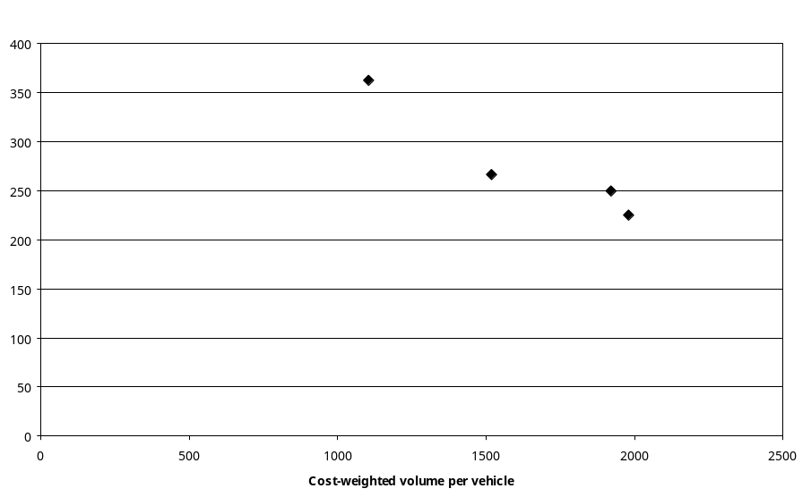
Figure 5.20 indicates the strong relationship between projected average cost per cost-weighted volume and cost-weighted volume per on-duty hour. It also explicitly indicates that three factors, volunteer input, labour resource utilisation and volume mix, are significant cost drivers. Efficient vehicle utilisation would also mean efficient labour resource utilisation, so it is not surprising that Figures 5.19 and 5.20 are similar. Therefore, in general, resource utilisation is a significant cost driver.

Figure 5.20: Metropolitan: projected average cost per cost-weighted volume versus cost-weighted volume per on-duty staff hour
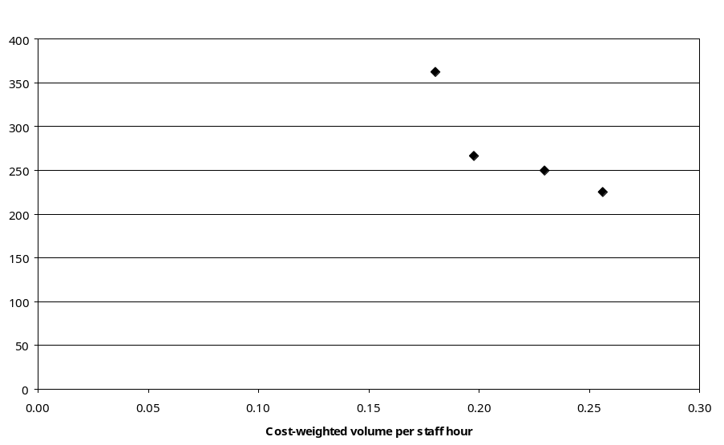

6 Pricing and Funding Analysis
This section integrates the issues of efficiency and significant cost drivers into a pricing and funding analysis framework.

6.1 Efficiency analysis
Efficiency analysis attempts to identify optimal values based on possible interactions between outputs and inputs (production efficiency or technical efficiency), and to identify how efficient a station would be, based on these optimal values. The DEA (Data Envelopment Analysis) model is a commonly used tool to conduct efficiency analysis and also benchmarking analysis.

For this optimisation technique, there are two kinds of basic DEA models: CRS (constant return to scale) and VRS (variable return to scale). It is appropriate to apply the CRS model in an environment in which there is a linear relationship between outputs and their costs. When economies of scale are significant, the VRS model is preferred. As there is strong evidence to show that road ambulance services experience economies of scale, the results derived from VRS models should be more reliable.

In the following efficiency analysis, emergency and non-emergency volumes have been used as two outputs and cost as an input. In Figure 6.1, ratios of output over input have been applied to construct intuitive efficiency frontiers for Level 5 and 6 stations. The ratio of output over input indicates the number of outputs per unit cost.

In Figure 6.1, Newtown, Paraparaumu and St Albans form an efficient frontier. The others will all be less efficient than one or more of these three stations. An efficiency level for a station not on this frontier is derived from the radial distance measure, represented by the relative distance of that station along the ray connecting it to the efficient frontier and the origin. As an example, Hamilton station is less efficient than Paraparaumu and St Albans. Its efficiency score can be calculated by the distance from the origin-to-Hamilton point divided by the distance from the origin to the point on the frontier. In other words, the distance from Hamilton point to the point on the frontier is its inefficient gap and also the target for Hamilton station to improve its efficiency.

However Newtown, Paraparaumu and St Albans could be considered as ‘super-efficient’ as they are far beyond the performance of other stations. It is generally believed that stations exhibiting extraordinary efficiency may not be fairly representing the efficiency frontier but may be reflecting some data anomaly in either the allocation of costs or the attribution of volumes. Note that Wigram is almost as efficient as St Albans. The results from the DEA analysis that follows provides a more quantitative description of ‘super-efficiency’.

Excluding these four super-efficient stations, Porirua, Lower Hutt, Hamilton and Tamaki become the most efficient, and form an inner efficiency frontier as shown in Figure 6.1.

Figure 6.1: Production frontier: emergency volume versus non-emergency volume
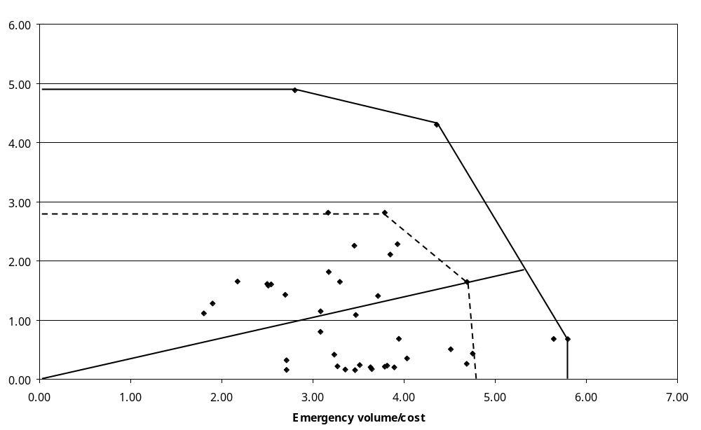

Data envelopment analysis models can realise all of these descriptions quantitatively. Table 6.1 shows the individual efficiency scores and sector efficiency score (structural efficiency) for Level 5 and 6 stations in different models, with or without the exclusion of four ‘super-efficient’ stations.

First, all of the Level 5 and 6 stations are included in the CRS or VRS model. The columns ‘CRS’ and ‘VRS’ in Table 6.1 are efficiency scores for individual stations. The row of ‘Level 5 and 6’ shows structural efficiencies based on different DEA models. For example, the VRS sector efficiency score is 75 percent, which means 25 percent of costs could result from inefficient performance based on comparison with the most efficient peer(s).

Meanwhile, CRS super-efficiency scores are calculated in the column of ‘CRS Super’ to identify the likely efficiency outliers, which are three stations on the outer frontier in Figure 6.1. Their scores reflect the relationships shown in Figure 6.1.

Note that St Albans and Wigram are very close in terms of efficiency scores. Therefore, if Wigram is much more efficient than its peers, St Albans must be similarly efficient. So in the calculation of super-efficiency scores, St Albans has also been classed as an outlier and excluded.

Table 6.1: DEA efficiency scores for Level 5 and 6 stations
Provider | Station | CRS | VRS | CRS Super | CRS EX4 | VRS EX4
NMDHB | Blenheim | 56.04 | 69.96 | 57.20 | 65.38 | 78.66
OSJC | Hastings | 71.70 | 78.12 | 72.29 | 87.18 | 89.23
OSJC | Levin | 52.39 | 53.53 | 52.85 | 63.43 | 71.45
OSJC | Napier | 70.42 | 70.48 | 71.59 | 80.55 | 85.50
OSJC | Palmerston North | 79.69 | 84.53 | 80.51 | 95.48 | 98.65
OSJC | Wanganui | 65.08 | 68.47 | 65.91 | 76.60 | 85.87
OSJM | Hamilton | 88.08 | 100.00 | 89.63 | 100.00 | 100.00
OSJM | Rotorua | 58.34 | 58.63 | 59.32 | 66.61 | 71.30
OSJM | Taupo | 46.60 | 55.99 | 46.86 | 58.75 | 81.82
OSJM | Tauranga | 64.32 | 65.84 | 65.53 | 73.83 | 75.91
OSJN | AIA | 59.69 | 100.00 | 61.32 | 72.81 | 100.00
OSJN | Central | 69.47 | 78.91 | 71.13 | 83.29 | 83.72
OSJN | Howick | 56.37 | 57.34 | 57.92 | 68.76 | 69.58
OSJN | Manukau | 69.54 | 69.64 | 71.44 | 84.82 | 84.83
OSJN | Mt Roskill | 62.63 | 63.46 | 64.35 | 76.40 | 77.08
OSJN | Mt Wellington | 80.84 | 96.35 | 83.06 | 98.61 | 99.69
OSJN | New Lynn | 65.33 | 66.50 | 67.13 | 79.69 | 79.86
OSJN | North Shore | 65.78 | 65.80 | 67.58 | 80.23 | 80.30
OSJN | Otara | 77.83 | 91.94 | 79.96 | 95.03 | 100.00
OSJN | Papakura | 60.58 | 63.36 | 62.24 | 73.89 | 75.66
OSJN | Rosedale | 62.87 | 68.56 | 64.59 | 76.68 | 79.28
OSJN | Silverdale | 46.72 | 49.51 | 48.00 | 56.99 | 58.53
OSJN | St Heliers | 57.85 | 63.96 | 59.44 | 70.57 | 73.19
OSJN | Tamaki | 81.98 | 82.12 | 84.23 | 100.00 | 100.00
OSJN | West | 67.13 | 73.47 | 68.97 | 81.88 | 82.37
OSJN | Whangarei | 56.03 | 57.15 | 57.46 | 68.15 | 69.31
OSJNRSI | Ashburton | 39.65 | 60.36 | 39.96 | 48.42 | 79.94
OSJNRSI | Christchurch Central | 64.17 | 100.00 | 64.84 | 76.73 | 100.00
OSJNRSI | Rangiora EMS | 46.77 | 68.80 | 48.01 | 57.08 | 71.94
OSJNRSI | St Albans | 100.00 | 100.00
OSJNRSI | Wigram | 97.47 | 100.00 | 118.90
OSJS | Dunedin | 51.71 | 59.94 | 52.15 | 62.78 | 63.55
OSJS | Invercargill | 36.99 | 37.16 | 37.33 | 44.67 | 48.27
TDHB | New Plymouth | 53.77 | 53.78 | 54.40 | 63.71 | 67.53
WDHB | Masterton | 51.72 | 61.04 | 52.18 | 62.62 | 84.00
WFA | H/Q Wellington | 77.23 | 86.00 | 78.11 | 91.88 | 93.05
WFA | Lower Hutt | 80.85 | 94.00 | 81.32 | 100.00 | 100.00
WFA | Newtown | 100.00 | 100.00 | 113.52
WFA | Paraparaumu | 100.00 | 100.00 | 119.07
WFA | Porirua | 70.62 | 80.52 | 70.78 | 100.00 | 100.00
 | Level 5 and 6 | 66.84 | 74.63 |  | 77.72 | 82.66

In a DEA model, a super-efficiency score for a unit is derived with the measurement of the extent to which this unit exceeds the efficient frontier formed by other efficient units.

St Albans (Wigram), Newtown, and Paraparaumu are super-efficient. Their super-efficiency scores are 119 percent, 114 percent and 120 percent respectively, which mean that St Albans (Wigram), Newtown, and Paraparaumu are at least 19 percent, 14 percent and 20 percent respectively more efficient than their peer group. Therefore, these four stations are excluded from the inner frontier analysis, increasing the efficiency rating of the remaining stations. Note that, with reference to Figure 5.16 and Table 5.11, all four of these stations are far below the trend line for a variety of reasons as discussed in Section 5.7.

The CRS and VRS models are also run with the exclusion of the four super-efficient outliers identified above. The columns ‘CRS EX4’ and ‘VRS EX4’ show these results. The sector efficiency with the super-efficient outliers excluded is 77.72 percent based on the CRS model and 82.66 percent based on the VRS model.

It is interesting to compare the efficiency scores in Table 6.1 with the outlier explanation in Table 5.22, or to compare the stations on the frontiers in Figure 6.1 and the outlier stations beyond one-standard-deviation lines in Figure 5.16. They show that the DEA results and statistical analysis give a similar message: higher efficiency scores in the DEA imply low average costs in statistical analysis whereas lower efficiency scores imply higher average costs. As the analysis in this section and the evidence in the cost driver analysis show, there are always reasons why a station is at the higher or lower end of the average cost range.

This DEA efficiency analysis is preliminary. Through the process, the efficiency scores can quantify how efficient a station is in terms of its input-output combination (technical efficiency) and its efficient peer(s) and efficiency targets can be identified. However, DEA efficiency analysis cannot directly identify which factors could drive efficiency significantly, and whether a factor is under or beyond the control of management. In terms of the identification of significant efficiency drivers (ie, environmental factors), the analysis would be similar to the cost driver analysis. The inefficient components as measured by efficiency scores can be regressed on possible environmental factors to test whether they are significant. But for practical purposes, only the environmental factors that can be controlled by management would result in ‘true’ inefficiency.

To sum up, only by incorporating significant impacts of efficiency drivers and/or cost drivers into the analysis may true efficiency components be identified. That is, an efficient funding price or efficient funding pool cannot be based on any of the sector efficiency scores in this section. But this efficiency analysis could be expected to be useful and to play a further role in the future study on the issues, such as benchmarking and diseconomies of scale.

6.2 Funding analysis
The analysis in Section 5.6 identified that the cost relativities between ‘emergency’ and ‘non-emergency’ (Other4) would be around $247 and $101, and that the cost relativities between ‘emergency’, PTS and Other3 would be around $247, $127, and $75.

These cost relativities could be applied to the following pricing and funding analysis.

Table 6.2: Estimation of national average costs
 | Emergency | Non-emergency | Total
Volume | 264,586 | 121,001 | 385,587
Cost weight | 247 | 101
Total cost weight |  |  | 77,588,618
Total actual cost |  |  | 85,216,414
Scaling factor |  |  | 1.10
Average cost | 272 | 111

In Table 6.2, the estimated total cost is equal to the sum of actual volumes multiplied by the relevant unit cost weights. The scaling factor is equal to total actual cost divided by the estimated total cost. The scaling factor is then applied to unit cost weights to get average costs for emergency and non-emergency volumes.

This process means that, if actual total costs were to be fully compensated, the average costs for emergency and non-emergency volumes would be $272 and $111 respectively. These average costs could be set as average prices at the break-even point at the national level.

Table 6.3: Emergency funding analysis
Provider | Total cost weights | Actual total cost | Scaling factor | Average cost | Emergency funding required | Actual emergency revenue | Variance
NMDHB | 563,266 | 643,673 | 1.14 | $282 | 584,190 | 684,695 | 100,505
OSJC | 8,482,024 | 9,191,198 | 1.08 | $268 | 7,498,422 | 8,210,390 | 711,968
OSJM | 12,143,898 | 12,391,118 | 1.02 | $252 | 10,867,522 | 11,443,193 | 575,671
OSJN | 26,465,412 | 29,597,994 | 1.12 | $276 | 25,907,820 | 25,879,474 | -28,346
OSJNRSI | 10,436,419 | 11,878,532 | 1.14 | $281 | 10,415,408 | 11,164,003 | 748,595
OSJS | 6,220,583 | 9,394,364 | 1.51 | $373 | 7,511,694 | 8,404,931 | 893,237
TDHB | 2,223,692 | 2,739,457 | 1.23 | $305 | 2,261,806 | 2,173,399 | -88,408
WDHB | 900,504 | 1,056,908 | 1.17 | $290 | 888,401 | 806,585 | -81,816
WFA | 10,152,822 | 8,323,170 | 0.82 | $203 | 6,099,869 | 6,346,241 | 246,372
Sector | 77,588,618 | 85,216,414 | 1.10 | $272 | 72,035,134 | 75,112,911 | 3,077,776

Table 6.3 repeats the process indicated in Table 6.2 but with the aim of fully compensating individual providers. The table shows the comparison between the emergency funding required to fully cover each provider’s costs and the actual emergency revenue received. Actual emergency revenues include three components: ACC funding, Ministry the EAS funding and part charges. Note that OSJC and TDHB revenues include PTS funding, but this does not affect the final conclusion. The variance column is, effectively, the funding that would move from an emergency purchase line to one for non-emergency volumes, should costs fall where the volumes lie. With respect to OSJC and TDHB, the variance indicated would be significantly smaller or negative if the actual non-emergency revenue was separated from the actual emergency revenue.

The drivers of efficiency are not considered in this process, but are likely to relate to utilisation of resources, levels of full crewing, and input from volunteers (effectively the rural/urban mix). This process does indicate that the sector and most of the providers are relatively over-funded for emergency services and under-funded for non-emergency services. That is, the historical funding levels do not match current service provision from a cost allocation perspective or there is a funding cross-subsidisation.

This costing analysis sets a lower cost for non-emergency services than emergency services, most probably as a result of higher utilisation and lower staffing requirements. This lower cost is greater than the current price for those services. No evidence has been found that the current pricing philosophy is particularly scientific, but it seems to relate to a view that emergency services should meet the cost of providing the base capacity. In this analysis, however, non-emergency services appear more than simply a marginal activity.

6.3 Volunteer replacement impact
Two scenarios were used to estimate the cost of replacing volunteers with paid staff.
- Volunteer hours would be costed directly, based on the total cost of providing paid staff hours at each qualification level with a proxy cost for volunteer hours on the lowest qualification level (say 75 percent of National Certificate rates).
- Volunteers on the lowest qualification level would be retrained to National Certificate level and there would be additional training costs at this level on an ongoing basis.

Based on the first scenario, the cost of replacing volunteers is about $21.8 million whereas the second scenario gives a larger first year cost because of the training input ($86.0 million), and an ongoing annual cost of $32.6 million. In reality, of course, any move to modify the workforce would not be possible over a short timeframe as finding and training staff would be a more significant task.

Figure 6.2: Impact of replacing volunteers with paid staff

Figure 6.2 indicates the effect on unit costs for the 80 stations with only volunteer input when their staff hours are re-costed based on the first scenario. Unit costs per incident increase at least three-fold in this calculation, even when all hours for these stations are at the lower on-call rate. Note that the ACC contract rates per flying hour for helicopters in 2002/03 were $2245 for single-engine and $3002 for twin-engine craft. This implies that only the least utilised, currently volunteer-only, road ambulance stations would be uncompetitive, in terms of cost, compared with air ambulances following replacement of volunteers with paid staff.

6.4 Costing of full crew requirement
The Standards document implies that the full crew requirement applies equally to patient transport vehicles, first response units and emergency ambulances. The joint Ministry/ACC service specification relates only to emergency vehicles and applies discretion with respect to level one services (which are entirely staffed by volunteers). DHB requirements with respect to patient transport vehicles vary but, from a limited sample, tend to expect the ambulance service to provide only vehicle and driver. There is, therefore, some lack of clarity about what ‘full crewing’ means.

Available data and sector understanding provide varying insights into the current level of full crewing of road ambulances. It is difficult, however to achieve a thorough understanding of the issue from any of these insights as the views they give sometimes conflict.

The range of information covers available staff hours (on-duty and on-call), rostered vehicle hours, numbers of emergency incidents to which a full crew responded, the understanding that volunteer crews will not respond without a full crew and that provider dispatch systems are not used to track staff on vehicles (and therefore under-report full crew attendances).

It is assumed for the purposes of analysis that rostered vehicle hours given to the review include hours for which staff are on-call. In four stations in the Central Region, however, job cycle times exceed rostered hours. This region generally shows job cycle times as a higher percentage of rostered hours than metropolitan areas, implying a lack of consistency in collection of this information.

Travel time is not captured directly but is a calculated variable based on job cycle times and so is of less use in assessing rostered hours than job cycle times.

Reported crewing of responses to emergency incidents is not consistent with other data. Total incident numbers in these columns rarely matched accident and medical emergencies.

The expectation was that dispatchers would preferentially utilise full crews, leaving single crewed vehicles as support. Calculated levels of full crewing based on available staff hours and rostered hours would therefore be a minimum level that would be exceeded by sensible dispatching. This was not consistently borne out by the data. The impression given by the data is that dispatch systems are not capturing some crew members. This is consistent with the reviewers’ understanding that volunteers tend to be organised at a rather more local level than is covered by the control centre. Reviewers understand that local arrangements tend to ensure full crews on volunteer-only vehicles. This implies that volunteer-only stations and those with nights and weekends covered by volunteer-only vehicles would have a high level of full crewing already.

Table 6.4 presents the results of calculations of full crew requirements based on a range of assumptions. All options assume the additional staff required should be costed at the National Certificate rate indicated through the manipulation process described in Section 4.5.2 ($27.92 per hour inclusive of all personnel costs).

The main assumption in the first set of options, ‘Calculated from vehicle rostered hours and actual staff hours’, is that maximum staff hours for full crewing may be derived from vehicle rostered hours on the basis of the full crew definition in Table 6.4.

The second set of options adds the assumption that volunteer-only stations should be regarded as full crewed. It takes the results of the first set and adds a condition that if a station appears to be staffed entirely by volunteers as indicated by either staff hours or volunteer cost as a proportion of total costs, then no additional staff are added into the costings.

The third set of options extends the assumption relating to volunteer-only stations to those where up to half of the staff hours are provided by volunteers on the basis that similar questions of data reliability may be raised on such stations.

The last set of options requires no information about the definition of full crew as it assumes that:
- stations with all paid crews will have reliable information on full crew attendances
- fully volunteer stations will be full crewed
- for all other stations, the minimum of either the directly reported full crew rate of attendances, or the apparent rate from the calculations in the first set of options, should apply on the basis that careful management may produce a better full crew attendance rate than would simple staff hour information.

Even the lowest of these costings may exceed the true cost as it accounts for preferential dispatching of full crews only in a minority of stations.

Table 6.4: Full crew costings
Full crew % | Full crew definition (no. of crew) |  |  | Additional cost ($ million)
Full crew % | EAS | FRU | PTS | Additional cost ($ million)
Calculated from vehicle rostered hours and actual staff hours | 2 | 2 | 2 | 17.5
 | 2 | 1 | 2 | 16.4
 | 2 | 1 | 1 | 16.4
As above except assume no additional staff needed for volunteer-only stations | 2 | 2 | 2 | 16.7
 | 2 | 1 | 2 | 15.2
 | 2 | 1 | 1 | 14.1
As above except assume no additional staff needed stations with 50% or more volunteer staff hours | 2 | 2 | 2 | 14.1
 | 2 | 1 | 2 | 12.7
 | 2 | 1 | 1 | 11.6
Take into account claimed full crew rates where these represent higher full crew levels as improvements over calculated levels may show management effectiveness (the full crew definition makes no difference in this costing) |  |  |  | 4.8

7 Summary
In this technical report, the costing analysis applies a ‘top-down’ approach while using a ‘bottom-up’ data collection process. An average cost pricing approach has been applied so that all providers maintain their financial position.

Regression models have been used as an effective tool to build up quantitative relationships between population, volume, cost and cost drivers. All regression analyses show significant relationships, at both provider and station level, between costs, population and incidents.

Most of the data used in this analysis is cross-sectional at a station level for 2002/03, the major exception being provider’s annual reports for which there was five years of data. The one-year data period could have restricted some conclusions if variances in costs or volumes between years were highly volatile. However, the evidence shows this not to be so, as cost structures shown by the annual reports are stable over a number of years, and volumes, particularly emergency volumes, match population consistently at station level. That indicates there is a strong relationship between population growth and cost growth.

Providers have co-operated fully to provide and consolidate information. As this was a task that had not been undertaken previously, the effort put into data reconciliation has been significant, and variables have been carefully selected to ensure the data is of acceptable quality.

Based on the quality, breadth and depth of the data, the analysis contained in this report is sound and is well supported by appropriate methodologies. The following findings of the Ambulance Sustainable Funding Review are outlined below.

7.1 Financial situation
This section outlines the financial performance at both organisational and road ambulance service level. Over the five-year period for which annual reports were collected, road ambulance providers appear to have been financially sustainable. Evidence for this finding includes the following.
- Over the five-year period, the service delivery model for ambulances in New Zealand has not changed significantly.
- In 2002/03 financial year, non-governmental organisation providers had an overall surplus on their overall operations of $6.7 million with individual deficits being insignificant. The revenue on their overall operations was $123.7 million.
- This overall surplus status had continued for five years since the 1998/99 financial year.
- For non-governmental organisation providers, overall, revenue from operations increased at slightly higher growth rates than those of the related expenses; and the other incomes (interest and donations, etc) were stable at about $6 million per year.
- With respect to the financial performance of road ambulance services in 2002/03 financial year collected as part of the Sustainable Funding Review, the nine providers collectively were almost breaking even on a service-related revenue of $87.8 million.
- Public funding (Vote: Health and ACC) was the predominant component, 85 percent, of the total road ambulance income, whereas donations were only 0.34 percent of the total road ambulance income. The remainder came from part-charges for those with use relating to medical emergencies (8.9 percent), private hire (1.1 percent) and other activity such as assistance at events (4.5 percent).

7.2 Fundamental analysis
This section describes the road ambulance service and the environment within which it operates. This analysis supports the following cost driver analysis and pricing and funding analysis. The main features of this section include the following points.
- There are 211 service stations across the country. The 40 stations at Level 5 and 6 (19 percent of total stations comprising the majority of the city and larger town stations) delivered 72 percent of emergency road ambulance services.
- The most reliable measures of ambulance activity, based on the current data available, are incidents or dispatches. The analysis in this review uses Number of Incidents as the measurement of volume.
- In terms of emergency volume structure, there is a ratio of 2.3:1 between non-accident or medical emergency incidents and accidents.
- Ambulance vehicle utilisation rates varied substantially between providers from those delivering 641 incidents per vehicle per year to others delivering 2716 incidents per vehicle per year. This is significant when considering the issue of capacity utilisation or production efficiency.
- Cost structures are stable through the five years of annual reports. For non-governmental organisation providers, total staff costs (direct and indirect) are about 62 percent of the cost pool according to their annual reports. For road ambulance services, direct staff costs are about 53 percent of the total cost as shown in the data reported to the review. The 9 percent difference could be considered as an indirect staff cost component. However it seems a little higher than expected (ie, around 5 percent), and could imply an over-allocation of costs to road ambulance services.
- On-duty staff paid rate is estimated at $30 per hour from the data reported. However, actual advanced paramedic rates are about $23 per hour. The difference of more than $7 could also relate to an over-allocation of costs to road ambulance services.
- The definitions of geographic area to which response time targets relate need to be made more precise to ensure consistent monitoring can occur.
- From a sample of the response time information presented it appears providers are not meeting their targets by about 2 percent. This applies to both their 80 percent of responses targets (targets being 80 percent of responses made within 10, 16 and 30 minutes respectively for the urban, rural and remote rural areas) and their 95 percent targets (20, 30 and 60 minutes respectively for the urban, rural and remote rural areas).
- Establishment of correlations between response times and resources will require additional information.
- Further work on objective descriptions of station service levels is needed before an indicator of quality relating to qualifications can be produced.
- The information collected on full crew levels was inconsistent and should not be used to assess current performance.

7.3 Cost driver analysis
This section presents a step-by-step analysis of the cost drivers facing the road ambulance sector. Simple regression analysis shows that volume data can explain 89 percent of total costs. Therefore only 11 percent of cost variance is explained by factors other than volume. Significant variances in average costs exist between providers. The factors driving these variances at a station level include economies of scale, volunteer input, resource utilisation, and volume mix. Finally, two case studies are presented to support these findings. The more detailed findings include the following.
- There is a strong correlation between the domicile population of stations’ coverage areas and emergency incidents attended by those stations (R² of around 90 percent) but a far weaker correlation with total incidents (R² of around 65 percent). This implies that the demands for emergency and non-emergency services were driven by quite different factors. Analysis shows that the cost relativity between emergency and non-emergency services is significant. The average cost per emergency volume is about double the average cost per non-emergency volume, based on the volume structure for the period relevant to the review.
- There is a strong relationship between total volume and cost (R² of around 89 percent) but a weaker relationship between station domicile population and cost (R² of around 75 percent).
- The cost-to-volume relationship is specific to individual providers. Hence, there is no recommendation for a national price schedule, but prices would need to be specific to providers until further work explains the provider differential.
- There is an ‘economies-of-scale’ effect that average costs are decreasing with increasing volumes.
- Average costs of responding to incidents decrease with increasing vehicle utilisation.
- Cost relativities also suggest that average costs vary according to the mix of different category volumes.
- So, total volume drives total costs; and resource utilisation, volume mix and level of volunteer input are the major identified cost drivers.

7.4 Pricing and funding analysis
This section integrates issues of efficiency and identifies cost drivers in a pricing and funding analysis framework. The following conclusions or suggestions are preliminary results and could be extended with further research.
- Production efficiency analysis shows that, overall, stations at Level 5 and 6 are 83 percent efficient. This analysis also supports the findings in the cost driver analysis relating to the identification of efficient stations. The extent to which these efficiencies are achievable, however, requires further analysis as inefficiency may relate to inappropriate positioning of stations, the trade-off between utilisation and response times, and so on, and such factors require in-depth analysis at a local level to be clarified.
- Cost weights have been applied to calculate average costs for emergency and non-emergency volumes on the basis of a break-even assumption at provider level. The national average emergency services price per incident of $272 ranges, at a provider level, from $203 to $373.
- The national average non-emergency services price per incident is $111. The application of these prices suggests that emergency funding cross-subsidises non-emergency services. This finding implies the funding structure should be reviewed.
- Understanding the relative input from each of the emergency service funders is important. A dedicated bottom-up study of the relative funding from ACC and the Ministry would be necessary to achieving this understanding.
- A useful piece of future work would be to independently review the service level categorisation of stations and assess whether robust prices could be devised for emergency responses at each level and what discount factors would apply for differing levels of volunteerism, and so on.
- The ambulance sector is dependent on volunteers to provide continuity of service, particularly in the more remote parts of the country. The value of the volunteer contribution is estimated at over $30 million annually. Note that such calculations are sensitive to estimates of hourly staff rates and also that all but about $2.5 million of this impact falls outside the main cities.
- Maintaining qualified staff is challenging in remote areas.
- Robust analysis costing a requirement for full crew in ambulances requires data of better quality than currently available. This analysis should occur with the evolution of the Standards.

Appendices
Appendix 1: Data collection format

Station information
2002/03 financial year |  |  |  |  |  |  |  | Direct, on-duty staff available hours |  |  |  |  | Direct, on-call staff available hours
Station name (for control room or PRIME) | Street address | Town | Predominantly urban, rural or remote | Service level | Emergency department most commonly used | Distance to emergency department | Travel time to emergency department | Paid |  |  | Volunteer |  | Paid |  |  | Volunteer |  | Vehicle rostered hours |  |  | Vehicles available |  |  | Rent area
 |  |  |  |  |  |  |  | National Certificate | National Certificate IV | Advanced paramedic | PHEC | National Certificate | National Certificate | National Certificate IV | Advanced paramedic | PHEC | National Certificate | EAS | FRU | PTS | EAS | FRU | PTS | Rent area
PRIME
Control room

Volumes
2002/03 financial year | Workload: travel time (hours) |  |  |  |  |  | Workload: service time (job cycle time) (hours) |  |  |  |  |  | Workload: no. of incidents |  |  |  |  |  | Workload: no. of dispatches |  |  |  |  |  | Workload: no. of patients |  |  |  |  |  | Dispatch crewing levels (accident or medical only)
Station name | 100–199 hospital authorised | 200–299 private hire | 400–599 accident | 600–699  non-hospital authorised | 700–799 medical | 800–899 other | 100–199 hospital authorised | 200–299 private hire | 400–599 accident | 600–699  non-hospital authorised | 700–799 medical | 800–899 other | 100–199 hospital authorised | 200–299 private hire | 400–599 accident | 600–699  non-hospital authorised | 700–799 medical | 800–899 other | 100–199 hospital authorised | 200–299 private hire | 400–599 accident | 600–699  non-hospital authorised | 700–799 medical | 800–899 other | 100–199 hospital authorised | 200–299 private hire | 400–599 accident | 600–699  non-hospital authorised | 700–799 medical | 800–899 other | Single | Full

Cost
2002/03 financial year | Personnel costs for paid, direct, on-duty staff |  |  | Personnel costs for paid, direct, on-call staff |  |  | Volunteer cost | Clinical cost | Ambulance vehicle cost |  | Station rent | Finance cost |  | Training cost | Administration overheads
Station name (or control room or PRIME) | National Certificate | National Certificate IV | Advanced paramedic | National Certificate | National Certificate IV | Advanced paramedic | Volunteer cost | Clinical cost | Fixed | Running | Station rent | Depreciation/ interest/ loans | Other lease/ rent | Training cost | Administration overheads
PRIME
Control room
Total

GIS
Station name | Distance to medical centre | Census area unit ID | Census area unit | Territorial authority | Population | Area | NZDep | NZDep decile
 |  | 500100 | Awanui | FAR NOR | 405 | 99 | 1117 | 10

Quality
2002/03 financial year | Priority One: Response times – % within time bracket |  |  |  |  |  | Of the no. of incidents reported in volumes section, no. of incidents attended by an advanced paramedic
Station name | Urban |  | Rural |  | Remote |  | 100–199  hospital authorised | 200–299  private hire | 400–599  accident | 600–699  non-hospital authorised | 700–799  medical | 800–899  other
Station name | <10 mins | <20 mins | <10 mins | <30 mins | <30 mins | <60 mins

Training
Qualification | No. qualified as at 30 June 2003 | No. attaining qualification in 2002/03 | Training cost
Pre-hospital emergency care
National Certificate
Paramedic – National Certificate with IV and cardiac
Advanced paramedic – Paramedic Diploma

Appendix 2: Data format notes

Station information
Variable | Comment
Station name | Name of ambulance station. Note that, with respect to station information and cost tabs, this column also includes PRIME and control room, where relevant information for those activities is to be aggregated in the appropriate columns.
Street address | Street number, street name and suburb (only for stations) as this information will also be used by Land Information New Zealand for another task.
Town | Town or city name (only for stations).
Predominantly urban, rural or remote | Whether the population in the area normally covered by the station is regarded as urban, rural or remote for monitoring purposes. Using the definition of urban as >15,000, rural <15,000 and rural remote as reported to the Ministry in current reporting data.
Service level | Categorisation of stations as described in Appendix 2 of the service specifications (see copy appended to this document)
Emergency department most commonly used | Name of the hospital or medical centre to which emergency cases would most commonly be delivered by that ambulance station.
Distance to emergency department | Shortest road distance between station and ED/medical facility named above. This is used to measure remoteness in the rural sector.
Travel time to emergency department | Estimated travel time for priority one job occurring at the station at midday to get to.  Emergency department/medical facility named above. This is used for measuring remoteness, not demand.
Available hours – direct staff (ambulance operational staff including line managers involved in ambulance service delivery and clinical care) | Number of hours that staff in various categories are available to respond to an emergency call-out. Where a staff member has both a direct ambulance officer role and a separate function (eg, district manager), an estimate of the direct hours is expected. PRIME practitioner time should be included under on-call hours, but with the number of PRIME sites specified. Communication centre call-takers and dispatchers should be included as, presumably, paid, direct, on-call staff with any qualification peculiar to them added as a separate column.  The primary categories are paid and volunteer and within those categories providers are asked to respond with a breakdown at the qualification level. A version of the qualifications is shown on the template, but providers should vary this as is appropriate for their organisation.
Vehicle rostered hours | Numbers of rostered hours for ambulance vehicles, separated into EAS vehicles, first response units and PTS vehicles. When a vehicle is used for both EAS and PTS, the rostered hours should be attributed to the service of predominant use with actual job cycle hours for the other service subtracted from that total and attributed to the other service.
Vehicles available | Numbers of operational ambulances, crewed and available for response, separated into EAS (number of vehicles expected to be available for emergency response at peak times), first response units and PTS (number of vehicles normally available for a dedicated daytime patient transport service requiring an ambulance officer; ie, not a health shuttle).
Rent area | Floor space in square metres used by the station.

Volume
Variable | Comment
Station name | Name of ambulance station (so the different spreadsheets can be linked).
Note on breakdown of workload parameters | Workload parameters have been separated into five categories matching the case code ranges, which most closely match with funders (DHB, private, ACC, the Ministry and sundry others that may be classed as an overhead). These are the case codes used on job completion grouped into series at the high level. They are provided on the understanding that they are in common use through New Zealand. If this is not the case, please get back to the sender to discuss an appropriate breakdown.
Travel time | Travel time is defined here as the estimated time for each dispatch to proceed through the job cycle and return to base. It is the sum of the job cycle times plus time for handover at hospital (if not available use 20 minutes) plus a second response time and a second time for transport from scene to hospital.
Service time (job cycle time) | The interval of time from when sufficient information is obtained as to the location and nature of the call, until the consumer/patient is delivered to a treatment centre.
Number of incidents | Number of situations for which an ambulance is dispatched.
Number of dispatches | Number of vehicles dispatched to incidents, regardless of whether the dispatch is cancelled en route.
Number of patients | Number of patients associated with those incidents
Dispatch crewing levels (accident or medical only) | Number of emergency dispatches crewed with single or full crews.

Costs
Variable | Comment | Allocation method
Station name | Name of ambulance station (so the different spreadsheets can be linked). | N/A
Personnel cost (excluding training) for paid staff | Personnel costs separated according to staff categories described above (in the ‘Station information’ sheet under ‘available hours – direct staff’) and including salaries, allowances, ACC levies, superannuation and, for paid staff, uniforms. Note that on-call fee costs for PRIME should be included in the ‘PRIME’ row under ‘advanced paramedic’. | Actual or estimated via allocation of appropriate salary pool across paid staff FTEs numbers.
Volunteer cost | Includes uniforms, mileage allowance and any gratuities paid – note training addressed separately. | Allocated across volunteer numbers (St John regions to use national workforce planning data for each station).
Clinical cost | Includes medical consumables and costs associated with R&M of equipment, calibration of Lifepaks, etc. Note that equipment kit costs for PRIME should be included in the ‘PRIME’ row. | Allocated across the total number of incidents for each station.
Ambulance vehicle costs | Fixed costs including depreciation and running costs including repairs, maintenance, insurance and fuel. | Fixed costs allocated by available vehicles and running costs allocated by travel time.
Station rent (actual) | Actual tenancy costs. If $0, or unknown, complete the following nominal station rent field. | Actual costs.
Station rent (nominal) | If actual tenancy costs unknown or $0, include a $50/m² charge applied to the floor area. | Allocated by floor area.
Finance cost | Includes depreciation (other than for vehicles), interest / long-term loans and lease / rent. | Allocated across station rent.
Training cost | Travel, accommodation, materials, etc, related to the direct provision of training to the National Qualifications Framework and in-service education costs for professional development and clinical skill revalidation. Note that training costs for PRIME should be included in the ‘PRIME’ row. | Allocated by station staff numbers (paid and volunteer ambulance officers).
Administration overheads | All other costs including control centre costs. Note this will be a single amount in the ‘Total’ row. | Allocated to station will be by a workforce measure, yet to be confirmed.

GIS (geographic information systems)
[Most of this data is provided. The missing element is the link between identifiers of land and the stations that would be most likely to respond in those areas. The object is, therefore, to name the stations that most relate to the census area unit and to estimate of the distance from that area unit (CAU) to the relevant emergency department or medical centre.]

Variable | Comment
Station name | Name of the station most likely to respond to emergency calls from this area.
Distance to medical centre | Estimated road distance to emergency department or medical centre most commonly used.
Census area unit ID | Unique identifier for CAU (supplied).
Census area unit | CAU name as used in 2001 census (supplied).
Territorial authority | TA as at 2001 census (supplied).
Population | 2001 usual resident population (supplied).
Area | Land area in hectares (supplied).
NZDep | Principal component score for deprivation index for 2001 census data (supplied).
NZDep decile | Decile of NZDep score where 10 indicates most deprived (supplied).

Quality
Variable | Comment
Station name | Name of ambulance station (so the different spreadsheets can be linked).
Priority one response times | Monitoring response time key performance indicator information presented at a station level.
Of the no. of incidents reported in volumes section, no. of incidents attended by an advanced paramedic | An advanced paramedic is an ambulance officer with the highest level of qualification and does not include a PRIME practitioner.

Training
Note that training costs should only be included for staff directly responding to ambulance call-outs.

Variable | Comment
Qualification level | Included are those qualifications used by St John. Please alter these if your organisation uses a different grouping of qualifications.
Number qualified as at 30 June 2003 | Snapshot of qualification standard.
Number attaining that qualification in 2002/03 | Indicates training demand.
Training cost | Travel, accommodation, materials, etc, related to the direct provision of training plus an estimate of additional salary cost imposed by backfilling rosters. Note that the total training cost will differ from that in the ‘Cost’ sheet in that the Emergency Ambulance Service staff are included and that the costs on this sheet include those related to backfilled rosters.

Appendix 3: Abbreviations
Category | Term | Definition or explanation
Providers | NMDHB | Nelson Marlborough District Health Board
Providers | OSJ | Order of St John
Providers | OSJC | Order of St John, Central Region
Providers | OSJM | Order of St John, Midland Region
Providers | OSJN | Order of St John, Northern Region
Providers | OSJNRSI | Order of St John, Northern Region (South Island)
Providers | OSJS | Order of St John, Southern Region
Providers | TDHB | Taranaki District Health Board
Providers | WDHB | Wairarapa District Health Board
Providers | WFA | Wellington Free Ambulance
General | ACC | Accident Compensation Corporation
General | AR | Annual Report
General | DHB | District Health Board
General | DR | Data reported
General | ED | Emergency Department
General | FTE | Full-time equivalent
General | GIS | Geographic Information Systems
General | the Ministry | Ministry of Health
General | NGO | Non-governmental organisation
General | R&M | Repair and maintenance
General | SFR | Sustainable Funding Review
Ambulance specific | Advanced paramedic | National Diploma in Ambulance Paramedic or its equivalent
Ambulance specific | ALS | Advanced Life Support ambulance
Ambulance specific | BLS | Basic Life Support ambulance
Ambulance specific | CAD | Computer Assisted Dispatch
Ambulance specific | EAS | Emergency Ambulance Service
Ambulance specific | FRU | First Response Unit
Ambulance specific | ILS | Intermediate Life Support ambulance
Ambulance specific | L0 | Service Level not applicable or provided
Ambulance specific | L1–L6 | Service Levels 1 to 6
Ambulance specific | National Certificate | National Certificate in Ambulance (Patient Care and Transport) or its equivalent
Ambulance specific | National Certificate IV | National Diploma IV/Cardiac or its equivalent
Ambulance specific | PRIME | Primary Response in Medical Emergency
Ambulance specific | PTS | Patient Transport Service
Ambulance specific | Service time | Term used in this review that is interchangeable with ‘job cycle time’
Ambulance specific | Standards | Standard DZ 8156: Ambulance Service Sector Standard
Analytical method | CAU | Census Area Unit
Analytical method | CRS | Constant return to scale
Analytical method | DEA | Data envelopment analysis
Analytical method | NZDep | Index of Deprivation, principal component score based on 2001 census data, Health Services Research Centre
Analytical method | VRS | Variable return to scale

References
Deloitte Touche Tohmatsu. 2000. A Report on the Financial Wellbeing of the Ambulance Service. New Zealand Ambulance Board.
Griffiths W, Hill R, Judge G. 1993. Learning and Practising Econometrics. John Wiley & Sons, Inc.
Magruire W, Rouse P. 2000. An Examination of Concepts Underlying the Activity-based Model. The University of Auckland.

Part B: Air Ambulance Services; Technical Report
Disclaimer
Charles River Associates (Asia Pacific) Ltd and its authors make no representation or warranty as to the accuracy or completeness of the material contained in this document and shall have, and accept, no liability for any statements, opinions, information or matters (expressed or implied) arising out of, contained in or derived from this document or any omissions from this document, or any other written or oral communication transmitted or made available to any other party in relation to the subject matter of this document.

Contents
1 Introduction 142
2 Data Quality 143
2.1 Level of detail 143
2.2 Aircraft information 144
2.2.1 Staff available hours 144
2.2.2 Average hourly charge rates 144
2.3 Volume information 144
2.3.1 Flying hours 144
2.3.2 Job cycle times 144
2.3.3 Missions 144
2.3.4 Number of patients 144
2.4 Cost information 144
2.4.1 Staff salaries 145
2.4.2 Aircraft and equipment costs 145
2.4.3 Rent/finance/overhead costs 145
2.5 Quality information 145
2.5.1 Activation times 145
2.5.2 Number of incidents attended by an advanced paramedic 145
2.6 Revenue information 145
3 Data Synthesis 146
3.1 Totals over all aircraft 146
3.2 Job cycle times 146
3.3 Monthly information 147
3.4 Cost information 147
4 Analysis of Data 148
4.1 Flying hours 148
4.2 Missions 154
4.3 Flying hours versus missions 159
4.4 Hourly charge rates 160
4.5 Cost curves 163
4.5.1 Average cost per flying hour 163
4.5.2 Average cost per mission 167
4.6 Revenue information 170
4.6.1 Categorisation of operators 170
4.6.2 Categorisation of revenue 170
4.6.3 Revenue analysis 171
4.7 Average total revenue and the surplus/deficit from operations 175
Appendices 176
Appendix A: Data request form 176
Appendix B: Data format notes 177
Appendix C: ACC contract prices 181

1 Introduction
The Ministry of Health (the Ministry) is leading a review of the costs of operating an ambulance service in New Zealand. The review is referred to as the “sustainable funding review” and covers road and air ambulances operating both emergency-response vehicles and inter-hospital transfer services.

The commercial sensitivity of cost and revenue data related to the provision of air ambulance services lead to reluctance by air ambulance operators to openly provide data to the Ministry as part of this project.

The Ministry retained Charles River Associates (CRA) to gather and collate cost and revenue data from the air ambulance operators, and then to provide that data to the Ministry in a way that does not identify the data relating to specific operators. Air ambulance operators and relevant community trusts provided data directly to CRA, using a template provided by the Ministry.

The remainder of this report is structured as follows:
- Section 2 provides our observations on the quality of data received;
- Section 3 outlines where it was necessary to adjust the data due to missing data points; and
- Section 4 provides a brief analysis of some of the key variables included in the Ministry’s template. In this section we also develop cost curves for rotary single engine, rotary twin engine, and fixed wing aircraft. The cost curves effectively “smooth over” different definitions in cost and allow total cost to be related to a relevant cost-driver such as flying hours or missions, and they also allow the identification of outliers in the data.

2 Data Quality
The following sections give a description of the level of quality of the data received from the air ambulance operators. These sections are separated into the sections provided on the Excel spreadsheet.

The Ministry of Health provided Air Ambulance Operators and associated charitable trusts with the data request shown in Appendix A and Appendix B. Table 1 shows the organisations that responded to the Ministry of Health’s request. The quality of these responses ranged from the operators providing all information to the level of detailed required to only providing information relating to certain areas.

Table 1: Organisations that responded to the Ministry of Health’s data request
Northland Rescue Helicopter Trust | Auckland Rescue Helicopter Trust
Philips Search & Rescue Trust | Hawkes Bay Helicopter Rescue Trust
Eastland Helicopter Rescue Trust | Taranaki Rescue Helicopter Trust
Life Flight Trust | Garden City Helicopters
Lakes District Air Rescue Trust Inc | Otago Rescue Helicopter Trust
Air Gisborne Ltd | Air Wanganui Ltd
Air Hawkes Bay | Mainland Air Services Ltd
Air New Plymouth | Christian Aviation
Coastwide Helicopters

2.1 Level of detail
A number of air ambulance operators were not able to provide information to the level of detail required in various places. Particular issues were:
- Some operators do not keep records of individual aircraft, but only keep the total results relating to all aircraft; and
- Some operators do not have records relating to the breakdown of different types of missions: Casevac, Medivac, IHT (ACC), IHT (DHB) and Other.

In one case, the operator was only willing to supply one month’s figures due to the time it would take to extract information for an entire year.

2.2 Aircraft information
2.2.1 Staff available hours
All of the air ambulance operators could provide information on the hours they have staff on-duty and on-call. From this information it was found that most operators have staff either on-duty or on-call 24 hours a day. It was also found that many do not employ medical staff directly. Most of the medical staff appear to be contracted through the Order of St John.

2.2.2 Average hourly charge rates
All of the air ambulance operators were able to provide this information in the requested level of detail.

2.3 Volume information
2.3.1 Flying hours
Some operators were unable to break down the flying hours into the categories required: Casevac, Medivac, IHT (ACC), IHT (DHB), Other Emergency, Other.

2.3.2 Job cycle times
A large proportion of the air ambulance operators do not keep records relating to job cycle times.

2.3.3 Missions
One air ambulance operator was not able to completely break down the number of missions into the mission type categories. All other operators were able to provide this information.

2.3.4 Number of patients
Five of the air ambulance operators do not keep complete records of the number of different patients in each class for each type of mission.

In some of these cases only the total number of patients for each mission type is recorded and it is not possible to separate it out into the different patient status. In one other case the number of patients for each mission type are classified under different patient statuses. And in the rest of these cases the air ambulance operators do not keep these records at all.

2.4 Cost information
A number of aircraft operators subcontract their work so were unable to supply some of the cost information. Other operators only had total cost information over all their aircraft. However, most of this information was able to be supplied by the air ambulance operators in some form.

2.4.1 Staff salaries
Some of the air ambulance operators were unable to provide this information as the salaries for their staff were paid by a party other than the operator, for example, medical staff being contracted through the Order of St John.

A possible area of concern in relation to the staff salaries is that when looking at the staff salaries and the staff available hours there appears to be no obvious relationship between the two values.

2.4.2 Aircraft and equipment costs
Some of the fixed costs provided by the air ambulance operators were given as a cost of replacement of the aircraft or equipment instead of a yearly cost of the aircraft/equipment.

2.4.3 Rent/finance/overhead costs
Although the air ambulance operators were able to provide this information the costs seem out of proportion in some cases. For example, having a very high administration or overhead cost compared to the hours of operation that they undertake. When querying the operators about these costs no reasonable explanation could be found as to why one was so much higher than another.

2.5 Quality information
2.5.1 Activation times
Two of the air ambulance operators only had records of activation times for a subset of the missions undertaken. Therefore, some of the activation times are based on incomplete information.

For fixed wing aircraft in most cases no information was provided on the activation times. The reason for this is that the activation time always falls above the 10 or 20 minute limits. In most cases the activation times for fixed wing aircraft is around an hour.

2.5.2 Number of incidents attended by an advanced paramedic
Some of the air ambulance operators do not keep records of the number of incidents attended by an advanced paramedic. In other cases a total over all aircraft is only kept.

2.6 Revenue information
Three of the operators were not willing to supply full revenue information due to the confidentiality of this information. In two cases the operator was only willing to supply the total revenue received in relation to air ambulance operation, and in the other case the operator was not willing to supply any information.

Revenue data was obtained from financial statements, and the accounts in which revenue was reported varied significantly between operators. Reporting against these categories would provide a very large number of categories with few observations in each. Accordingly, where possible we have grouped the revenue data into the categories of ACC, DHBs, donations, corporate sponsorships, etc.
3 Data Synthesis
A number of areas in the spreadsheet were incomplete as is stated in the data quality section above. In order to provide more useful information, where possible, gaps in the spreadsheet were filled in and incorrect values were altered. In this section we describe the assumptions made where data gaps have been filled using synthetic data.

3.1 Totals over all aircraft
Where the information provided by the air ambulance operator was a total over all aircraft that they operate the values were allocated to the individual aircraft based on the number of flying hours undertaken by that aircraft compared to the total number of hours undertaken by all aircraft. This assumption is likely to be reasonable for all costs that are directly related to flying hours, but is entirely arbitrary for overhead costs (as would be any other allocation mechanism).

3.2 Job cycle times
Job cycle times were not provided for 14 of the 35 aircraft. Table 2 shows the number of aircraft that have information on the job cycle times available and the number that do not.

Table 2: Breakdown of availability of job cycle times
 | Rotary single | Rotary twin | Fixed pressurised | Fixed non-pressurised
Provided | 9 | 4 | 3 | 5
Not provided | 1 | 4 | 2 | 7
Total | 10 | 8 | 5 | 12

To fill in the missing values, job cycle times were calculated from the flying hours and numbers of missions given by the air ambulance operator (ie, the average flying hours per mission is used as a proxy for the job cycle time). This provides only a rough approximation to the job cycle time, as job cycle time and flight time can differ significantly, as we discuss further below. However, the job cycle time synthesised in this manner is not used in any of the analyses presented in this report.

However, the data from those operators who did supply job cycle time indicates that there is not a close match between job cycle time and flying hours per mission. Table 3 shows the job cycle time given by the operator less the flying hours per mission. The differences can be either positive or negative. Negative differences indicate that flying hours per mission are greater than the job cycle time – this would happen when the time spent flying both legs of the journey is greater than the time from notification to delivery of the patient. This in turn suggests a relatively long flight time compared to the combined time for activation, and loading and unloading the patient. Positive differences indicate that flight time is relatively short compared to the combined time for activation, and loading and unloading the patient. The highlighted numbers in Table 3 show where the differences are substantially different.

Table 3: Difference between given job cycle time and flying hours/mission (minutes)
Aircraft type | Hours flown | Mission type
Aircraft type | Hours flown | Casevac | Medivac | IHT(ACC) | IHT(DHB) | Other emergency
Rotary single engine | 0–100 | -6 |  | -42
Rotary single engine | 100–300 | 26 | 24 | 15 | 22 | -0
Rotary single engine | 300+ | 76 | 155 | 254 | 112
Rotary twin engine | 100–300
Rotary twin engine | 300+ | 28 | -42 | -56 | 51 | -52
Fixed wing pressurised | 0–100 |  |  |  | -136
Fixed wing pressurised | 100–300 |  |  | -0 | 0
Fixed wing pressurised | 300+ |  |  | -0 | 0
Fixed wing non-pressurised | 0–100 |  |  | -0 | -140
Fixed wing non-pressurised | 100–300
Fixed wing non-pressurised | 300+ | 116 |  | -103 | 425

3.3 Monthly information
In the case where one air ambulance operator could only provide one month’s information it was first confirmed that this information related to an average month and then was extrapolated to the year.

3.4 Cost information
Part of the analysis involved determining the costs of operating a particular class of aircraft. In the cases where another party paid some of the costs of the aircraft operation, these costs were filled in to get an accurate representation of the aircraft operation costs. For example, in the case where another party supplied the aircrew the cost of the aircrew was estimated using the average cost of aircrew from the other aircraft.

Where costs of aircraft and equipment were given as replacement costs instead of the cost per year the values were adjusted to 10 percent of the original cost plus the value of depreciation. This provides an estimate of both the required return on capital (covering all sources of financing) and depreciation.

4 Analysis of Data
The following presentation of findings are broken down into four groups: single-engine rotary aircraft, twin-engine rotary aircraft, fixed wing pressurised aircraft, and fixed wing non-pressurised aircraft. Further breakdown of these classes by flying hours does not provide any additional useful information.

Keeping the groups at a higher level also means there are more observations in each category. When categorised by the number of flying hours, some of the groups had very few observations, therefore it was hard to extract any useful information from the analysis.

Table 4 shows the number of observations that were used in each group of aircraft.

Table 4: Number of observations
Aircraft group | Number of observations
Single-engine rotary aircraft | 8
Twin-engine rotary aircraft | 7
Fixed wing pressurised aircraft | 5
Fixed wing non-pressurised aircraft | 12

4.1 Flying hours
Table 5 shows the average annual flying time for each type of aircraft and the total time spent flying by each type of aircraft. Comparing the average annual flying time indicates that on average a twin engine rotary aircraft spends more than twice as much time flying as a single engine rotary aircraft, and a pressurised fixed wing aircraft spends approximately 75 percent more time flying than a non-pressurised fixed wing aircraft. Twin engine rotary aircraft and non-pressurised fixed wing aircraft have the highest total flying times and together account for about 61 percent of the total flying hours.

Table 5: Flying times by aircraft type
Aircraft type | Average annual flying time (hours) | Total flying time (hours) | Proportion of total flying time
Rotary single | 162 | 1622 | 17%
Rotary twin | 353 | 2824 | 30%
Fixed wing pressurised | 431 | 2157 | 23%
Fixed wing non-pressurised | 245 | 2935 | 31%
Total |  | 9538 | 100%

Figure 1 shows that the largest proportion of flying hours for single-engine rotary aircraft are used in Casevac missions, these account for 40 percent of the total flying hours. DHB funded inter hospital transfers, other emergency and other missions also each have a significant proportion of flying hours.

Figure 1: Proportions of total flying hours for single engine rotary aircraft
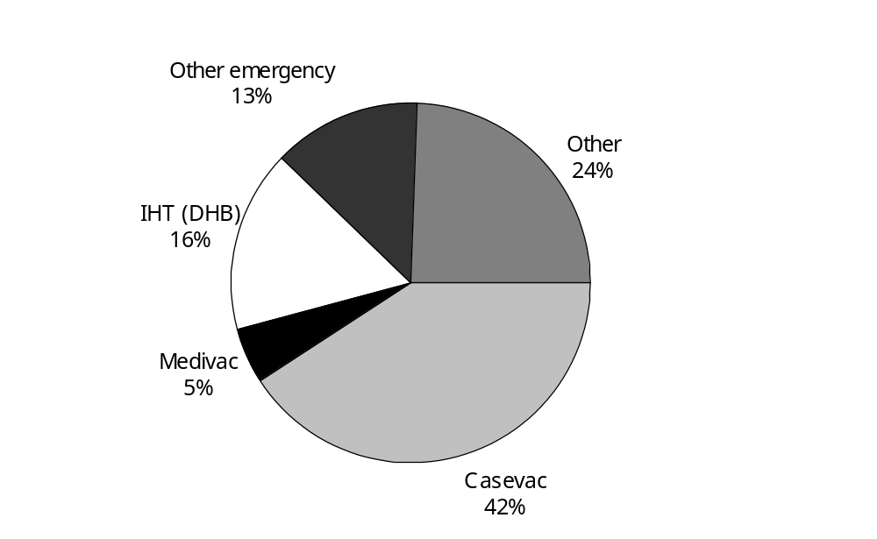

Figure 2 shows the range of flying hour values that the single engine rotary aircraft have for each type of mission.

Figure 2: Ranges of flying hours for single engine rotary aircraft
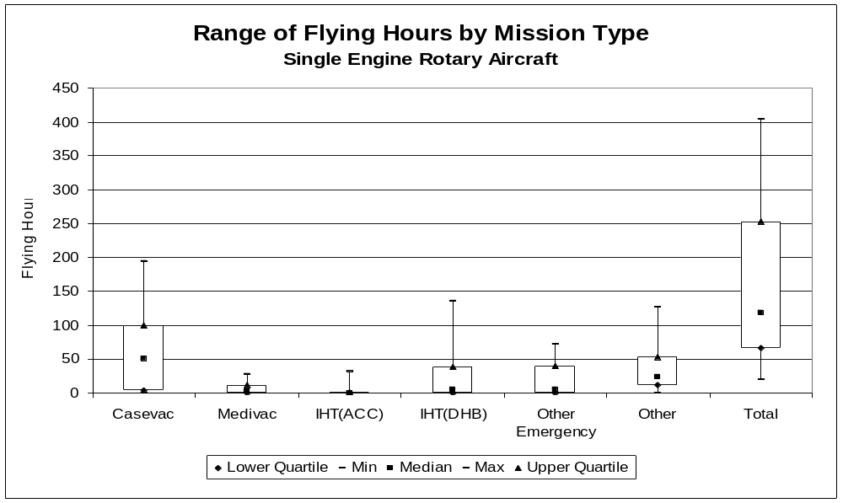

Figure 3 shows that the largest proportion of flying hours for twin-engine rotary aircraft are used in DHB funded inter hospital transfers, accounting for 33 percent of the flying hours. Casevac missions also have a large proportion of total flying hours among this type of aircraft, providing 30 percent of the total flying hours.

Figure 3: Proportions of total flying hours for twin engine rotary aircraft
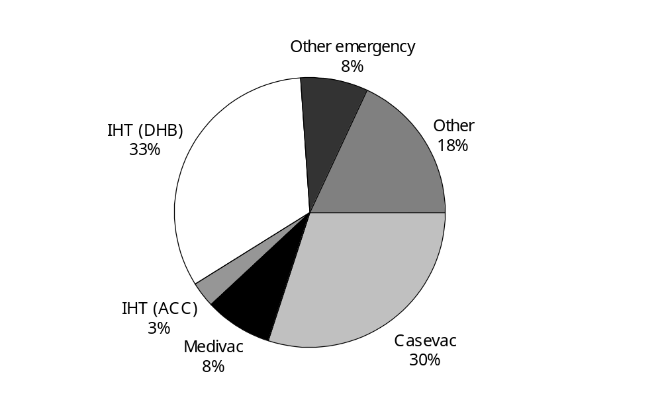

Figure 4 shows the range of flying hour values for the twin engine rotary aircraft for each type of mission.

Figure 4: Ranges of flying hours for twin engine rotary aircraft
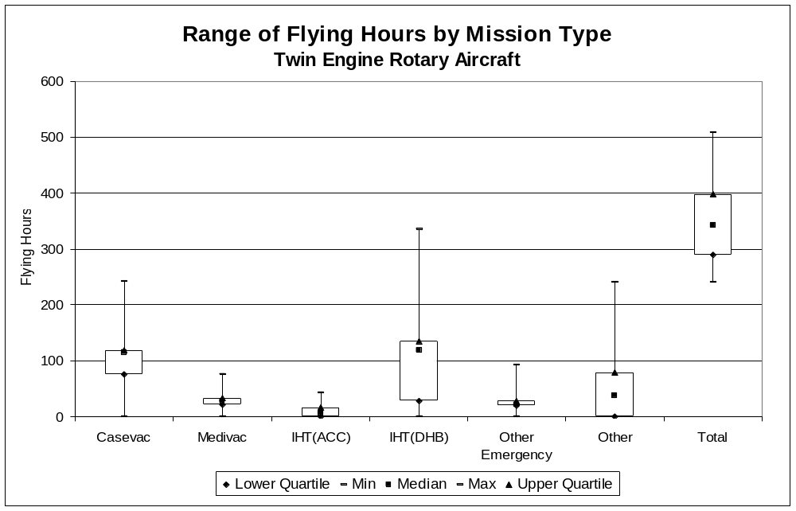

Figure 5 shows that the majority of flying hours undertaken by fixed wing pressurised aircraft are inter hospital transfers (90%) with 81% of total flying hours used in DHB funded inter hospital transfers, and approximately 9% used in ACC funded inter hospital transfers.

Figure 5: Proportions of total flying hours for fixed wing pressurised aircraft
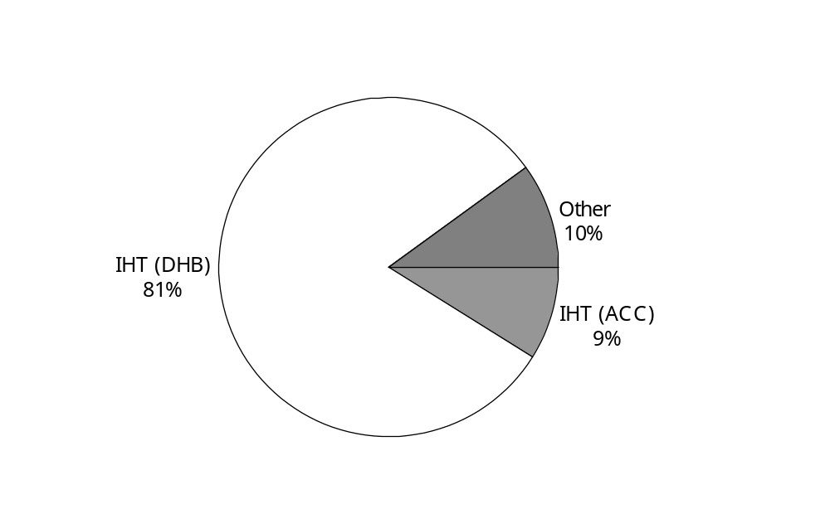

Figure 6 shows the range of flying hour values for fixed wing pressurised aircraft for each type of mission.

Figure 6: Ranges of flying hours for fixed wing pressurised aircraft
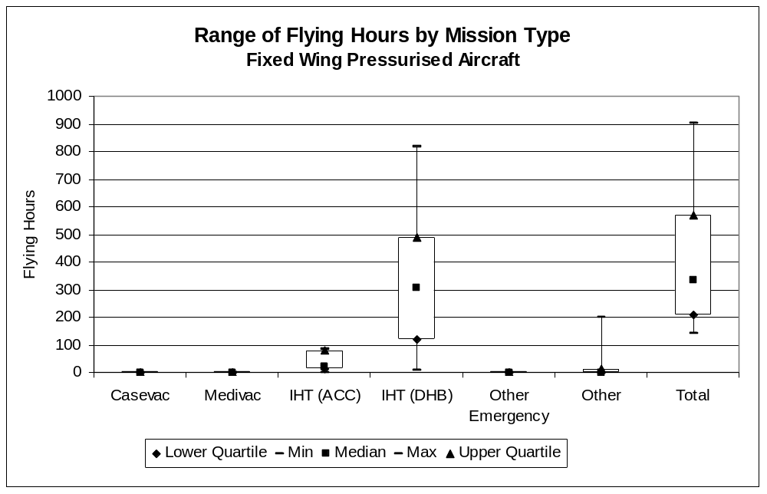

Figure 7 shows a similar result for fixed wing non-pressurised aircraft as with fixed wing pressurised aircraft. An almost identical proportion of flying hours are utilised for DHB funded inter-hospital transfers (85% vs 90% for pressurised). The most notable difference between the flying hours for pressurised and non-pressurised aircraft is that 5% of non-pressurised aircraft flying hours are for ‘other emergency’ (SAR) missions, whereas pressurised aircraft do not undertake any ‘other emergency’ missions.

Figure 7: Proportions of total flying hours for fixed wing non-pressurised aircraft
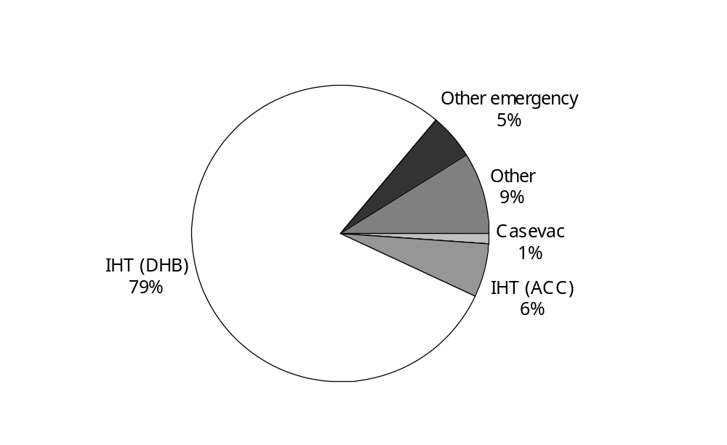

Figure 8 shows the range of flying hour values for fixed wing non-pressurised aircraft for each type of mission. It is evident from that figure that although 5% of flying hours on average are for ‘other emergency’ missions, most non-pressurised aircraft do not undertake any of these missions. It is also evident that while the maximum flying hours recorded are approximately 600, the average is a little under 200 flying hours.

Figure 8: Ranges of flying hours for fixed wing non-pressurised aircraft
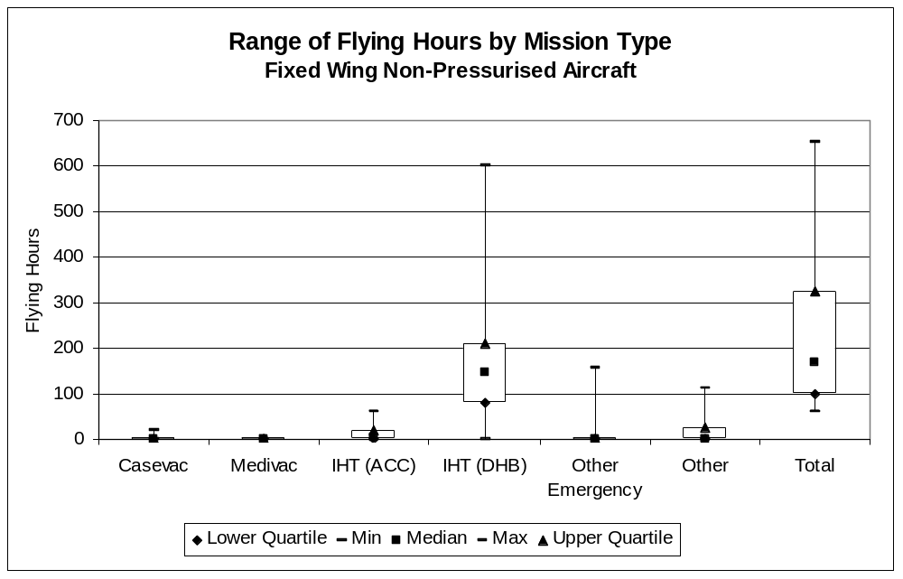

Figure 9 provides a comparison of the proportion of flying hours for each type of mission between the four classes of aircraft. As would be expected, there is a significant difference between the missions undertaken by fixed wing and rotary wing aircraft. The major difference is that rotary aircraft are suitable for casevac missions, by fixed wing aircraft are not. Focussing on rotary aircraft, single engine rotary aircraft are predominantly focussed on casevac missions, and twin-engine rotary aircraft have a larger proportion of IHT flying hours because the nature of the aircraft (larger interior able to take more people and equipment) lends itself more to IHT work than does single engine rotary aircraft. Given the absence of casevac and medivac flights for fixed wing aircraft, fixed wing aircraft are almost entirely devoted to IHT flights.

Figure 9: Proportion of total flying hours by mission types
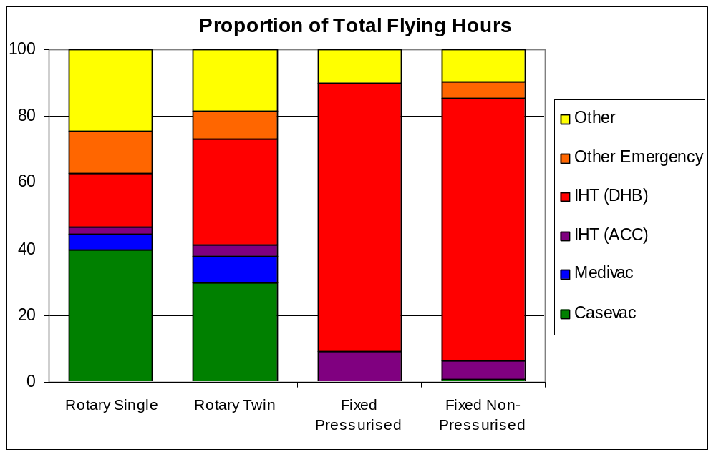

Figure 10 shows the total flying hours of each type of aircraft for each type of mission. Fixed wing aircraft clearly have the major share of IHT flying hours, and rotary twin aircraft have a greater share of casevac and medivac flying hours than do single engine rotary aircraft. Also of note is that non-pressurised fixed wing aircraft undertake almost as many ‘other emergency’ flying hours as do single engine rotary aircraft.

Figure 10: Number of flying hours per mission type
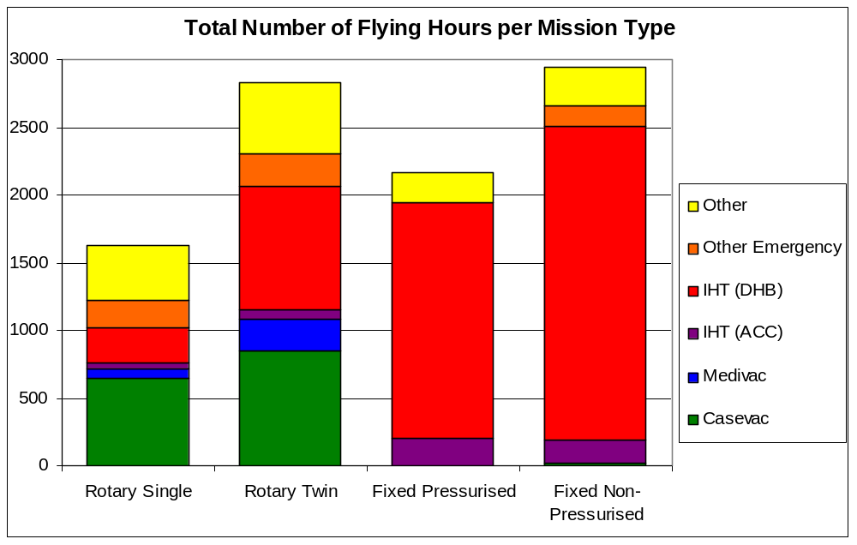

4.2 Missions
From Figure 11 it can be seen that the most common mission flown for single-engine rotary aircraft are casevac missions (44%), followed by “other” missions (35%).

Figure 11: Proportions of total missions for single engine rotary aircraft
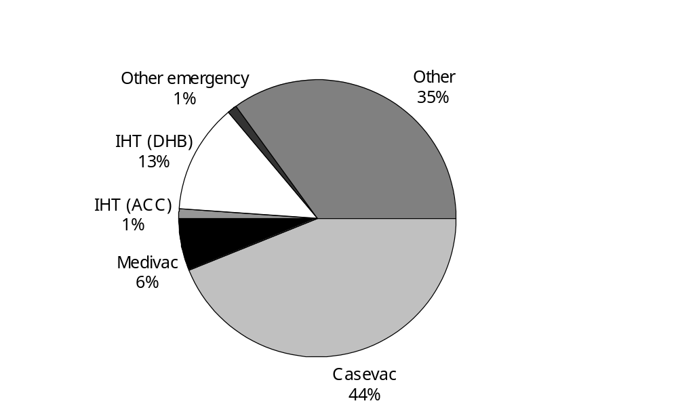

Figure 12 shows the range of the number of missions flown for single engine rotary aircraft by mission type.

Figure 12: Range of number of missions for single engine rotary aircraft
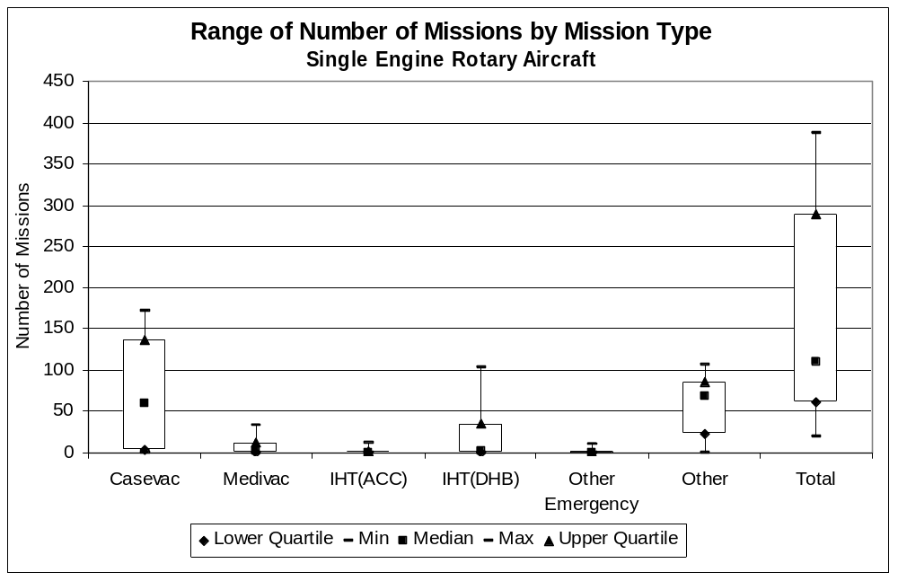

Figure 13 shows the most common mission undertaken by twin-engine rotary aircraft are the Casevac missions (32%), closely followed by DHB funded inter hospital transfers (30%).

Figure 13: Proportions of missions for twin engine rotary aircraft
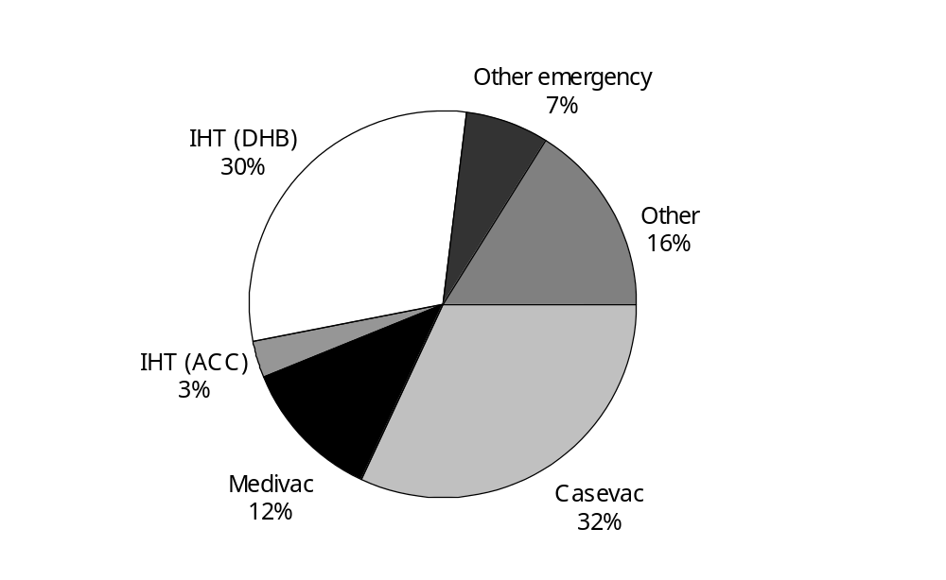

Figure 14 shows the range of the number of missions flown by twin engine rotary aircraft by mission type.

Figure 14: Range of number of missions for twin engine rotary aircraft
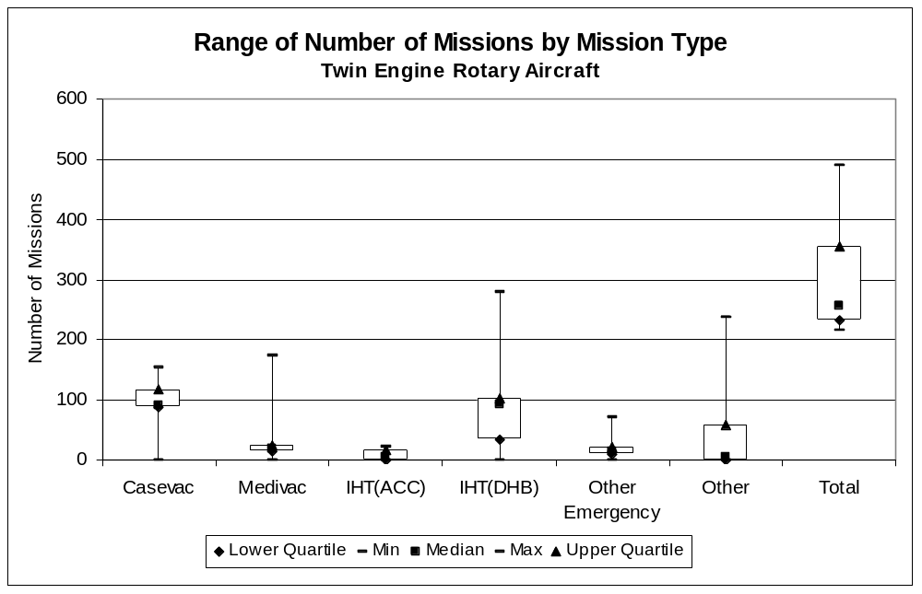

From Figure 15 it can be seen that the majority of missions flown by fixed wing pressurised aircraft are DHB funded inter hospital transfers. Total inter hospital transfers account for almost all of the missions flown for these aircraft with only a very small proportion of ‘other’ missions being flown.

Figure 15: Proportions of total missions for fixed wing pressurised aircraft
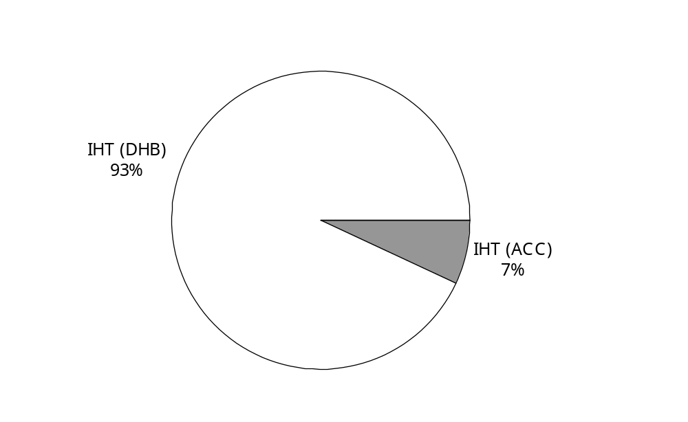

Figure 16 shows the range of the number of missions flown by fixed wing pressurised aircraft by mission type. Clearly most aircraft fly no more than 300 missions, but a few fly a very large number of missions.

Figure 16: Range of number of missions for fixed wing pressurised aircraft
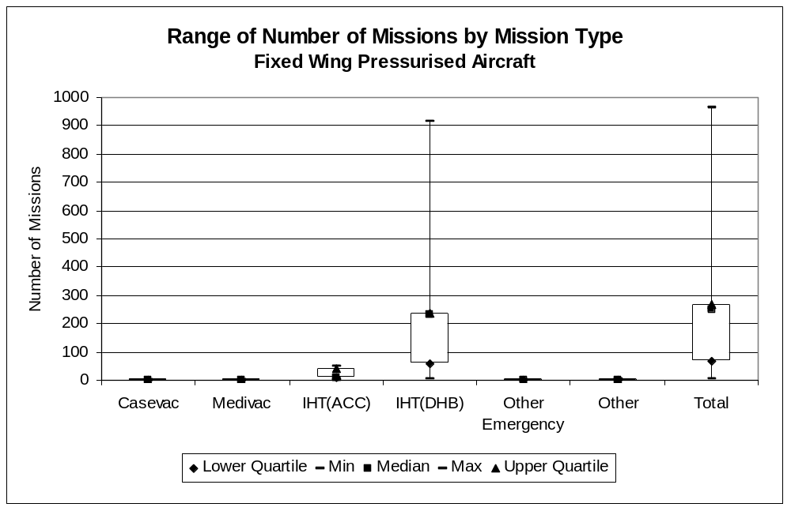

Figure 17 shows that as with the pressurised fixed wing aircraft, the non-pressurised fixed wing aircraft most commonly perform inter-hospital transfer missions (89%). However they also spend a reasonable proportion of their time attending “other” missions (10%).

Figure 17: Proportions of total missions for fixed wing non-pressurised aircraft
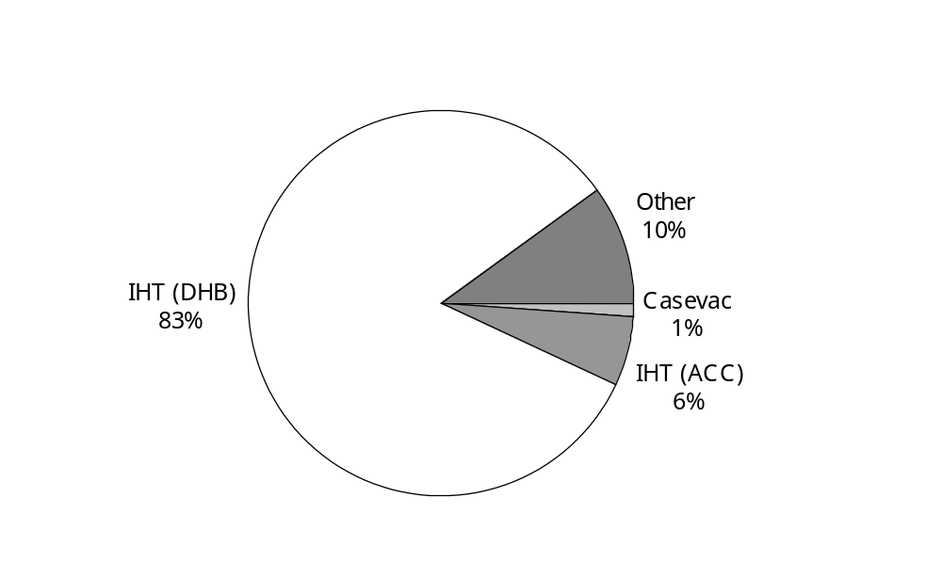

Figure 18 shows the range of the number of missions flown by fixed wing non-pressurised aircraft by mission type.

Figure 18: Range of number of missions for fixed wing non-pressurised aircraft
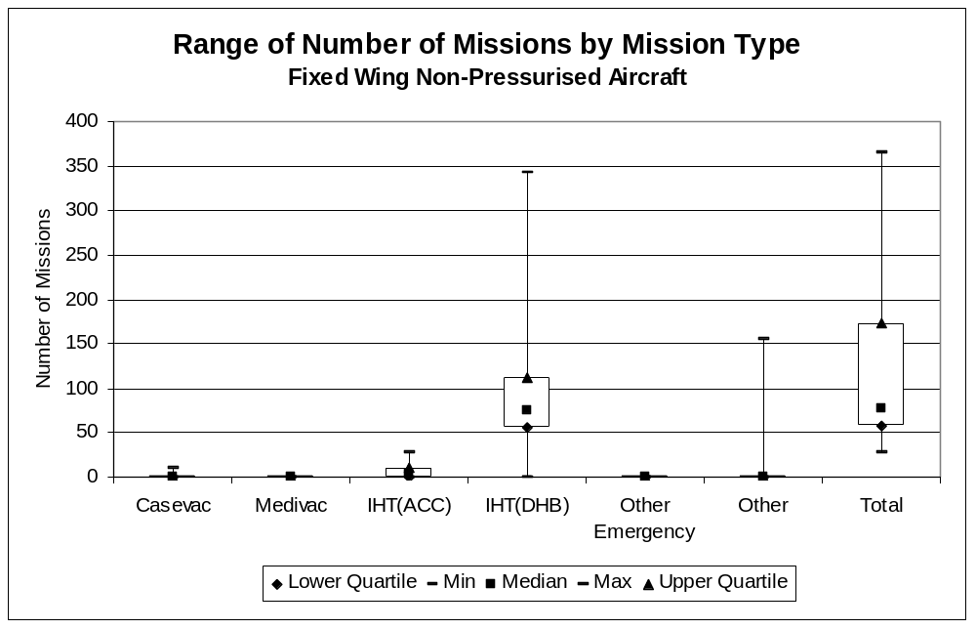

Figure 19 shows a comparison of the proportion of missions for each type of aircraft. As was evident with the comparison of flying hours, the nature of the aircraft means that fixed wing aircraft do not undertake any casevac work. The vast majority of missions for fixed wing aircraft – both pressurised and non-pressurised – is DHB funded inter hospital transfers. It is also evident that a significant number of missions for rotary aircraft are Casevac and Medivac missions.

Figure 19: Proportion of total missions by mission type
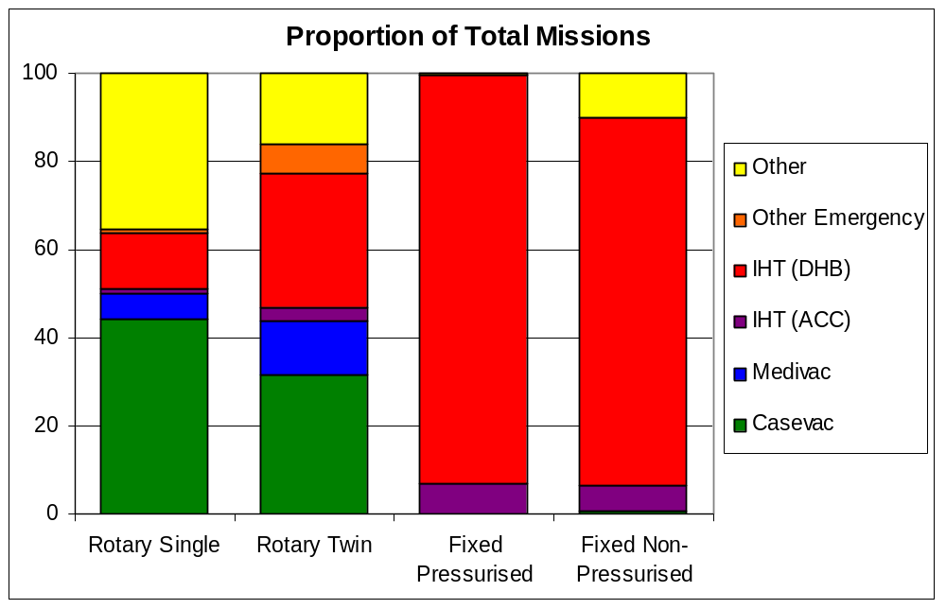

Figure 20 shows the total number of missions flown by aircraft type and by mission type. Focussing on rotary aircraft, the proportion of casevac missions is nearly identical between single engine rotary aircraft and twin engine rotary aircraft, whereas twin engine aircraft have a greater proportion of flying hours (Figure 10). This indicates that although the twin engine rotary aircraft are flying fewer casevac missions than single engine rotary aircraft, those missions are longer on average. This is to be expected because the twin engine rotary aircraft are typically located in major centres with a large catchment area.

Figure 20: Number of missions by mission type
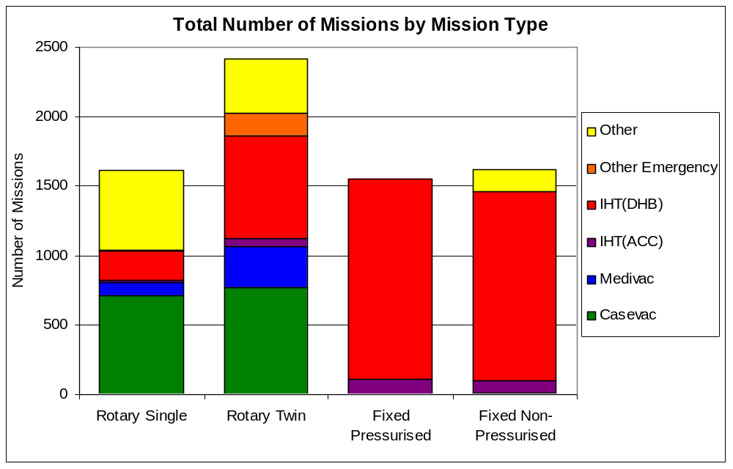

4.3 Flying hours versus missions
Figure 21 compares the proportion of flying hours spent on each mission type with the proportion of number of missions for each mission type. From this graph it can be seen that the flying hours and mission proportions are very similar for each of the aircraft types.

There are, however, some notable differences between the flying hours and the number of missions for single-engine rotary aircraft. Here the ‘Other Emergency’ flying hours proportion is a lot larger than the missions proportion, and the ‘Other’ flying hours proportion is smaller than the missions proportion. ‘Other Emergency’ missions include search and rescue (SAR) missions, where a single mission may involve many hours of flying time during a search. Conversely, ‘Other’ missions include pilot training and commercial work, and the data indicates that operators fly a relatively high number of short duration missions.

The discrepancy in the data between the flying hours proportion and missions proportion for fixed wing aircraft for ‘Other Emergency’ missions can simply be attributed to the fact that this is one aircraft where the number of missions for other emergency was not available.

Figure 21: Comparison of proportion of flying hours versus proportion of missions
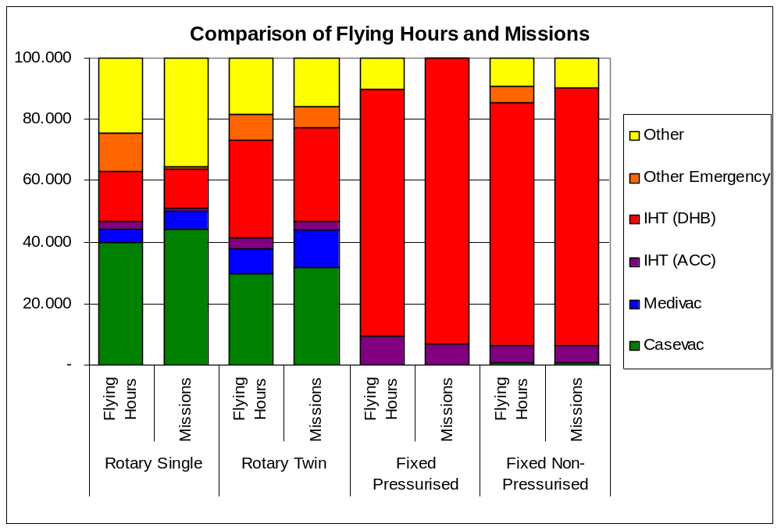

4.4 Hourly charge rates
Figure 22 shows the range of average hourly charge rates for single-engine rotary aircraft. The top point represents the maximum average hourly charge rate over all aircraft. Similarly the bottom point represents the minimum average hourly charge rate. The middle point represents the median, or the middle hourly charge rate over all single engine rotary aircraft. The top line represents the upper quartile, or the middle value between the median value and the maximum value. The bottom line represents the lower quartile, or the middle value between the median value and the minimum value.

We would expect that all ACC-funded missions (casevac and IHT) would have similar hourly charge rates for each type of aircraft, as the ACC has a nationwide price schedule. We understand that differences may exist between the North Island and the South Island because of a differential paid by the ACC. We also understand that the ACC rates include a fixed allowance per mission for communications and medical crew from the Order of St John (OSJ). ARHT employs its own medical crew, so we would expect that it does not receive the OSJ allowance, which would introduce further variation.

Given that medivac and DHB-funded IHT flights do not include the cost of medical crew, we would expect the rates for these flights to be less. We would also expect more variation to be apparent in the rates for DHB-funded IHT flights, as these are negotiated directly between the Operator and the relevant DHB.

From Figure 22 it can be seen that the Medivac mission charge rates have the most variation across the single-engine rotary aircraft. Between all types of missions the charge rates vary from being around $2,200 per hour for Casevac and ACC-funded IHT missions to $1,500 per hour for DHB inter hospital transfers and other missions. This is consistent with the ACC contract price of $2,245.

Figure 22: Charge rates for single engine rotary aircraft
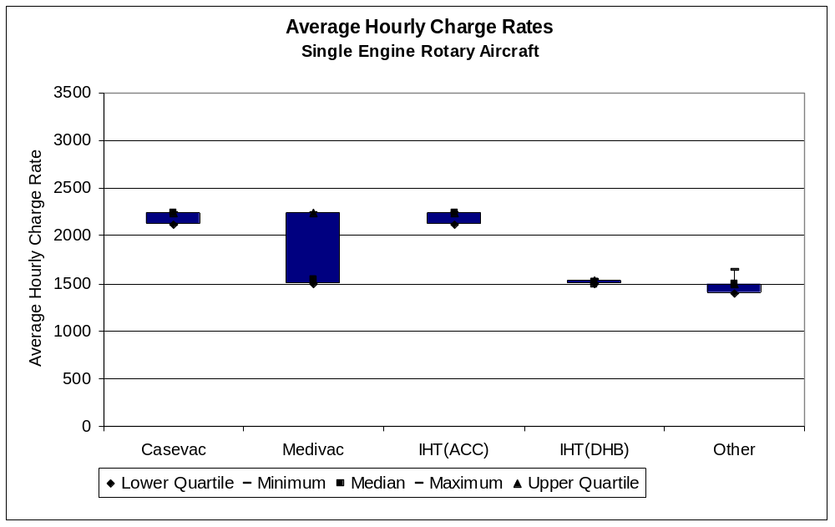

Figure 23 shows that the average hourly charge rates have a large variation of values over the twin-engine rotary aircraft. Almost all aircraft have an hourly charge rate of just over $3,000 for casevac and ACC-funded IHT missions (which is consistent with the ACC contract price of $3,002), with an outlier as low as about $2,250. The charge rates for other flights range from approximately $1,500 per hour to $3,000 per hour for the remaining missions.

Figure 23: Charge rates for twin engine rotary aircraft
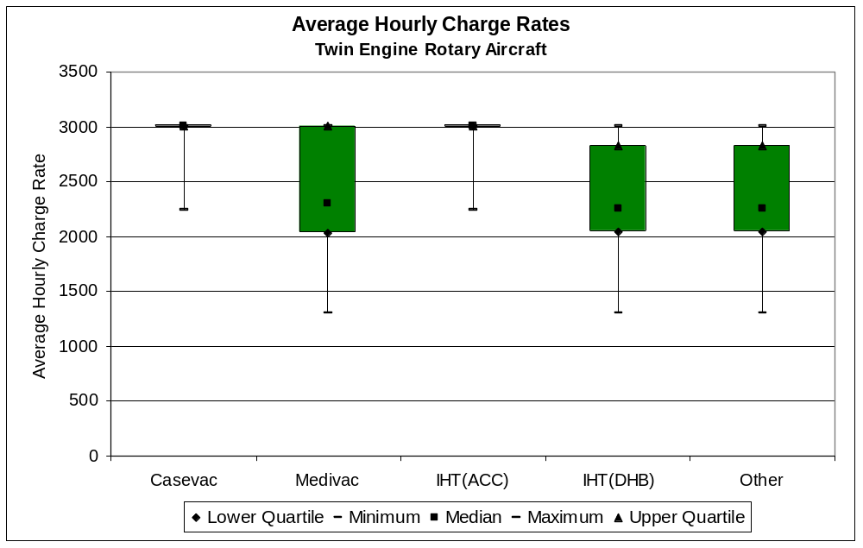

Figures 24 and 25 show the range of charge rates for fixed wing pressurised and fixed wing non-pressurised aircraft, respectively. Comparing these two graphs it is evident that the charge rates for pressurised aircraft are a lot higher than the charge rates for non-pressurised aircraft. The pressurised aircraft are larger, more expensive to purchase, and being turbine aircraft are more expensive to operate, so the difference in charge rates is be expected.

Figure 24: Charge rates for fixed wing pressurised aircraft
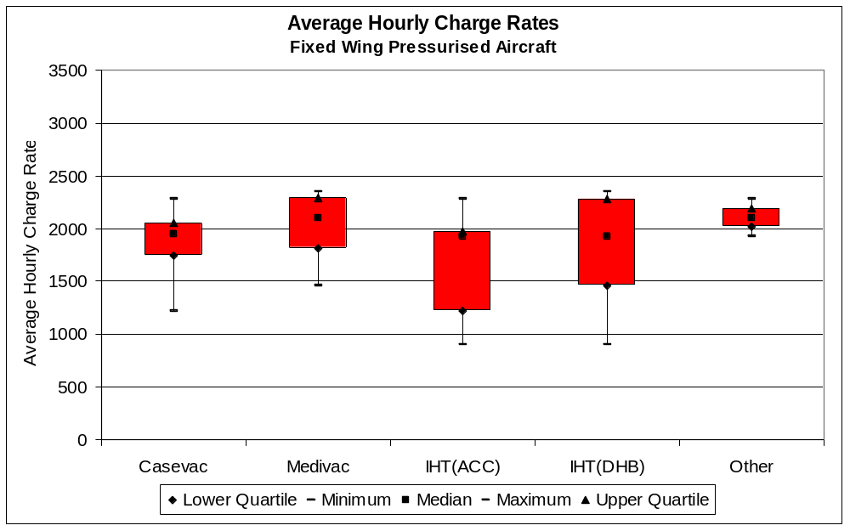

Figure 25: Charge rates for fixed wing non-pressurised aircraft
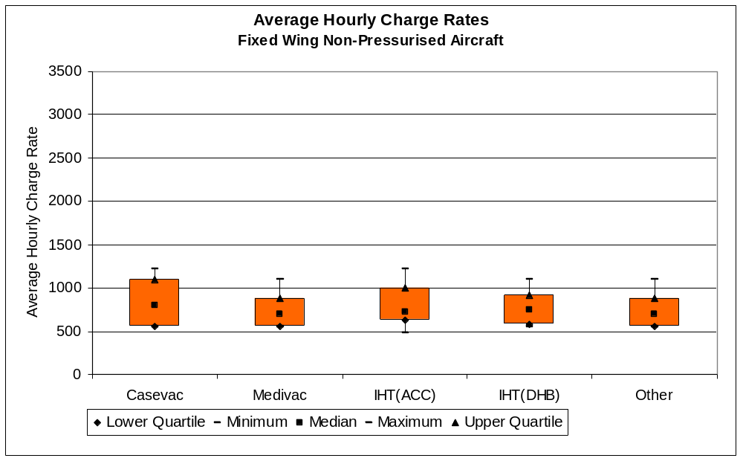

Figure 26 shows the average hourly charge rates across the aircraft in the different aircraft classifications and mission types. This clearly shows that fixed wing pressurised have the lowest charge rates, single-engine rotary aircraft and non-pressurised fixed wing aircraft have the middle charge rates and the twin-engine rotary aircraft have the highest charge rates. This is purely a function of the costs of owning and operating the respective aircraft.

Figure 26: Average hourly charge rates
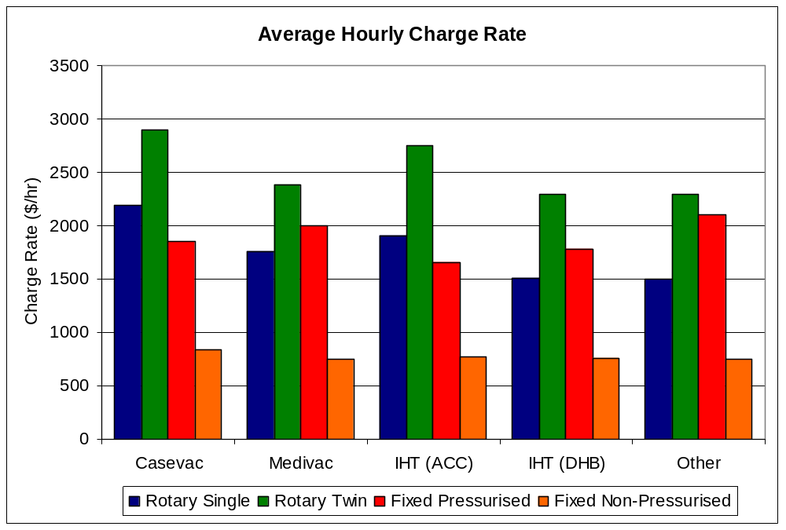

The variations in charge rates between mission types are as we would expect. Casevac and ACC-funded IHT flights include an allowance for medical crew in the charge out rates. The charge out rates for medivac and DHB-funded IHT missions do not include medical crew, so the charge out rates would be expected to be lower. We also note that the average charge out rates for “other” missions are very similar to those for medivac and DHB-funded IHT missions.

4.5 Cost curves
Cost curves are a useful way of summarising cost data and presenting it in a form whereby it is easy to identify outlying observations. In this section we present cost curves for average cost per flying hour and average cost per missions flown, with separate cost curves for each type of aircraft.

4.5.1 Average cost per flying hour
It can reasonably be expected that plotting average cost per flying hour against flying hours would yield a cost curve for each type of aircraft that will show declining average costs as flying hours increase.

The average cost per flying hour was calculated by summing all the costs associated with the aircraft. Therefore, this includes the staff costs, equipment costs, overheads, rent etc. The total cost was then divided by the total number of flying hours to obtain the average cost per flying hour.

The cost curves are of the form:


The cost curves were constructed by estimating the parameters that minimised the sum of squared errors between the predicted values on the cost curve and the values from the actual observations.

There were several outlier observations that depart significantly from the cost curves.
- The twin-engine rotary aircraft positioned at 430 flying hours and $7511 cost per hour is an outlier due to very high fixed aircraft costs. This aircraft was also the only aircraft with medical staff and ambulance officer costs.
- The twin-engine rotary aircraft positioned at 387 flying hours and $5,791 cost per hour is an outlier due to having slightly higher aircraft costs and administration/overhead costs.
- The pressurised fixed wing aircraft positioned at 568 hours and $2,025 cost per hour is an outlier because the aircraft has a high depreciation/interest/loans costs.
- The pressurised fixed wing aircraft positioned at 902 hours and $3,205 cost per hour is an outlier because the aircraft has high administration/overhead costs and high aircraft running costs.
- The non-pressurised fixed wing aircraft positioned at 654 hours and $133 cost per hour is an outlier because a large proportion of the costs are paid by another air operator.

Figure 27 shows the results of fitting a curve when the outliers are removed from the data set, and Figure 28 shows the results when all the data points are included in the data set.

All outliers removed
Figure 27: Flying hours vs costs with outliers removed
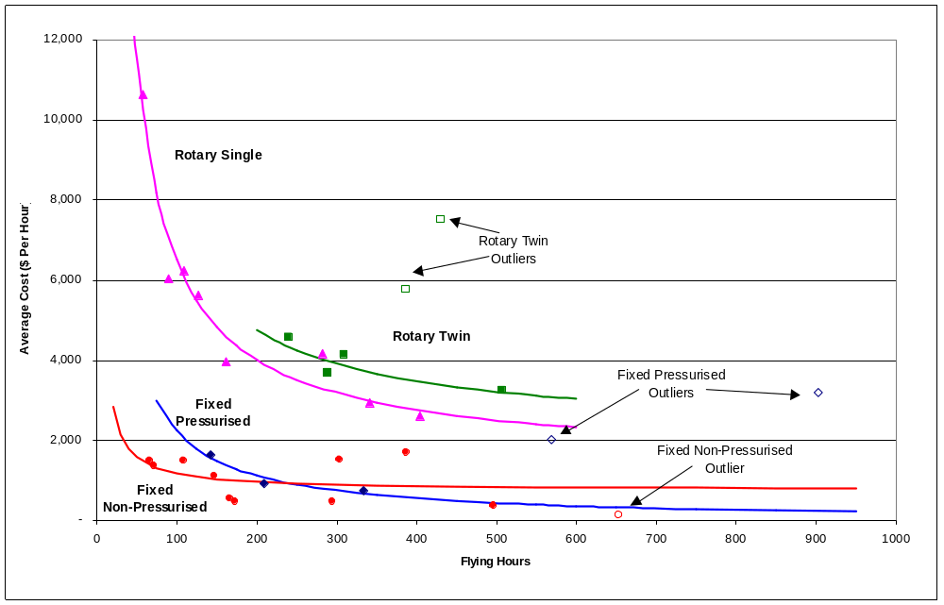

Table 6 shows the parameters corresponding to the cost curves that best fit the data when the outliers are removed (Figure 27).

Table 6: Cost curve parameters with outliers removed
 | Rotary single | Rotary twin | Fixed pressurised | Fixed non-pressurised
Fixed cost | 501,495 | 517,135 | 224,995 | 41,870
Variable cost | 1,500 | 2,177 | -10 | 754

The cost curves for the rotary aircraft look reasonable, but the cost curves for the fixed wing aircraft should be treated with caution. The negative variable cost for pressurised fixed wing aircraft is obviously incorrect, and the fixed cost for non-pressurised fixed wing aircraft appears to be too low.

All data points included
Figure 28 shows that with all the data points included in the data set the rotary twin curve slopes upwards, meaning as the flying hours increase the average cost per flying hour increases. This distortion has been created by the outliers pulling the curve up on the right end of the curve. To eliminate the distortion the twin-engine rotary outliers should be excluded from the curve fitting. The pressurised fixed wing curve also slopes up because of the outliers pulling the curve up on the right side, therefore these outliers should also be excluded from the curve fitting. Including the non-pressurised fixed wing outlier has made little difference to the curve.

Figure 28: Flying hours vs costs with all data points
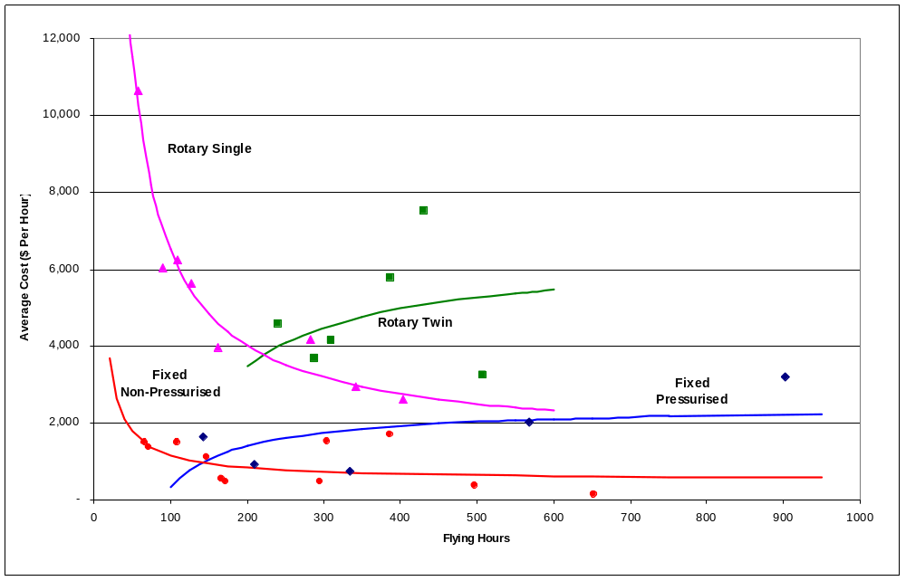

Table 7 shows the cost curve parameters that best fit the data when all the data points are included in the curve fitting procedure. The negative fixed cost for rotary twin and pressurised fixed wing indicates that the respective curves are upward sloping. The negative fixed cost also indicates that these curves are not representative of the true costs of operating the respective aircraft.

Table 7: Cost curve parameters with all data points
 | Rotary single | Rotary twin | Fixed pressurised | Fixed non-pressurised
Fixed cost | 501,495 | -594,730 | -211,756 | 63,363
Variable cost | 1,500 | 6,461 | 2,454 | 516

As would be expected, the cost curves have the following characteristics:
- Rotary aircraft are more expensive per flying hour than fixed wing aircraft;
- Single-engine rotary aircraft seem to have very high fixed costs, and a relatively low per-hour variable cost so that the average cost declines heavily with increases in flying hours; and
- For a given number of flying hours, twin-engine rotary aircraft have higher average costs than single engine rotary aircraft.

Summary
Cost curves were computed for the three aircraft types under the following scenarios:
- Excluding all obvious outliers;
- Including all data points.

There are no apparent outliers for single engine rotary aircraft, so the cost curves were the same under both scenarios. Two very high cost data points for twin engine rotary aircraft produce cost curves with negative fixed costs and an average cost that increases with flying hours. This is not a reasonable representation of a cost curve for aircraft operation, so the most appropriate cost curve for twin engine rotary aircraft is likely to be the curve with these two outliers omitted. No suitable cost curve was obtained for pressurised fixed wing aircraft. The most reasonable cost curve for non-pressurised fixed wing aircraft appears to be the curve with all data points included, although the fixed cost does appear to be low. Table 8 below summarises the parameters for the most appropriate cost curves, and provides the calculated total cost for the average flying hours for each aircraft type.

Table 8: Cost curve parameters and average costs by aircraft type
 | Rotary single | Rotary twin | Fixed pressurised | Fixed non-pressurised
Fixed cost ($) | 501,495 | 517,138 | N/A | 41,870
Variable cost ($/hr) | 1,500 | 2,177 | N/A | 754

4.5.2 Average cost per mission
A similar analysis on the cost per mission against number of missions can be carried out as was done above with the flying hours. In this case, the cost curves are of the form:


Only two of the five outliers identified in the previous section are identified as being outliers in this analysis. The twin-engine rotary aircraft positioned at 339 missions, the pressurised fixed wing aircraft positioned at 269 missions, and the non-pressurised fixed wing aircraft positioned at 365 missions now all fall within the same range of values as the other data points in their group.

Figure 29 shows the costs curves that are derived when the outliers are removed. Figure 30 shows the costs curves that are derived when all the data points are included in the analysis.

All outliers removed
Figure 29: Average cost per mission with outliers removed
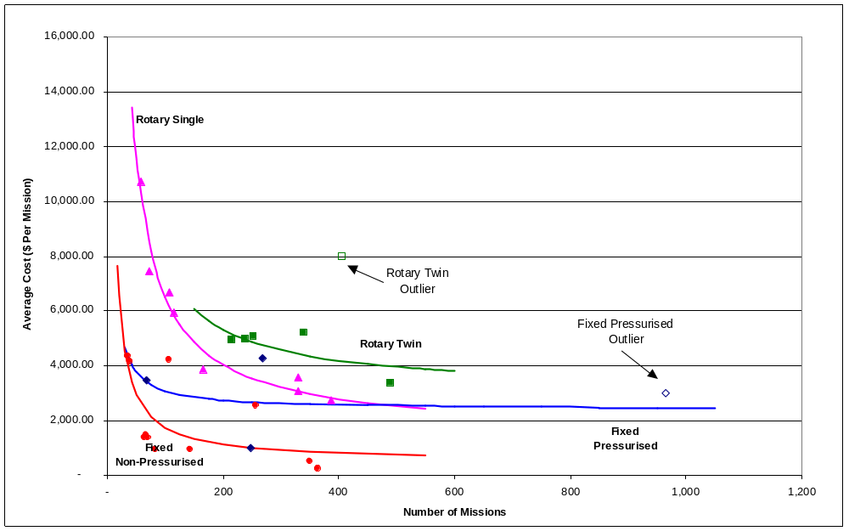

Table 9 shows the cost curve parameters that best fit the data when all the outliers are excluded from the curve fitting process. The per-mission variable cost associated with fixed wing pressurised aircraft appears to be too low; otherwise the parameters do not appear unreasonable.

Table 9: Cost curve parameters with outliers removed
 | Rotary single | Rotary twin | Fixed pressurised | Fixed non-pressurised
Fixed cost | 499,109 | 453,056 | 226,668 | 120,771
Variable cost | 1,533 | 3,061 | 94 | 531

All data points included
Figure 30 shows that including all data points in the analysis has made little difference for the fixed wing aircraft and has made the twin engine rotary aircraft curve slope slightly upwards.

Figure 30: Average cost per mission with all data points
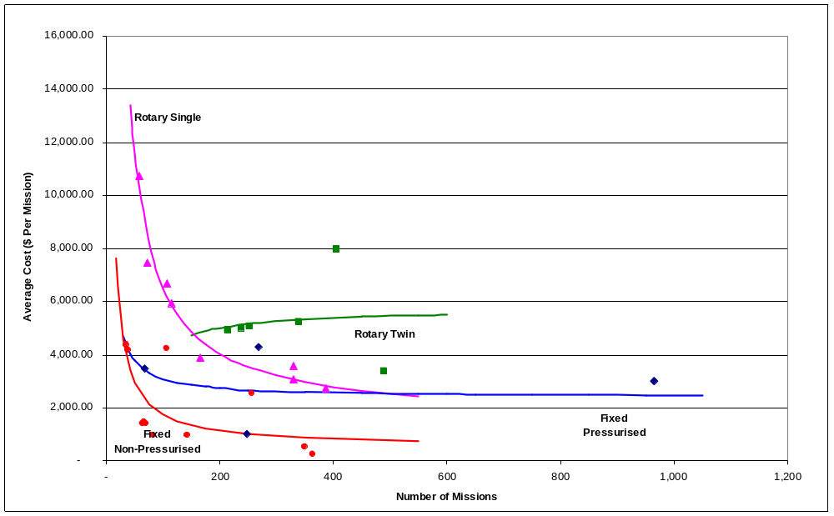

Table 10 shows the cost curve parameters that best fits the data when all the data points are included in the curve fitting process. The negative fixed cost for rotary twin indicates the curve is upward sloping and not representative of the true cost of operating a rotary twin aircraft.

Table 10: Cost curve parameters with all data points
 | Rotary single | Rotary twin | Fixed pressurised | Fixed non-pressurised
Fixed cost | 499,109 | -153,003 | 68,343 | 120,771
Variable cost | 1,533 | 5,763 | 2,404 | 531

Again we can note similar characteristics of the graphs as in the flying hours analysis. Namely, rotary aircraft are more expensive per mission than fixed wing aircraft, single-engine rotary aircraft seem to have very high fixed costs, and a relatively low per-mission variable cost and twin-engine rotary aircraft have higher average costs than single engine rotary aircraft. Again the cost curve for twin engine rotary aircraft is upward-sloping with a negative fixed cost, which indicates that it is not representative of the true costs of twin engine rotary aircraft.

4.6 Revenue information
Note: Following is only for operators who have supplied revenue information (ie, does not include all the operators).

4.6.1 Categorisation of operators
It was expected that operators with fixed wing aircraft would have a much greater proportion of their income from donations and corporate sponsorship than operators who only operate helicopters. We therefore split the revenue information into those operators that only have rotary wing aircraft and those that have fixed wing aircraft or both fixed wing and rotary wing aircraft.

Table 11 shows the average number of aircraft of each type operated by the two classes of air ambulance operator. Operators who only operate rotary wing aircraft operate an average of 0.4 single engine rotary aircraft and 1.0 twin engine rotary aircraft. Operators who operate both fixed and rotary wing aircraft operate an average of 1.14 single engine rotary aircraft, 0.43 twin engine rotary aircraft, and 1.29 fixed wing aircraft.

Table 11: Average number of aircraft operated by each class of air ambulance operator
Operator type | Aircraft type
Operator type | Rotary single | Rotary twin | Fixed pressurised | Fixed non-pressurised | All aircraft
Rotary only | 0.4 | 1.0 | 0.0 | 0.0 | 1.4
Fixed and rotary | 1.14 | 0.43 | 0.57 | 0.71 | 2.86
All operators | 0.83 | 0.67 | 0.33 | 0.42 | 2.25
Note: Averages are calculated across only those operators that supplied revenue information.

4.6.2 Categorisation of revenue
This section provides an overview of the sources of income for air ambulance operators, and how much is received from each source. Information was obtained directly from operators’ (and Trusts’) financial statements. Reflecting the differences between the various operators, there was little consistency in the categories of income listed on the financial statements resulting in a large group of different categories. These, therefore, had to be grouped together to allow analysis to be more consistent. The final categories of income are:
- Sponsorships and Grants;
- Donations;
- DHBs;
- ACC;
- St John;
- Other Government Agency;
- Other Air Ambulance Operator;
- Commercial Activities;
- Interest/Investment Income;
- Recoveries; and
- Other.

4.6.3 Revenue analysis
Figure 31 shows that the majority (52%) of the revenue received by operators who only have rotary aircraft comes from donations. A significant amount of their revenue also comes from ACC (13%), sponsorships and grants (14%), and recoveries (14%). Collectively, these categories account for 93% of income for rotary wing operators.

Figure 31: Proportion of total revenue for operators with only rotary aircraft
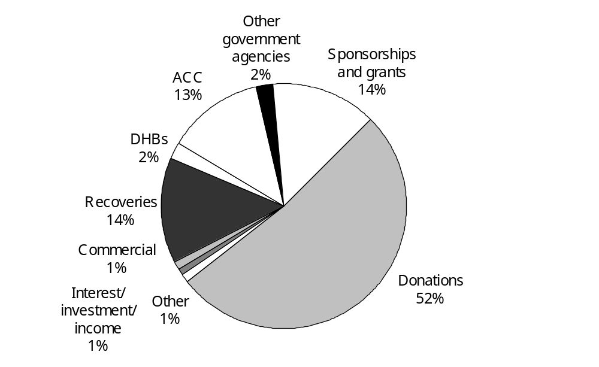

Figure 32 shows the range of income received by operators who only operate rotary aircraft.

Figure 32: Range of revenue for operators with only rotary aircraft
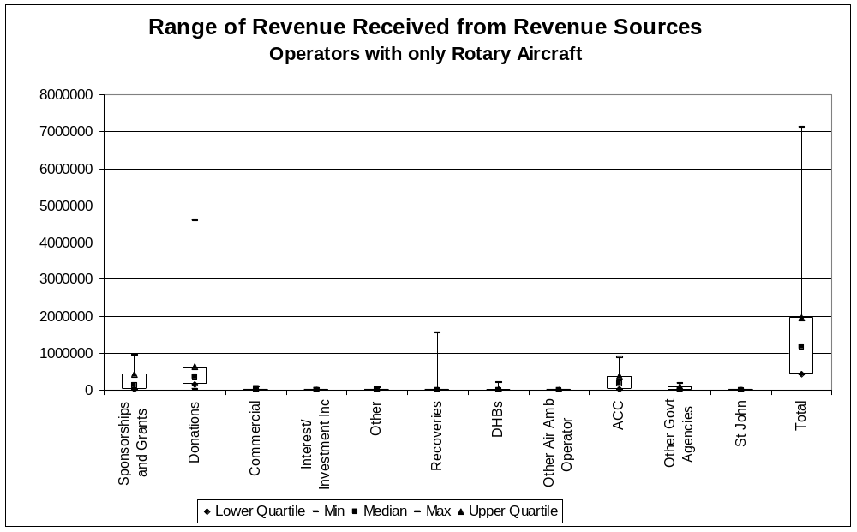

Figure 33 shows that operators who either operate only fixed wing aircraft or operators who operate both fixed wing and rotary aircraft receive a large proportion of their income from commercial activities (28%). They also receive a significant proportion of their revenue from DHBs (16%), ACC (15%), donations (14%), and sponsorships and grants (13%).

Figure 33: Proportion of total revenue for operators with only fixed wing aircraft or with both fixed wing and rotary aircraft
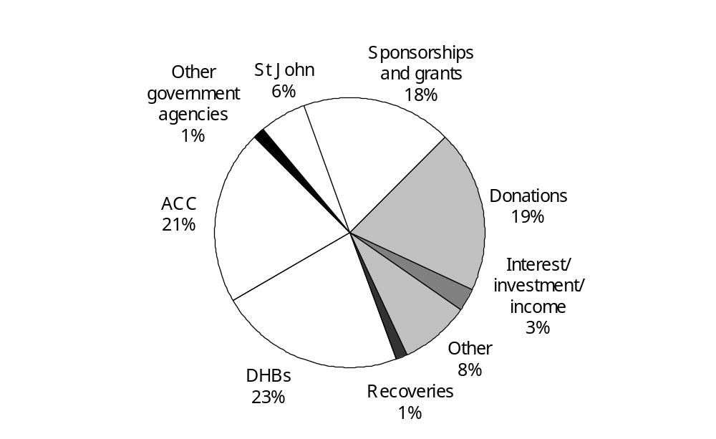

Figure 34 shows the range of revenue received by operators who only have fixed wing aircraft or who have both fixed wing and rotary aircraft.

Figure 34: Range of revenue for operators with only fixed wing aircraft or with both fixed wing and rotary aircraft
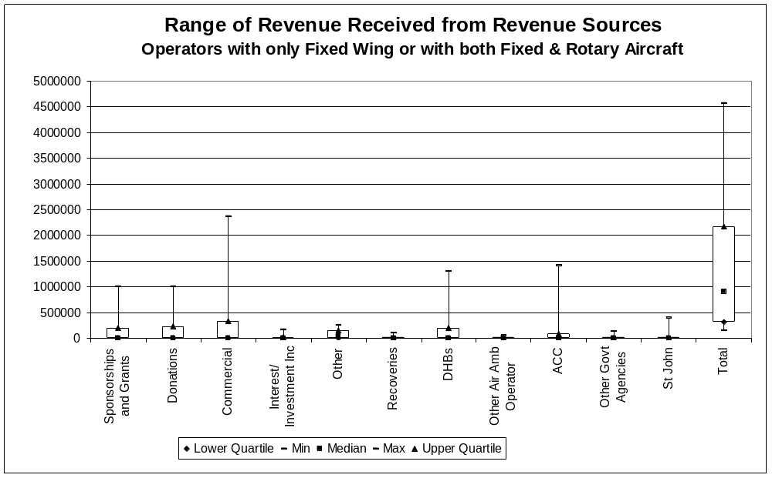

Figure 35 shows the range of revenue received by all air ambulance operators. From this it can be seen that there is a wide range of values received by the air ambulance operators, with a few very high values and the majority being quite low.

Figure 35: Range of revenue for all air ambulance operators
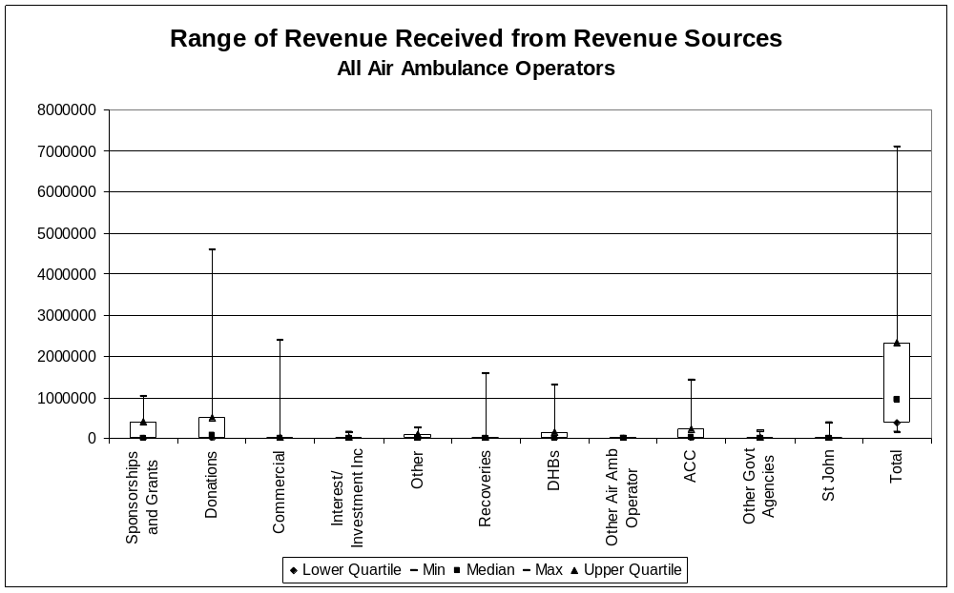

For the following analysis on the comparison between operators operating only rotary aircraft and operators operating fixed wing aircraft the categories have been aggregated further. This has been done by combining other, interest and investment income, St John, other air ambulance operators and other government agencies into one category ‘Other’.

Figure 36 compares the proportions of revenue received from different sources between operators who only operate rotary aircraft and operators who operate either only fixed wing aircraft or both fixed wing and rotary aircraft. From this it can be seen that rotary aircraft operators receive a much greater proportion of their income from donations whereas operators with fixed wing aircraft receive fairly even proportions of their income from each of the sources except for recoveries.

Figure 36: Proportion of total revenue received
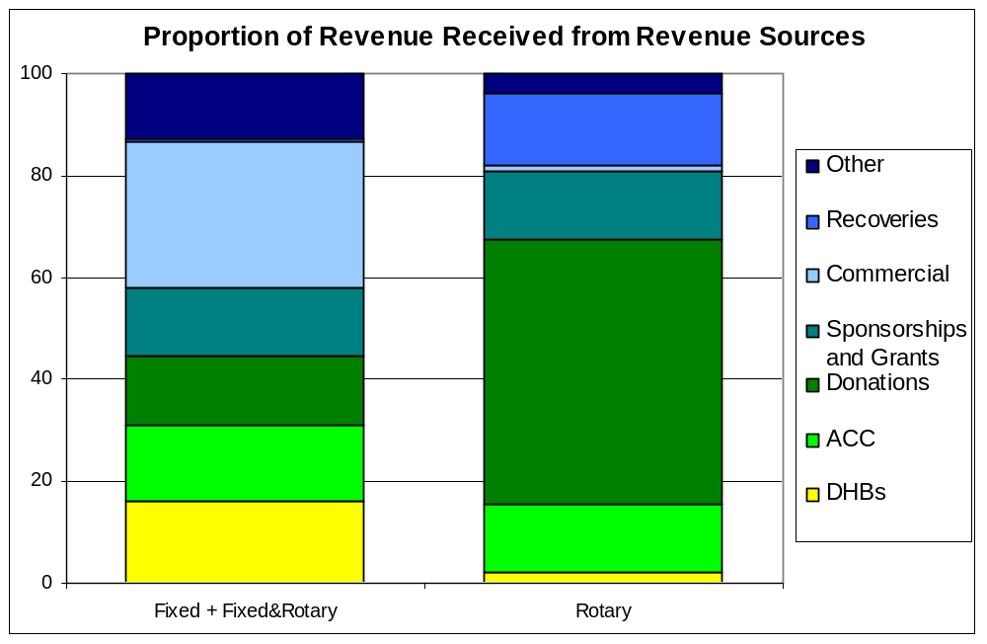

4.7 Average total revenue and the surplus/deficit from operations
Figure 37 shows the average revenue that each operator receives from the various sources. This shows that, on average, operators who only operate rotary aircraft receive more income than operators who operate fixed wing aircraft. However, rotary wing aircraft are considerably more costly than fixed wing aircraft, so this difference is not surprising.

Figure 37: Average revenue received
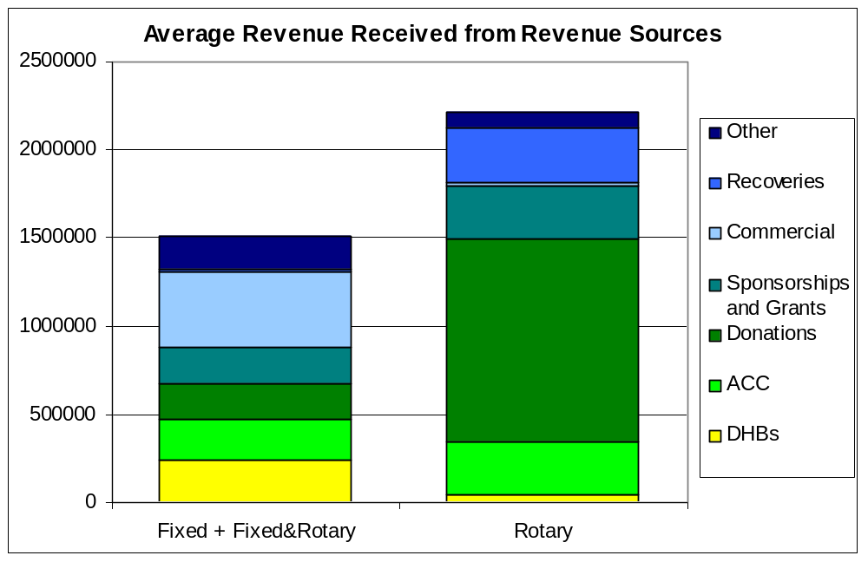

Figure 38 shows the range of surplus/deficit that air ambulance operators have received from their operations, calculated as revenue less expenses. The distribution of operating surplus is skewed positively for fixed wing operators, and skewed negatively for “Rotary Only” operators However, both “Rotary Only” operators and fixed wing operators approximately break even on average, with most operators grouped fairly closely around the break-even point.

Figure 38: Range of surplus/deficit from operations
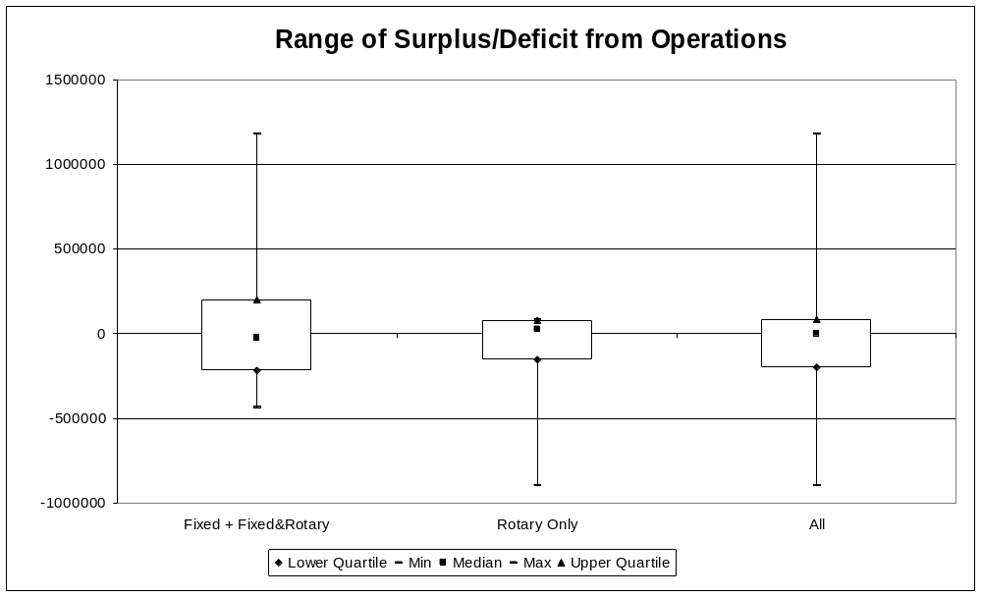

Appendices
Appendix A: Data request form

Aircraft information
Aircraft characteristics |  |  |  |  |  |  |  |  | Direct, on-duty staff available hours |  |  |  | Direct, on-call staff available hours |  |  |  | Direct, on-duty staff available hours |  |  |  | Direct, on-call staff available hours |  |  |  | Indirect FTEs | Hangar area | Average hourly charge rate
Aircraft identifier | Rotary or fixed wing | IFR/ VFR | Pressurised (Y/N) | Multi-engined (Y/N) | Service level (s11) | Patient capacity | Home airport | Dedicated ambulance (Y/N) | Paid |  |  |  | Paid |  |  |  | Volunteer |  |  |  | Volunteer |  |  |  | Indirect FTEs | Hangar area | Casevac | Medivac | IHT (ACC) | IHT (DHB) | Other
 |  |  |  |  |  |  |  |  | Air crew | Ground crew | Ambulance officers | Medical staff | Air crew | Ground crew | Ambulance officers | Medical staff | Air crew | Ground crew | Ambulance officers | Medical staff | Air crew | Ground crew | Ambulance officers | Medical staff

Volume
Aircraft identifier | Flying hours |  |  |  |  |  | Job cycle time |  |  |  |  |  | Missions |  |  |  |  |  | Number of patients
Aircraft identifier | Casevac | Medivac | IHT (ACC) | IHT (DHB) | Other emergency | Other | Casevac | Medivac | IHT (ACC) | IHT (DHB) | Other emergency | Other | Casevac | Medivac | IHT (ACC) | IHT (DHB) | Other emergency | Other | Casevac |  |  |  | Medivac |  |  |  | Inter-hospital transfers – ACC funded |  |  |  | Inter-hospital transfers – DHB funded
 |  |  |  |  |  |  |  |  |  |  |  |  |  |  |  |  |  |  | Status 1 | Status 2 | Status 3 | Status 4 | Status 1 | Status 2 | Status 3 | Status 4 | Neonate | ICU | Paediatric | Other | Neonate | ICU | Paediatric | Other

Cost
Aircraft identifier | Direct, on-duty staff salaries |  |  |  | Direct, on-call staff salaries |  |  |  | Indirect staff salaries | Volunteer costs | Other ambulance staff costs | Other medical staff costs | Other personnel costs | Clinical cost | Aircraft cost |  | Role equipment cost |  | Medical equipment cost |  | Actual property rent | Notional property rent | Finance cost |  | Training cost | Administration overheads
Aircraft identifier | Air crew | Ground crew | Ambulance officers | Medical staff | Air crew | Ground crew | Ambulance officers | Medical staff |  |  |  |  |  |  | Fixed | Running | Fixed | Running | Fixed | Running | Actual property rent | Notional property rent | Depreciation/ interest/loans | Other lease/ rent | Training cost | Administration overheads

GIS
Census area unit ID | Census area unit | Territorial authority | Population | Area | NZDep | NZDep decile | Home airport

Quality
Aircraft identifier | Activation times |  | Workload: Number of incidents attended by an advanced paramedic
Aircraft identifier | 0630–2100 | 2100–0630 | Casevac | Medivac | IHT (ACC) | IHT (DHB)

Appendix B: Data format notes
B.1 Aircraft information
Variable | Comment
Aircraft identifier | Registration number ideally but would accept anything that could be matched consistently through the tabs of the spreadsheet.
Aircraft characteristics | Six of these characteristics require a simple binary response (eg, that the aircraft is a rotary rather than fixed wing). IFR/VFR refers to the current operational use, rather than the potential capability, of the aircraft. Service level (s 11) refers to the service specification, clause 11, a copy of which is appended to this document. Patient capacity refers to the aircraft capacity in its emergency response format.
Direct staff available hours | Available hours are requested separately for on-duty and on-call rosters. Direct staff does not include management, administration or marketing, but includes only those staff employed by the organisation. The costs of staff of other organisations that are hired on a casual basis (eg, paramedics) are included in the ‘costs’ tab. A matching set of fields for volunteers is included for completeness.
Hangar area | Floor area of buildings utilised by the organisation.
Average hourly charge rate | To match with Cull Report data request.

B.2 Volume
Variable | Comment
Aircraft identifier | Registration number ideally but would accept anything that could be matched consistently through the tabs of the spreadsheet.
Note on breakdown of workload parameters | Workload parameters for flying hours, job cycle time and missions have been separated in to five categories. Casevac are those emergency responses related to trauma cases (funded by ACC). Medivac are the emergency responses related to non-trauma conditions (eg, heart attacks). IHT (ACC) is the inter-hospital transfers for trauma cases that occur within 24 hours of the related accident and which are funded by ACC. IHT (DHB) are other inter-hospital transfers. Other emergency means non-ambulance assistance provided to the police and fire services through SAR or other activities. Other includes all other activity from pilot training to tourist flights.
Flying hours | Time spent in the air.
Job cycle time | Means the interval of time from when sufficient information is obtained as to the location and nature of the call, until the consumer/patient is delivered to a treatment centre or a road ambulance. Includes activation time and time spent on the ground at the scene.
Missions | Number of times the aircraft is dispatched inclusive of aborted missions.
Note on breakdown of numbers of patients | Casevac and medivac patients are separated in to patient status levels while inter-hospital transfer patients are separated in to categories mentioned below.
Number of patients by status | Patient status is defined in section 10.2.2 of the air ambulance service specs and in the ambulance sector service standards. Status 0 patients (dead) are not included.
Inter-hospital transfer patient categories | For the purposes of this survey, neonates, ICU and paediatric patients are those patients whose transfer is organised between or to neonatal, adult or paediatric intensive care units respectively. Any other transfers are to be included under ‘other’.

B.3 Costs
Variable | Comment | Allocation method
Aircraft identifier | Registration number ideally but would accept anything that could be matched consistently through the tabs of the spreadsheet. | N/A
Personnel costs | Personnel costs separated according to staff categories described above (in the ‘Aircraft information’ sheet under ‘direct staff’, ‘available hours’) and including salaries, allowances, ACC levies, superannuation and, for paid staff, uniforms. Note, only include staff employed by your organisation (eg, payments for use of road ambulance paramedics is captured under ‘other ambulance staff costs’). | Actual expenditure extrapolated to a full year.
Volunteer cost | Includes uniforms, mileage allowance and any gratuities paid but not training – training costs are captured elsewhere. | Allocated across numbers of casevac or medivac missions flown by each aircraft.
Other ambulance staff costs | Includes payments to ambulance operators for the use of ambulance officers / paramedics. | Allocated across numbers of casevac or medivac missions flown by each aircraft.
Other medical staff costs | Includes payments for the casual use of medical staff. | Allocated across numbers of casevac, medivac or IHT missions flown by each aircraft.
Other personnel costs | Includes payments for the casual use of staff other than ambulance officer or medical staff. | Allocated across total numbers of missions.
Clinical cost | Includes medical consumables. | Allocated across numbers of casevac, medivac or IHT missions, excluding those aborted.
Aircraft costs | Fixed costs including depreciation and running costs including repairs, maintenance, insurance and fuel. | Fixed costs allocated to individual aircraft and running costs allocated by flying hours.
Role equipment costs | Role equipment includes specialist flying equipment (eg, night vision goggles), spotlights, winches, etc. | Fixed costs allocated to individual aircraft and running costs allocated by flying hours.
Medical equipment costs | Medical equipment includes stretchers, cots, ventilators, etc. | Fixed costs allocated to individual aircraft where the equipment is mostly used and running costs allocated by flying hours.
Actual property rent | Actual tenancy costs. If these are unknown or $0, refer to the following field. | Actual costs.
Notional property rent | Where actual tenancy costs are unknown or $0, include a $50/m² charge applied to the floor area. | Allocated by floor area.
Finance cost | Includes depreciation (other than for aircraft and equipment mentioned above), interest / long-term loans and lease / rent. | Allocated by aircraft mission numbers.
Training cost | Travel, accommodation, materials, etc related to the direct provision of training plus an estimate of additional salary cost imposed. | Allocated by direct staff available hours.
Administration overheads | All other costs including indirect staff costs, marketing, etc. | Allocated by flying hours.

B.4 GIS (geographic information systems)
Variable | Comment
Census area unit ID | Unique identifier for census area unit (supplied)
Census area unit | CAU name as used in 2001 census (supplied)
Territorial authority | TA as at 2001 census (supplied)
Population | 2001 usual resident population (supplied)
Area | Land area in hectares
NZDep | Principal component score for deprivation index for 2001 census data (supplied)
NZDep decile | Decile of NZDep score where 10 indicates most deprived (supplied)
Home airport | Name of the home airport from which casevac or medivac missions would be dispatched

B.5 Quality
Variable | Comment
Aircraft identifier | Registration number ideally but would accept anything that could be matched consistently through the tabs of the spreadsheet.
Activation times | The time from receipt of dispatch instructions from the control centre to lift-off. Relates to responses to casevac or medivac cases only. Note this is not a current monitoring requirement.
Number of incidents attended by an advanced paramedic | An advanced paramedic is an ambulance officer with the highest level qualification and does not include a PRIME practitioner.

B.6 Key service components

Crewing
The crewing requirements for each level of service are described in the following table, and comply broadly with the National Ambulance Standards.

Service level | Road | Water | Air
Basic | All emergency Basic Life Support capable ambulances must be crewed with at least one crew member who is qualified to at least Ambulance New Zealand recognised Certificate in Ambulance (Primary Care) or its equivalent. |  | All emergency Basic Life Support capable air ambulances must be crewed with:  - A medical doctor; and/or  - An ambulance officer who holds at least the Certificate in Ambulance (Primary Care) or its equivalent.
Intermediate | All emergency Intermediate Life Support capable ambulances must be crewed with two crew who hold a recognised ambulance qualification. One crewmember must be qualified to at least Ambulance New Zealand recognised National Certificate in Ambulance (Patient Care and Transport) or its equivalent, and one must be qualified to at least the National Diploma IV/Cardiac or its equivalent as recognised by Ambulance New Zealand. |  | All emergency Intermediate Life Support capable air ambulances must be crewed with two crew, including:  - A medical doctor or ambulance officer who holds at least the National Diploma in Ambulance Paramedic or its equivalent; and  - An Intermediate Care Officer skilled in trauma management and intubation.
Advanced | All emergency Advanced Life Support capable ambulances must be crewed with two crew who hold recognised ambulance qualifications. One crewmember must be qualified to at least the National Diploma IV/Cardiac or its equivalent as recognised by Ambulance New Zealand, and the other crewmember must hold at least the National Diploma in Ambulance Paramedic or its equivalent as recognised by Ambulance New Zealand. |  | All emergency Advanced Life Support capable air ambulances must be crewed with two crew, including:  - An ambulance officer who holds at least the National Diploma in Ambulance Paramedic or its equivalent; and  - A medical Consultant or Registrar, skilled in anaesthetics, intensive care, emergency medicine or paediatrics.

Appendix C: ACC contract prices
Aircraft |  | Total | Crew and communications allowance | Air component
Helicopter
Twin engine
Bell 222B | Hamilton | 3,002 | 464 | 2,538
BK 117B | Auckland | 3,002 | 464 | 2,538
 | Wellington | 3,002 | 464 | 2,538
 | Christchurch | 3,002 | 464 | 2,538
 | Dunedin | 3,002 | 464 | 2,538
S76 | Northland | 3,002 | 464 | 2,538
Single engine
Eurocopter AS 350 B, BA, B2 (single engine) |  | 2,245 | 361 | 1,884
Eurocopter AS355 (twin engine AS 350 model Squirrel) |  | 2,245 | 361 | 1,884
Fixed wing
Twin engined (piston) non-pressurised
Chieftain | Hamilton | 1,221 | 0 | 1,221
Navajo | Mid Central and Hawkes Bay | 1,221 | 0 | 1,221
Senacca | Hawkes Bay | 1,221 | 0 | 1,221
Twin engined (turbine) pressurised
Metroliner | Auckland and Wellington | 2,200 | 0 | 2,200
Conquest | Christchurch | 2,200 | 0 | 2,200

Part C: Appendices

Appendix A: Project membership

Steering Group
Name | Role | Responsibility
Stuart Powell | Ministry project sponsor | - Delegated responsibility on behalf of the Ministry  - Chair of Project Steering Group
Chris Crane | DHB representative | - To represent interests of DHBs  - Strategic advice  - Member of Project Steering Group
John Ayling | Sector representative | - To represent interests and co-ordinate input from ambulance service sector  - Strategic advice  - Member of Project Steering Group
Anne O’Connell | ACC project sponsor | - Delegated responsibility on behalf of ACC  - Member of Project Steering Group

Working Group
Name | Role | Responsibility
Carl Weller [previously Brian O’Sullivan (August 2002 to April 2003)] | Project manager | - To organise process to ensure delivery of project objectives and effective communication  - Chair of Project Working Group
Paul Howard | Technical support | - Delegated responsibility on behalf of the Ministry  - Member of Project Working Group
Weiguo Ding | Technical support | - Delegated responsibility on behalf of the Ministry  - Member of Project Working Group
Sandy Dawson | Clinical advisor | - Clinical advice and support  - Member of Project Working Group
Simon Bidwell | Policy analyst | - Ministry link to policy work programme  - Member of Project Working Group
Peter Wood  Programme Manager | Technical advisor | - Delegated responsibility on behalf of ACC  - Member of Project Working Group
Stuart Francis  Consultant | Funder representative | - Delegated responsibility on behalf of ACC  - ACC link to policy work programme  - Member of Project Working Group
Tony Blaber  CEO, St John, Northern Region (SI) | Road ambulance representative | - Member of Project Working Group
Keven Tate  CEO, St John, Northern Region (represented by Noel Winsloe) | Road ambulance representative | - Member of Project Working Group
Steve Nickson  CEO, Wellington Free Ambulance (represented by Graham Presland / Peter Goldup / Marty Smyth) | Road ambulance representative | - Member of Project Working Group
Julie Rodgers  GM, Planning, Nelson Marlborough DHB | Road ambulance representative | - Member of Project Working Group
David Wickham  Partner, Stretton and Co | Air ambulance representative | - Member of Project Working Group
Pauline Hanna  Programme Manager, Provider Arm, Planning and Funding, Counties Manukau DHB | DHB representative | - Member of Project Working Group
Liz Prior  Manager, Emergency Planning, Waikato DHB | DHB representative | - Member of Project Working Group

Appendix B: Service levels
Table B1: Road ambulance service levels
Level | Description | Crew qualification | Vehicle type | Support
1 First response | Capable of providing on-scene BLS, preferably operating 24-hour/seven-day | Preferably two crew per ambulance; one crew member Certificate in Ambulance (Primary Care) level | Class 3 ambulance | Nearest level 2 and/or PRIME provider within 60 min by road, 30 min by air
2 Rural | Capable of providing on-scene BLS, operating 24-hour/seven-day | Preferably two crew per ambulance (crew usually on call); one crew member National Certificate (Patient Care and Transport) level with second crew member Certificate in Ambulance (Primary Care) | Class 2 ambulances | Nearest level 6 and/or PRIME provider within 30 min by road or air
3 Provincial | Capable of providing mix of ILS and BLS, operating 24-hour/seven-day | Two crew per ambulance (crewed by a mix of on-duty and on-call staff), one crew member National Diploma (IV/Cardiac) level, with second crew member National Certificate in Ambulance (Patient Care and Transport) | Class 1 or Class 2 ambulances | Nearest level 6 and/or PRIME provider within 30 min by road or air
4 Town | Capable of providing at least ILS, operating 24-hour/seven-day | Two crew per ambulance (crewed by a mix of on-duty and on-call staff), one crew member National Diploma (IV/Cardiac) level, with second crew member National Certificate in Ambulance (Patient Care and Transport) | Class 1 ambulances | Nearest support from neighbouring road or air providers
5 Urban | Capable of providing ALS 24-hour/seven-day supported by a mix of ILS and BLS as appropriate | Two crew per ambulance (crewed by on-duty staff) except for BLS ambulances; one paramedic, one National Diploma (IV/Cardiac) for ALS vehicle(s); one National Diploma (IV/Cardiac), one National Certificate in Ambulance (Patient Care and Transport) for ILS ambulances and for BLS vehicles, preferably two crew per ambulance with a mix of National Certificate (Patient Care and Transport) level and Certificate in Ambulance (Primary Care) | Class 1 ambulances | Nearest support from neighbouring road or air providers
6 Metropolitan | Capable of providing ALS 24-hour/seven-day as primary response with a mix of ALS, ILS and BLS rostered to meet anticipated workload | Two crew per ambulance (crewed by on-duty staff) except for BLS ambulances; one paramedic, one National Diploma (IV/Cardiac) for ALS vehicle(s); one National Diploma (IV/Cardiac), one National Certificate in Ambulance (Patient Care and Transport) for ILS ambulances and BLS vehicles, preferably two crew per ambulance with a mix of National Certificate (Patient Care and Transport) level and Certificate in Ambulance (Primary Care) | Class 1 ambulances | Nearest support from neighbouring road or air providers

Table B2: Basic, intermediate and advanced life support defined
Service level | Road | Water | Air
Basic | All emergency BLS capable ambulances must be crewed with at least one crew member who is qualified to at least Ambulance New Zealand recognised Certificate in Ambulance (Primary Care) or its equivalent. |  | All emergency BLS capable air ambulances must be crewed with a medical doctor, and/or an ambulance officer who holds at least the Certificate in Ambulance (Primary Care) or its equivalent.
Intermediate | All emergency ILS capable ambulances must be crewed with two crew who hold a recognised ambulance qualification. One crew member must be qualified to at least Ambulance New Zealand recognised National Certificate in Ambulance (Patient Care and Transport) or its equivalent, and one must be qualified to at least the National Diploma IV/Cardiac or its equivalent as recognised by Ambulance New Zealand. |  | All emergency ILS capable air ambulances must be crewed with two crew, including a medical doctor or ambulance officer who holds at least the National Diploma in Ambulance Paramedic or its equivalent, and an Intermediate Care Officer skilled in trauma management and intubation.
Advanced | All emergency ALS capable ambulances must be crewed with two crew who hold recognised ambulance qualifications. One crew member must be qualified to at least the National Diploma IV/Cardiac or its equivalent as recognised by Ambulance New Zealand, and the other must hold at least the National Diploma in Ambulance Paramedic or its equivalent as recognised by Ambulance New Zealand. |  | All emergency ALS capable air ambulances must be crewed with two crew, including an ambulance officer who holds at least the National Diploma in Ambulance Paramedic or its equivalent, and a medical Consultant or Registrar, skilled in anaesthetics, intensive care, emergency medicine or paediatrics.

Definitions of mission types are provided in Appendix B.2.
Note, however, that the Ministry of Health will be provided a copy of the compiled data with the aircraft identifiers removed, and this data classifies aircraft by both the type of aircraft and the number of flying hours.
A copy of the price schedule is provided in Appendix C.
We understand that OSJ is the primary customer for medivac flights and provides their own medical crew. Similarly, the hospitals provide their own medical crew for DHB-funded flights.
Note the minimum crewing for BLS ambulances in this service specification is a single crew compared with double crewing in the National Ambulance Standards.

